**Hong Kong Institute of Vocational Education (21-22) Department of Information Technology**

**HD in Software Engineering**

**System Analysis and Design Report**

**Date:** 4th April 2022

**Group 2**

|  |  |  |
| --- | --- | --- |
| **Student** | **Contribution to the project (%)**  **(Total 100%)** | **Signature** |
|  |  |  |
|  |  |  |
|  |  |  |
| **MAK Chi Wang**  **(210045798)** | **25%** |  |

We declare that this is a group project and that no part of this submission has been copied from any other student’s work or from any other source except where due acknowledgment is made explicitly in the text, nor has any part been written for us by another person.

**Abstract**

This report reviews the current system of Better Limited and we are required to identify the problems and develop a new application system for the Company. Better Limited offers all kinds of electronic appliances and provides delivery and installation services to their customers. There are two retail stores currently located at Kowloon and Tsuen Wan.

Recently, they are planning to expand their business in Hong Kong and Pearl River Delta Region, such as Shenzhen and Guangzhou, as the business becomes larger. However, the current system has a multitude of infrastructural issues, and it is bound with a lot of limitations. By receiving the feedback in the user interviews, we are tasked to design a more comprehensive system and provide the necessary building blocks for the company’s future expansions.

In February, our group identified several major issues that affected the company’s operational capabilities and limited the company’s future expansions, issues such as handwritten records and transferences, absence of internet infrastructure, isolated workstations, and the lack of centralized data. These issues have led to difficulty in data sharing, data inconsistency, intense manual work, and a huge workload endurance in departments. Overall, affecting the company’s operation. In order to fix these issues and accommodate the major changes in the future, the current system will be replaced by a more comprehensive network infrastructure and internal system. Providing a more reliable and efficient workflow to the staff and enhancing the company’s operations. The aim is to optimize the management system by computerizing the workstations across the departments to minimize the paperwork and centralize the data into a database. The new system will also provide the basic functionalities for management and have the capabilities to cater to the company’s future expansion, such as multiple language preferences, online stores, and digital payment transactions.

The problem findings, functional requirements, and non-functional requirements of our proposed system will show the improvements in detail. It lays down the fundamental structure of the application system and provides a clear concept of how a central computerized management system can support and strengthen the company’s business model.

In April, we have designed the proposed system. It shows the system architecture which includes the proposed hardware, software, network configurations and a brief explanation of those configurations along with the constraints and limitations. It also showcases an in-depth look of the new system displayed in UML (Unified Modeling Language) which includes Use Case Diagram, Class Diagram and Sequence Diagram. In addition, it provides a detail database design which clearly shows name, data type and brief description of primary keys, foreign keys and all other attributes. At the end, we present a project schedule display in Gantt Chart, covering all stages of the project.

**Table of Content**

1. Introduction 8

1.1. Company’s Background 8

1.2. Project Background 8

2. Problems Findings 9

2.1. Problems in Sales Department 9

2.1.1. General Operations 9

2.1.2. Delivery 11

2.1.3. Installation 12

2.2. Problems in Assets Management 14

2.2.1. Sales Management 14

2.2.2. Stock Management 14

2.2.3. Products & Inventory Management 15

2.3. Problems in Inventory Department 16

2.3.1. Task 1: Handling Delivery Requests 16

2.3.2. Task 2: Restock Inventory 16

2.3.3. Task 3: Handling Defect Items 19

2.4. Problems in Accounting Department 20

2.5. Problems in Technical Support Department 21

2.6. Additional Problems 22

3. Functional Requirements 23

3.1. Sales Department 23

3.1.1. Sales Order 23

3.1.2. Receipt 23

3.1.3. Restock 24

3.1.4. Delivery Request 24

3.1.5. Goods Returned Note 25

3.1.6. Digital payment 25

3.2. Accounting Department 26

3.2.1. Receive Receipt 26

3.2.2. Receive Purchase Order 26

3.2.3. Data Analyze 26

3.2.4. Generate Reports 27

3.2.5. Return Defective Goods 27

3.3. Purchase Department 27

3.3.1. Purchase Order 27

3.4. Inventory Department 28

3.4.1. Re-order Request 28

3.4.2. Delivery Note 28

3.4.3. Completed and Uncompleted Delivery 29

3.4.4. Goods Received Note 29

3.5. Technical Support Department 30

3.5.1. Installation Order 30

3.5.2. Completed and Uncompleted Installation 30

3.5.3. Duty Record 30

3.6. User Management 31

3.6.1. Login Module 31

3.6.2. Logout Module 31

3.6.3. Update Account Details 31

3.7. Data Management 31

3.7.1. Stock Level Data Can Be Viewed 31

3.7.2. Data Modification 31

3.8. System Functions 32

3.8.1. Restock Module 32

3.8.2. Notification Module 32

3.8.3. Data Presentation & Logical Interface 33

3.8.4. Printing Function for Receipt and Delivery Note 33

3.8.5. Language Preference 33

4. Non-Functional Requirements 34

4.1. Usability 34

4.2. Operational 34

4.2.1. Logging 34

4.2.2. Run Hours 34

4.2.3. Delivery Sessions 35

4.2.4. Assign Item ID 35

4.3. Security 36

4.3.1. Access control 36

4.3.2. Data Storing 42

4.4. Compatibility 42

4.5. Performance 42

4.6. Reliability 42

5. System Architecture 43

5.1. Hardware 43

5.2. Software 50

5.3. Network Configuration 51

6. Driving Question 54

7. Constraints & Limitations 55

8. System Analysis & Design 57

8.1. Use Case Diagram 57

8.1.1. In-house System – User Authentication Module 57

8.1.2. In-house System – POS Module 63

8.1.3. In-house System – Retail Stock Management Module 66

8.1.4. In-house System – Inventory Stock Management Module 71

8.1.5. In-house System – Delivery & Installation Module 76

8.1.6. In-house System – Product Management Module 81

8.1.7. In-house System –Accounting Analysis Module 85

8.1.8. In-house System – Return Items Module 92

8.2. Class Diagram 95

8.2.1. In-house System – User Authentication Module 95

8.2.2. In-house System – POS Module 96

8.2.3. In-house System – Retail Stock Management Module 98

8.2.4. In-house System – Inventory Stock Management Module 100

8.2.5. In-house System – Delivery & Installation Module 102

8.2.6. In-house System – Goods Management Module 104

8.2.7. In-house System –Accounting Analysis Module 105

8.2.8. In-house System – Return Items Module 106

8.2.9. Entire Module 107

8.3. Sequence Diagram 108

8.3.1. In-house System – User Authentication Module 108

8.3.2. In-house System – POS Module 121

8.3.3. In-house System – Retail Stock Management Module 124

8.3.4. In-house System – Inventory Stock Management Module 135

8.3.5. In-house System – Delivery & Installation Module 151

8.3.6. In-house System – Goods Management Module 160

8.3.7. In-house System – Accounting Analysis Module 167

8.3.8. In-house System – Return Items Module 185

9. Entity Relation Diagram 191

10. Detailed Database Design 192

11. Project Schedule 197

12. Conclusion 198

13. Project Log 199

14. Reference 200

1. Introduction
   1. Company’s Background

Better Limited is an electronic appliance retail store. The Company's primary business is to sell different sizes of electronic appliances, such as hairdryers, television, air-conditioner, etc. They also provide delivery and installation service to the customers.

The company is divided into five departments which are the Sales Department, Inventory Department, Purchase Department, Accounting Department, and the Technical Support Department. The Sales Department is responsible for the daily sales in the two retail stores which are located at Kowloon Bay and Tsuen Wan. The company’s only office is situated in Kowloon Bay and has a 6000 sq/feet warehouse next to it. The company currently employs approximately 90 employees.

* 1. Project Background

Better Limited is planning to expand the business in Hong Kong and Pearl River Delta Region, such as Shenzhen and Guangzhou, as the business becomes larger. In order to accommodate the major changes, the current system will be replaced by a new and more comprehensive internal system. Providing a more reliable and efficient workflow to the staff and enhancing the company’s operations. We aim to optimize the management system by computerizing the workstations across the departments to minimize the paperwork and centralize the data into a database. The new system will also provide the basic functionalities for management and have the capabilities to cater for the company’s future expansion.

1. Problems Findings
   1. Problems in Sales Department
      1. General Operations

|  |
| --- |
| **Problem Description** |
| In the current system, the Sales Representatives in retail stores receive sales orders from customers every day. If the item is available in-store, payment will be processed directly. The payment receipt is currently handwritten, one copy for the store and the other for the customer.  Firstly, the paper / handwritten receipts and copies will cause a lot of manual work to the staff. It is prone to human error and damage. Also, it is very difficult to back up the data.  Moreover, the paper receipt has a high possibility of data loss and high risk in security since the copies can be easily lost and stolen. Also, anyone with copies of the receipts can view the information.  In addition, paper records and documents have a high volume in storage which will lead to storage insufficiency. Also, it is difficult to transport. Overall, it will slow down the department’s operation. |
| **Solution** |
| The new system software will digitize all forms of paper and handwritten documents, including all the receipts and records. The software will provide input brackets for the necessary fields in a receipt. Allowing the Sales Representative to input the sales data. The system will then generate a digital receipt and import the data into the centralized database management system, and the database will back it up. Finally, the Sales Representatives are given an option to print it out. |

|  |
| --- |
| **Problem Description** |
| In the current system, if the requested item is unavailable in-store or the stock level of that item is close to or below re-order level, the sales manager will call the Inventory Department at the warehouse for restocking.  However, the system does not have a clear definition to identify the minimum stock level for each item. This unclear definition will cause confusion for the manager on the re-order amount.  In addition, the verbal exchange of the re-order information from the sales manager to the Inventory department can be eliminated since the restock process should be handled by a computerized platform, thereby enhancing the efficiency of the process and reducing the wastage of human resources. |
| **Solution** |
| The new system software will have the capability to identify the unclear definitions, including the minimum stock level of each item by calculating the quantity of the items in stock. The system will then pop up a notification to inform the Sales Representative whenever an item has met the minimum stock level, below the stock level or out of stock.  The new system software will provide an intranet infrastructure and cross-departmental communication features. The software will send the restocking request, along with the relative items and the re-order amount, in a form of a message to the related department. Allowing the staff to communicate and share data across departments simultaneously. Eliminating the use of verbal communication. |

|  |
| --- |
| **Problem Description** |
| In the current system, the customer needs to pay 20% or more of the price as a deposit for unavailable items over $5000.  The lack of computerization in the current system makes additional calculations very difficult for the Sales Department. Resulting in a manual approach to the calculations which is prone to human errors. |
| **Solution** |
| The new system software will automatically detect the requirements of an additional fee and calculate the correct prices of the respective item during payment. Ensures the correct charges are applied to the customers. |

|  |
| --- |
| **Problem Description** |
| In the current system, deposit receipts are kept in the deposit folder until the payment is completed.  A large number of deposit receipts in a folder will cause difficulty in searching useful data. |
| **Solution** |
| The new system software will automatically import the sales data of each transaction into the centralized database management system, and the database will back them up. The Sales Representative can easily retrieve records of complete and incomplete payments from the database through the software in a form of a payment deposit. |

* + 1. Delivery

|  |
| --- |
| **Problem Description** |
| The Sales Representative will arrange the deliveries with the Inventory Department for large items, and the availability of delivery workman will be checked before the delivery.  Currently, the system does not have a clear definition to identify a large item. This unclear definition will cause confusion for the Sales Representative on the decision of item deliveries.  The lack of automation in the scheduling model within the delivery system may cause a heavy workload at the Sales Department and the Inventory Department in the peak periods of sales. Also, the large among of delivery arrangements will increase the possibilities of human error, such as mistaking the wrong delivery date.  Moreover, the department will need to check the availability of each delivery workman and manually assign them to different delivery schedules. This can significantly slow down the workflow of the delivery services. |
| **Solution** |
| The new system software will have the capability to identify the unclear definitions, including the volume (size) of each item in the store by importing the items’ data from the centralized database through the software. Then, it will inform the Sales Representative whenever an item is large enough to require a delivery.  The new system software will provide a scheduling assistant to automatically arrange available workmen to a delivery schedule. When dealing with purchases that required a delivery, the software will automatically arrange the deliveries to the three different delivery sessions for the Sales and Inventory Department. After the customer has given a delivery address and approved the schedule, the software will arrange the available workmen to the schedule. |

|  |
| --- |
| **Problem Description** |
| The company uses standalone PCs and electronic spreadsheets to manage the delivery services in the centres. Since the PCs are not inter-connected, data between different centres cannot be readily shared.  The lack of proper interconnection between workstations makes data sharing very difficult. This will increase the probability of data inconsistency. |
| **Solution** |
| The new system will provide a network infrastructure to connect all departments, and provide newly purchase devices and peripherals that have the hardware capabilities to connect all workstations, including computers, servers, monitors, printers, etc. |

* + 1. Installation

|  |
| --- |
| **Problem Description** |
| The Sales Representative will arrange installation service with Technical Support Department and availability of the workman will be checked before the arrangement can be made successfully. Also, the Installation time should be at least 2 hours after the delivery.  The lack of centralized data and platformization in the communication between three departments makes data sharing very difficult and slow down both delivery and installation operations.  Also, the department needs to check the availability of each workman and manually assign them to different installation schedules. This can significantly slow down the workflow of delivering an installation service.  The lack of automation in the scheduling model may cause a heavy workload at the Sales Department and the Technical Support Department in the peak period of sales.  The lack of automation in calculating the additional 2 hours delay period in each installation after delivery makes scheduling installations even more difficult and complex. |

|  |
| --- |
| **Solution** |
| The new system software will provide cross-departmental communication features. The software will send a message to the Sales Department after the Inventory department has completed delivery. Then, the Sales Department will message the Technique Support Department that the respective delivery has completed and can proceed with the installation schedule.  The new system software will provide a scheduling assistant to automatically arrange available workmen and technicians for a delivery that needs an installation. When dealing with purchases that required delivery and installation, the software will automatically arrange the installation schedule 2 hours after the delivery schedule for the Sales and Technique Support Department. After the customer has approved the delivery schedule, along with the installation schedule, the software will arrange the available technicians for the schedule.  The new system software will automatically calculate the correct schedule for each installation arrangement according to the delivery schedule. |

* 1. Problems in Assets Management
     1. Sales Management

|  |
| --- |
| **Problem Description** |
| In the current system, the Sales Representatives need to frequently work on sales data to see if the stock matches with sales and inform the sales manager.  The lack of automation in the calculation for data checking results in an inefficient manual approach in the calculation of sales data. A large number of sales and the exchange of that information between the Sales Representatives and the sales manager will increase the possibilities of human error, and a large amount of time will be wasted. |
| **Solution** |
| Since the payment records and the in-store stock amount of each store is stored in the centralized database, the new system software will import both records to calculate and create a presentation of mismatch data. Therefore, the Sales Representatives do not need to compare and calculate it manually. |

* + 1. Stock Management

|  |
| --- |
| **Problem Description** |
| Currently, the Sales Manager will decide the restock amount and send the request to Inventory Department when the stock level is too low.  Firstly, the current system does not have a clear definition to identify the minimum stock level for each item. This unclear definition will cause confusion for the manager on the restock amount.  Moreover, the lack of platformization in requesting a restock between departments resulted in a verbal exchange of information. It is inefficient and will increase the possibilities of human error by mistaking the restock amount. |
| **Solution** |
| The new system software will have the capability to identify the unclear definitions, including the minimum stock level of each item by calculating the quantity of the items in stock. The system will then pop up a notification to inform the Sales Representative whenever an item has met the minimum stock level, below the stock level or out of stock. #Repeat solution  The new system software will provide an intranet infrastructure and cross-departmental communication features. The software will send the restocking request, along with the relative items and the re-order amount, in a form of a message to the related department. Allowing the staff to communicate and share data across departments simultaneously. Eliminating the use of verbal communication. |

* + 1. Products & Inventory Management

|  |
| --- |
| **Problem Description** |
| In the current system, the Sales Managers, Accounting Manager and Purchase Manager will update the price, re-order level and re-order amount of each item, and mark the phasing out products if necessary.  The lack of centralized data between departments makes data sharing and managing products in the inventory very difficult.  Also, the enormous amount of handwritten paperwork means the data need to be modified manually. This will increase the probabilities of human error and data inconsistency. Also, it will slow down the workflow of the management. |
| **Solution** |
| Since all the receipts, records and documents have been digitalized and all these data are stored in the centralized database, the managers from different departments can define, access, modify and maintain (create, read, update & delete) these share resources from the database through the software easily. Eliminates manually work surrounding the handwritten paperwork. |

* 1. Problems in Inventory Department
     1. Task 1: Handling Delivery Requests

|  |
| --- |
| **Problem Description** |
| In the current system, each delivery request is followed up by three handwritten copies of delivery notes, one for the Inventory Department, and two others will be delivered together with the item.  The handwritten copies of the delivery note will increase the possibility of human error and the chance of data inconsistency. |
| **Solution** |
| The new system software will digitize all forms of paper and handwritten documents, including the delivery notes. The software will provide input brackets for the necessary fields in a delivery note. Allowing the Inventory Clerk to input the delivery data. Then, the software will generate a digitized delivery note. Finally, the clerk will be given an option to print it out, along with the print quantity. Moreover, the software will automatically import the delivery notes into the centralized database management system, and the database will back them up. |

* + 1. Task 2: Restock Inventory

|  |
| --- |
| **(Requesting a Restock)** |
| **Problem Description** |
| In the current system, the inventory Clerk will monitor the stock. If a non-phasing out item reaches a certain level, the Inventory Clerk will send a re-order request to the Purchase Department for approval.  The system does not have a clear definition to identify the minimum stock level for each item. This unclear definition will cause confusion for the Inventory Clerk on identifying the restock amount.  Also, the lack of platformization in exchanging information and requesting a re-order is inefficient, and it makes the restocking procedure in the Inventory Department very time consuming. This will slow down the operations of the department drastically when there are multiple items that need to be restocked. Also, the verbal exchange of the information will increase the possibilities of human error by mistaking the re-order amount. |
| **Solution** |
| The new system software will have the capability to identify the unclear definitions, including the minimum stock level of each item by calculating the quantity of the items in the warehouse. The system will then pop up a notification whenever an item has met the minimum stock level, below the stock level or out of stock.  The new system software will provide an intranet infrastructure and cross-departmental communication features. As for the **Inventory Department**, the software will send the restocking request, along with the relative items and the re-order amount, in a form of a message to the **Purchase Department**. Allowing the staff to communicate and share data across departments simultaneously. Eliminates the use of verbal communication. Then, the department will wait for approval. |

|  |
| --- |
| **(Request Approval)** |
| **Problem Description** |
| After the request is approved, a Purchase Order will be generated and sent to the Accounting Department.  The paper form of the purchase order generated by the purchasing department makes data backups very difficult and it will have a high impact on data loss. |
| **Solution** |
| The new system software will provide cross-departmental communication features. The software will generate a digital Purchase Order and sent it to the Accounting Department in the form of a message. |

|  |
| --- |
| **(Restock Purchase)** |
| **Problem Description** |
| After the purchase approval, the purchase order will be sent to the supplier, and another copy will be sent to the Inventory for checking with the Goods Inwards Clerk later.  The hardcopy form of the purchase order is inefficient and difficult for data checking when receiving goods. it also will have a high impact on data loss.  The lack of automation in the calculation for data checking will increase the possibilities of human error. |
| **Solution** |
| Since the Purchase Order is generated digitally, the software will import it to a centralized database management system, and the database will back it up. Allowing the Good Inwards Clerk to retrieve the data from the database. Eliminates the hardcopy form of the order. Also, the software will compare the items and the quantity in the order with the initial purchase request by checking the data automatically. |

|  |
| --- |
| **(Receiving Goods)** |
| **Problem Description** |
| Finally, the Inventory clerk needs to check the Delivery Note to see if the received goods match with the corresponding Purchase Order. If the items and the corresponding quantity are correct, a Goods Received Notes will be generated by the Inventory Department, and it will be sent to the Purchase Department and the Accounting Department.  The lack of automation in the calculation for data checking is inefficient and time consuming when dealing with multiple received goods from different suppliers and it will increase the possibilities of human error.  The paper form of the Goods Received Note generated by the Inventory Department is inefficient and makes data backups very difficult. It will also cause a high impact on data loss.  The lack of centralized data makes data sharing and sending information to different departments very difficult and inefficient. |
| **Solution** |
| The new system software will provide cross-departmental communication features. The software will generate Goods Received Notes for the Inventory Department and sent them to the Purchase and the Accounting Department in the form of a message.  Since the Goods Received Notes is generated digitally, the software will import them to a centralized database management system, and the database will back it up. Allowing the Purchase and the Accounting Department to retrieve the data from the database. Eliminates the paper form of the Goods Received Notes and makes data sharing and sending information more efficient between departments. |

* + 1. Task 3: Handling Defect Items

|  |
| --- |
| **Problem Description** |
| Defect items from the customers are returned to the Inventory Department. Two copies of the Goods Returned Note are prepared; one is kept in Inventory, and the other is sent to the Accounting Department.  The paper form of the Goods Returned Note is inefficient and makes data backups very difficult. It will also cause a high impact on data loss.  The lack of centralized data for data sharing makes sending information to the Accounting Department very difficult. |
| **Solution** |
| The new system software will provide cross-departmental communication features. The software will generate Goods Returned Notes for the Inventory Department and sent them to the Accounting Department in the form of a message.  Since the Goods Returned Notes is generated digitally, the software will import it to a centralized database management system, and the database will back it up. Allowing the Accounting Department to retrieve the data from the database. Eliminates the paper form of the Goods Returned Notes and makes data sharing and sending information more efficient between departments. |

* 1. Problems in Accounting Department

|  |
| --- |
| **Problem Description** |
| In the current system, the Accounting Department will receive receipts of completed orders on the first day of each month. The department also receives payment receipts monthly, purchase orders and invoices from Purchase Department and Suppliers. All these data will use to analyze the sales activities and generate reports.  Firstly, the lack of centralized data between departments makes sharing and sending data to the Accounting Department very difficult and inefficient. Also, the absence of real-time data sharing will cause a delay in data modification. If the Accounting Department wants to make any changes involving the money, they must wait until the very first day of each month. However, real-time data sharing still has its shortcoming because it has a huge reliance on internet speed and the database will endure a massive workload.  Although, in a traditional sense, the Accounting Department will handle the methods for the calculation and will only demand the data that they needed. The new system application should provide the necessary needs for basic calculations and analyses.  In addition, the Accounting Department is burdened with a heavy workload in a short period of time due to a large number of handwritten receipts being handover each month, and the possibilities for analysis error will be increased. Therefore, the exchange of data should be more frequent. Handwritten receipts should be eliminated for reducing the possibility of human error, and the analysis process should be computerized. Also, the lack of automation in the calculation is inefficient and it will slow down the operations of the department. |
| **Solution** |
| The new system software will send the required data to the Accounting Department per week for analysis. This keeps a balance between the internet speed and the workload of the database. Making sure the data will not bottleneck the bandwidth of the internet and the database will not endure a large amount of data all at once. Minimizing the data lost in less frequent backups and the overflow of data in rapid uploads.  The new system software will provide basic calculation and analysis functionalities to the Accounting Department. Also, it can present the organized data in the form of charts to the managers from a different departments. |

|  |
| --- |
| **Problem Description** |
| Besides, if there are any defective items, Accounting Department will ask Inventory to send them back to the supplier after informing them.  The lack of platformization in communication between departments results in verbal communication when handling defective items. This will increase the possibilities of human error. |
| **Solution** |
| The new system software will provide cross-departmental communication features. The software will message the Inventory Department to send the defective items back to the respective supplier after the Accounting Department has received the Goods Returned Notes from them. |

* 1. Problems in Technical Support Department

|  |
| --- |
| **Problem Description** |
| Technical Support Department receives the installation requests from the Sales Representative, the manager will arrange workman to install the item for the customer.  The Technical Support Department need to check the availability of each workman and manually assign them to different installation schedules.  The lack of automation in the scheduling model may cause a heavy workload at the Sales Department in a peak period of sales.  The lack of centralized data in sending data and handling requests resulted in a verbal communication between departments. This will increase the possibilities of human error and slow down the operations of the department. |
| **Solution** |
| The new system software will provide a scheduling assistant to automatically arrange available workmen and technicians for a delivery that needs an installation. When dealing with purchases that required delivery and installation, the software will automatically arrange the installation schedule 2 hours after the delivery schedule for the Sales and Technique Support Department. After the customer has approved the delivery schedule, along with the installation schedule, the software will arrange the available technicians for the schedule. #Repeat Solution  The new system software will provide cross-departmental communication features. The software will send a message to the Sales Department after the Inventory department has completed delivery. Then, the Sales Department will message the Technique Support Department that the respective delivery has been complete and can proceed with the installation schedule. #Repeat Solution |

* 1. Additional Problems

|  |
| --- |
| **Problem Description** |
| As a new store will be opened in Pearl River Delta Region soon, both English and Simplified Chinese user interfaces are expected, especially for the functions used by the staff in the retail store.  In terms of business, the limited language preferences will cause a lack of diversity for customers leading to customer churn. In a long term, this will reduce business volume and decrease the company’s revenue.  In terms of the company’s inner workings, the limited language preferences will increase the learning curve for new employees who are not familiar with the default language. Resulting in spending more time in induction training. This will cause wastage in human resources which will increase the operational cost. |
| **Solution** |
| The new system software will provide three main language preferences, including English, Traditional Chinese, and Simplified Chinese, to both customers and employees. |

1. Functional Requirements
   1. Sales Department
      1. Sales Order

The sales representative will scan the barcode of the goods or input the item details, such as the goods ID, or goods name to this system, and it will create a sales order with the full list of goods information including the quantity and price, payment, or deposit when the goods are not available at the moment. When the sales order is placed, the system will automatically generate a receipt for the company and customer.

This system will store the sales order and receipt details in the database, and share the data with another department, such as the accounting department. The sales representative can create, read, update, and delete the sales order or receipt. All of these changes will update the database data as well. The system can increase productivity and decrease manpower.

* + 1. Receipt

The system will print a payment receipt according to the sales order. This receipt will be given to the customer when the payment is fully completed.

If the item is out of stock and over $5000, the Receipt will show the deposit payment and the final payment. Receipts will be sent to the Accounting Department.

Due to the current system is using the handwritten receipt, when there is a mistake written or changes, the sales representative needs more time to write a new receipt, moreover, when the handwritten receipt is lost, it will lead to a lot of problems, like data loss, and unclear payment. So, the automatically generated receipt is good for the company and it can reduce human errors and increase productivity.

* + 1. Restock

The system will automatically send a re-stock request to the inventory department when the stock level in the retail store is too low or out of stock, the re-stock request will list the goods that need to be delivered to the retail store, the quantity of the goods and the retail store location. For example, if the sales managers set the re-stock level as 5, the system will notify the sales department when the goods stock level is nearly 5. So, the sales manager can use this function to request a delivery. Moreover, when the goods’ stock level is lower than 5 or out of stock, the system will automatically send a re-stock request to the inventory if the sales manager forgot to send a request for the re-stock. A restock request will be generated by the system after the user input the re-stock amount and the corresponding items. Then, the request will be sent to the Inventory Department.

* + 1. Delivery Request

The sales representative will arrange a delivery service with the inventory department for sales orders with large items. The system will create the sales delivery note when the sales order required delivery service, the sales delivery note will be sent to the inventory department, the delivery workman will deliver the goods based on the sales delivery note and upload the note with the customer’s signature photo when the delivery is done. In the current system, the sales delivery note is handwritten, if the note is lost, it is hard to track whether goods were delivered to customers successfully.

* + 1. Goods Returned Note

The system will create goods returned Notes when the customer returns defective items to the retail store. The sales representative will check if the goods have a fault or do not work correctly, the goods name with return reason will be input into the system. When the goods returned note is created, it will be sent to the inventory department and accounting department for the record. After the accounting department receives the goods returned note from the sales department, the accounting department will contact the supplier about the defective goods, and notify the inventory department to send them back to the supplier.

* + 1. Digital payment

The company will offer electronic payments such as Octopus, WeChat Pay, Alipay, visa and master for customers to pay on the retail store from Kowloon Bay and Tsuen Wan. The reason for using Digital payment because it makes it easier to record transactions.

* 1. Accounting Department
     1. Receive Receipt

When the sales order is completed, the system will automatically send the related receipt to the accounting department, all receipts will be stored in the database. Deposit receipt will be stored in the receivable account table, the accounting department can view the deposit receipt to check if there is any bad debt.

* + 1. Receive Purchase Order

The purchase order will be sent to the accounting department from the inventory department for approval. The accounting department will decide the purchase order may have more than one item. After the accounting department receives the purchasing order, the accounting department will make a deal with the supplier to purchase the goods that need to be purchased.

* + 1. Data Analyze

The accounting department can view the payment receipts on the system and use the data to analyze the sales activities. All documents and sales data will be stored in the database, which is convenient for accounting clerks to do data analysis, the system will generate a daily, weekly, or monthly report for the accounting department. The system will analyze the sales data from the sales order and show it on the report to identify the specific sales profit and net income.

* + 1. Generate Reports

The accounting department receives the sales order and receipts from the sales department once a month in the current system, it is hard to do the data analysis because of the purchase department and suppliers. There will be a function to generate reports using the data received from the other departments.

* + 1. Return Defective Goods

After the accounting department receives the goods returned note from the sales department, the accounting department will contact the supplier about the defective goods and notify the inventory department to send them back to the supplier. The system will create a table to store all defective goods in the database, the accounting clerk can see the goods return to reason and check the supplier details to notify the inventory department to send it back.

* 1. Purchase Department
     1. Purchase Order

When the purchasing department approves the re-order request, the system will create a purchase order for those items and send it to the accounting department to make a purchase. The purchase order will list the goods that need to be purchased, the quantity of the goods, and the supplier name, this order will send to the accounting department and request a payment. The purchasing department can update or delete the order when there are any changes or cancel orders.

* 1. Inventory Department
     1. Re-order Request

The system will automatically send a re-order request to the purchasing department when the stock level in the warehouse is too low or out of stock, the re-order request will list the goods that need to be purchased, the quantity of the goods, and the supplier’s name. For example, if the inventory department set the re-stock level as 5, the system will notify the inventory department when the goods stock level is nearly 5. So, the inventory clerk can use this function to request a re-order. Moreover, when the goods’ stock level is lower than 5 or out of stock, the system will automatically send a re-order request to the purchasing department if the inventory clerk forgot to send a request for the re-order.

* + 1. Delivery Note

In the current system, the sales delivery note is handwritten, if the note is lost, it is hard to track whether goods were delivered to customers successfully. The system will create the sales delivery note when the sales order required delivery service, the sales delivery note will be sent to the inventory department, when the inventory clerk receives a delivery request from the sales department. The system will create a delivery note for the sales order with the delivery service and print it to the delivery workman for the delivery. The delivery workman will deliver the goods based on the sales delivery note and upload the note with the customer’s signature photo when the delivery is done.

* + 1. Completed and Uncompleted Delivery

The delivery workman will upload a photo of the customer’s signature to the system to confirm that the delivery is completed. If the delivery is unsuccessful, the delivery workman will report the problem and arrange a rescheduled delivery on the system. The system will check the available time slot for the delivery.

* + 1. Goods Received Note

When the goods from the supplier are inbound to the warehouse, the goods inward clerk will check the goods received with the corresponding Delivery Note and Purchase Order.

When all details are correct, the goods will count into the stock, and the system will create the goods received the note. The system will send it to the purchasing department and the accounting department for the record.

* 1. Technical Support Department
     1. Installation Order

The system will create an Installation Order to arrange installation according to the Delivery Note with the items required. The technical support department follows the delivery sessions timetable to arrange the Installation service, so the technical support clerk marks the installation time in the installation service arrangement for installation workmen the following work. The system will update the installation time automatically when the delivery time has changed.

* + 1. Completed and Uncompleted Installation

The installation workman will upload a photo of the customer’s signature to the system to confirm that the installation is completed. If the installation is uncompleted, the installation workman will report the problem and arrange a rescheduled installation on the system. The system will check the available time slot for the re-installation.

* + 1. Duty Record

After the installation workman finishes the installation, the workman will access the system to report the installation is completed. The system will save the data to the duty record. The technical support manager can check the duty record in the system to see the daily work schedule and completed installation order.

* 1. User Management
     1. Login Module

The system will require the staff to login for user authentication to access data throughout the system. The login module provides security to data access.

The system will provide different access permissions for the users according to their accounts, and the accounts are given to the staff according to their position in the company.

The account also makes user activities traceable by the user’s log.

* + 1. Logout Module

The users can log out from their account in the system application.

* + 1. Update Account Details

The admin user (management-level staff) can change the user's account details, including username, password, position, department, etc.

* 1. Data Management
     1. Stock Level Data Can Be Viewed

The sales department can check the warehouse stock level and in-store stock level through the system.

* + 1. Data Modification

The price, re-order level, re-order amount, and marking phasing out items can be updated by sales managers, accounting managers, and purchase managers.

* 1. System Functions
     1. Restock Module

The restock module simplifies the re-order process in both retail stores and Inventory Department. It provides an intranet and graphical user interface for the store managers and inventory clerks to input the corresponding re-order amount for a specific item and send their requests to the corresponding department. This helps to improve the efficiency of the operations in both departments.

For the Sales Department, a restock request will be generated by the system after inputting the re-order amount and the corresponding items. Then, the request will be sent to the Inventory Department.

For the Inventory Department, a restock request will be generated by the system after inputting the re-order amount and the corresponding items. Then, the request will be sent to the Purchase Department for approval.

* + 1. Notification Module

For the Sales Department, the system will inform the store manager for a restock if an item is nearly reached or reached the minimum stock level or it is out of stock. After the item is delivered, a notification will inform the store manager that the item should have arrived. This applies to the Inventory Department as well.

A notification will appear at the “Restock Tab” to remind the user to restock. The notification will only appear for the store manager at the retail store to eliminate the verbal exchange of information between the sales representative and store manager.

The Inventory Department will receive a notification of a restock from the Sales Department. The notification will specify the specific items and corresponding amount.

The Purchase Department will receive a notification of a reorder request from the Inventory Department. The notification will specify the specific items and corresponding amount. After the request is approved by the Accounting Department, another notification is sent to the Purchase Department and they will proceed with the purchase.

The Accounting Department will receive a notification for the purchase order from the Purchase Department. The notification will specify the specific items, corresponding amount and the related price.

* + 1. Data Presentation & Logical Interface

The system will display the relations from the database in real-time and provide functionalities that enable the user to add, modify and delete data.

The Inventory Department can view the in-stock items through the interface.

* + 1. Printing Function for Receipt and Delivery Note

The printing function can allow the staff to print the payment receipt to the customer, and it also allows the Inventory Department to print out the two Delivery Notes to the delivery workman and customer.

* + 1. Language Preference

To cater to the company’s expansion in the Pearl River Delta Region, the system offers three different kinds of language options to the users. English, Traditional Chinese, and Simplified Chinese. The users can change their language preferences according to their needs.

1. Non-Functional Requirements
   1. Usability

Due to containing plenty of information and function, the system must provide a user friendly and neat interface for users.

It is essential to boost users’ working efficiency, the system sets up several classifications for different departments and positions. The user cannot find the information and function of another department or higher position on the interface.

However, some of the users in the information Technology Officer are being trained to use C#, manage the database server and application server.

The system will provide two search functions including item search functions and consumer search functions. The item search functions involve different attributes such as Category, Item Name, Item ID for users to search. Besides, the consumer-order search functions involve different attributes such as consumer name, order ID, phone number for users to search.

* 1. Operational
     1. Logging

Protecting the important and complete information, the system should provide a logging function to trace the transactions and details of products. On the other hand, the operation logging function should set permission for different positions to check the details.

* + 1. Run Hours

The database server will be open 24 hours to prevent data loss.

As the main user of the system is company staff, the application system does not provide 24 hours service to save money. It will operate on working hours from 6 am to 12 pm, excluding public holidays.

* + 1. Delivery Sessions

The company will offer 3 delivery sessions from Monday to Saturday, excluding public holidays. Each delivery session only accepts a maximum of 5 appointments.

|  |
| --- |
| **Time of Delivery Session:** |
| * Morning (9:00 a.m. – 12:00 p.m.) * Afternoon (1:00 p.m. – 5:00 p.m.) * Evening (6:00 p.m. – 10:00 p.m.) |

* + 1. Assign Item ID

The assignment system will assign an ID for each item automatically when the item is inbounded in the warehouse.

* 1. Security
     1. Access control

For staff accounts, the specified department managers can create, read, modify, delete accounts of that department.

A login function means that the users will have to login to the system to have different permission of operation in the system. In addition, the users need to log out after using the system. The system allows permission below:

|  |  |  |  |  |
| --- | --- | --- | --- | --- |
| **The Access of Admin User** | | | | **Data** |
| **CREATE** | **READ** | **UPDATE** | **DELETE** |  |
| ✓ | ✓ | ✓ | ✓ | Permission of Staff Account |

|  |  |  |  |  |
| --- | --- | --- | --- | --- |
| **The Access of Sales Manager** | | | | **Data** |
| **CREATE** | **READ** | **UPDATE** | **DELETE** |  |
| ✓ | ✓ | ✓ | ✓ | Re-stock Request (Warehouse to store) (specify stores) |
|  | ✓ |  |  | Inventory List |
| ✓ | ✓ | ✓ | ✓ | Item List |
| ✓ | ✓ | ✓ | ✓ | Customer List |

|  |  |  |  |  |
| --- | --- | --- | --- | --- |
| **The Access of Sales Representatives** | | | | **Data** |
| **CREATE** | **READ** | **UPDATE** | **DELETE** |  |
| ✓ | ✓ | ✓ | ✓ | Payment Receipt (specify stores) |
| ✓ | ✓ | ✓ | ✓ | Sale Order (specify stores) |
|  | ✓ |  |  | Re-stock Request (Warehouse to store) (specify stores) |
| ✓ | ✓ | ✓ | ✓ | Sales Delivery Note |
| ✓ | ✓ | ✓ | ✓ | Installation Note |
|  | ✓ |  |  | Inventory List |
| ✓ | ✓ | ✓ | ✓ | Goods Return Note |
|  | ✓ |  |  | Item List |
| ✓ | ✓ | ✓ |  | Customer List |

|  |  |  |  |  |
| --- | --- | --- | --- | --- |
| **The Access of Inventory Clerk** | | | | **Data** |
| **CREATE** | **READ** | **UPDATE** | **DELETE** |  |
|  | ✓ |  |  | Re-stock Request (Warehouse to store) |
|  | ✓ | ✓ |  | Inventory List |
| ✓ | ✓ | ✓ | ✓ | Re-order Request |
|  | ✓ |  |  | Good Return Note |
|  | ✓ |  |  | Sales Delivery Note |
|  | ✓ |  |  | Goods Received Note (inventory to purchase clerk) |
|  | ✓ | ✓ |  | Item List |
|  | ✓ |  |  | Supplier List |

|  |  |  |  |  |
| --- | --- | --- | --- | --- |
| **The Access of Goods Inwards Clerk** | | | | **Data** |
| **CREATE** | **READ** | **UPDATE** | **DELETE** |  |
|  | ✓ |  |  | Purchase Order |
| ✓ | ✓ | ✓ | ✓ | Goods Received Note |
|  | ✓ | ✓ |  | Inventory List |
|  | ✓ |  |  | Item List |
|  | ✓ |  |  | Supplier List |

|  |  |  |  |  |
| --- | --- | --- | --- | --- |
| **The Access of Purchase Manager** | | | | **Data** |
| **CREATE** | **READ** | **UPDATE** | **DELETE** |  |
|  | ✓ |  |  | Inventory List |
| ✓ | ✓ | ✓ | ✓ | Item List |

|  |  |  |  |  |
| --- | --- | --- | --- | --- |
| **The Access of Purchase Clerk** | | | | **Data** |
| **CREATE** | **READ** | **UPDATE** | **DELETE** |  |
|  | ✓ |  |  | Re-order Request (inventory to purchase clerk) |
| ✓ | ✓ |  | ✓ | Purchase Order |
|  | ✓ |  |  | Good Received Note |
|  | ✓ |  |  | Item List |
| ✓ | ✓ | ✓ | ✓ | Supplier List |

|  |  |  |  |  |
| --- | --- | --- | --- | --- |
| **The Access of Delivery Workman** | | | | **Data** |
| **CREATE** | **READ** | **UPDATE** | **DELETE** |  |
|  | ✓ | ✓ |  | Re-stock Request (Warehouse to store) |
|  | ✓ | ✓ |  | Sales Delivery Note |

|  |  |  |  |  |
| --- | --- | --- | --- | --- |
| **The Access of Technical Support Manager** | | | | **Data** |
| **CREATE** | **READ** | **UPDATE** | **DELETE** |  |
| ✓ | ✓ | ✓ | ✓ | Arrangement of Installation for Installation Workman |
|  | ✓ |  |  | Sales Delivery Note |
|  | ✓ |  |  | Delivery Sessions Timetable |
|  | ✓ |  |  | Duty Record |

|  |  |  |  |  |
| --- | --- | --- | --- | --- |
| **The Access of Technical Support Clerk** | | | | **Data** |
| **CREATE** | **READ** | **UPDATE** | **DELETE** |  |
|  | ✓ |  |  | Installation Note |
|  | ✓ |  |  | Sales Delivery Note |
|  | ✓ |  |  | Delivery Sessions Timetable |
|  | ✓ |  |  | Duty Record |

|  |  |  |  |  |
| --- | --- | --- | --- | --- |
| **The Access of Installation Workman** | | | | **Data** |
| **CREATE** | **READ** | **UPDATE** | **DELETE** |  |
|  | ✓ | ✓ |  | Installation Note |
|  | ✓ |  |  | Sales Delivery Note |
|  | ✓ |  |  | Inventory List |
|  | ✓ | ✓ |  | Duty Record |
|  | ✓ |  |  | Delivery Sessions Timetable |

|  |  |  |  |  |
| --- | --- | --- | --- | --- |
| **The Access of Accounting Manager** | | | | **Data** |
| **CREATE** | **READ** | **UPDATE** | **DELETE** |  |
|  | ✓ |  |  | Item List |
|  | ✓ |  |  | Inventory List |
|  | ✓ |  |  | Payment Receipts |
|  | ✓ |  |  | Purchase Order |
|  | ✓ |  |  | Goods Received Note |
|  | ✓ |  |  | Goods Return Note |
|  | ✓ |  |  | Supplier List |
| ✓ | ✓ | ✓ | ✓ | Generate Reports |
| ✓ | ✓ | ✓ | ✓ | Data Analyze |

|  |  |  |  |  |
| --- | --- | --- | --- | --- |
| **The Access of Accounting Clerk** | | | | **Data** |
| **CREATE** | **READ** | **UPDATE** | **DELETE** |  |
|  | ✓ |  |  | Payment Receipts |
|  | ✓ |  |  | Purchase Order |
|  | ✓ |  |  | Goods Received Note |
|  | ✓ |  |  | Goods Return Note |
|  | ✓ |  |  | Item List |
|  | ✓ |  |  | Supplier List |
| ✓ | ✓ | ✓ | ✓ | Generate Reports |
| ✓ | ✓ | ✓ | ✓ | Data Analyze |

* + 1. Data Storing

All data from different departments will be centralized on a database server (in a third-party database server) providing SQL service in pursuit of data integrity. Also, users will not worry about data inconsistency as the same documents were put in a different department since the third-party is going to be responsible for the data protection. In addition, each department has its own independent database to store the data. Therefore, the database must have enough capacity to store the data.

To avoid data loss, all data from the company databases will be backed up by the NAS server per week. Backing up the data per week will balance between the possibility of data loss caused by backing up once a month and the huge operational cost caused by backing up once a day.

* 1. Compatibility

The system should be compatible with the geographic operation system. The application server will be provided with three languages such as English, Simplified Chinese, and Traditional Chinese to meet different district users’ needs. In addition, various regional users can apply an electronic spreadsheet that is a unified format. The system will narrow the gap of stores between Hong Kong and the Pearl River Delta Region and speed up the operation.

* 1. Performance

The system is required to display a concise interface for users to search for information and deal with consumer requests. Thus, performance should be tidy and reloaded quickly. For instance, the loading time on inserting information and getting information should be reduced. When the user fills the electronic spreadsheet, the performance should provide many options for the user to choose from.

* 1. Reliability

Saving plenty of consumers and transaction information, the system must be reliable. It must use a stable and fast server and test perfectly to avoid exceptions before launching. Also, maintenance services play a vital role to ensure that the system and servers work smoothly.

To solve the problem of data inconsistency, the system will provide multi-threading. Only one user can update information in a section at a time lest other users repeat to update.

1. System Architecture
   1. Hardware

|  |  |  |
| --- | --- | --- |
| **Hardware Type** | **Name** | **Specification** |
| DESKTOP | ASUS Mini PC PN62 (PN62-I58G512W11) | Core™ i5-10210U Processor 1.6GHz (6M Cache, up to 4.2GHz)  8GB DDR4 Memory  512GB M.2 NVMe™ PCIe® 3.0 SSD  Wi-Fi 5, Bluetooth 4.2, 2*2  Gigabit LAN, Intel® WGI219V  Realtek® ALC3236-VB2 HD Audio CODEC  Windows 10 Home |

**The reason for choosing this specification:**

For an ordinary commercial computer, the performance of i5-10210u is sufficient for general document purposes. If using i7 CUP, it will have excess performance. In terms of cost, i5 is the most balanced choice. Of course, i3 processors can also be used, but it does not rule out the need to process more calculations or complex documents in the future, and the six-core i5 can be no need to upgrade in the next five years.

In addition, purchasing the company's computer package can reduce the time to assemble the computer and make the plan easier to implement. At the same time, they also provide maintenance services and repair services, reducing the cost of purchasing new components due to damage.

|  |  |  |
| --- | --- | --- |
| **Hardware Type** | **Name** | **Specification** |
| NAS | Synology DiskStation DS3622xs+ | **Operating system:** DSM 7  **Volume type:** RAID 5, RAID 6  **Drives:** All trays loaded with Synology SAT5200-960G SATA SSD  **Memory:** 16GB (2 x 8GB)  **File system:** Btrfs  **Network bandwidth:** DS3622xs+: 40GbE (2 x built-in 10GbE port + 1 x Synology E10G18-T2 NIC) |

**The reason for choosing this specification:**

This NAS has a 12bay NAS enclosure, currently, we will only use six bays for RAID 5, and the other six bays will be used for future expansion of the company when the requirements for servers are higher in the future.

|  |  |  |
| --- | --- | --- |
| **Hardware Type** | **Name** | **Specification** |
| RECEIPT PRINTER | STAR TSP650II | Max. Print Speed 300mm/sec.  Resolution 203 dpi  No. of Columns 48 / 64 col. Depending on Paper Width  Autocutter Partial Cut (Guillotine)  Paper Width 80mm (58mm Using Paper Guide)  Paper Thickness 0.053 – 0.085mm  Paper Roll Standard Option 83mm |

**The reason for choosing this specification:**

Thermal printers are more durable than other printers since it is comprised of fewer body parts.

High print resolution since it does have not the print color pages function, so it has a greater accuracy and greater print quality.

It has a high printing speed since it is just used for printing texts which is not a complex type of thing that could be printed slowly.

|  |  |  |
| --- | --- | --- |
| **Hardware Type** | **Name** | **Specification** |
| SIM CARD (INTERNET SERVICE PROVIDER) | (HKBN)4.5G 42Mbps 8GB Data Mobile Service Plan | 4.5G 42Mbps 8GB Data |

**The reason for choosing this specification:**

The use of hkbn's plan is because this company is the most used ISP (INTERNET SERVICE PROVIDER) in Hong Kong, so the quality is guaranteed, and its price is also cheap.

|  |  |  |
| --- | --- | --- |
| **Hardware Type** | **Name** | **Specification** |
| Router | MikroTik 4011 Series 10 Port Dual Band Ethernet Router, Wi-Fi Model, RB4011iGS+5HacQ2HnD-IN-US | **Product code:** RB4011iGS+RM  **Architecture:** ARM 32bit  **CPU:** AL21400  **CPU core count:** 4  **CPU nominal frequency:** 1400 MHz  **Dimensions:** 228 x 120 x 30 mm  **RouterOS License:** 5  **Operating System:** RouterOS  **Size of RAM:** 1 GB  **Storage size:** 512 MB  **Storage type:** NAND  **MTBF:** Approximately 200'000 hours at 25C  **IPsec hardware acceleration:** Yes |

|  |  |  |
| --- | --- | --- |
| **Hardware Type** | **Name** | **Specification** |
| MESH WIFI  (ROUTER+SATELLITES) | ORBI MESH WIFI-6 SYSTEM | HIGH-PERFORMANCE - AX4200 (RBK753) TRI-BAND MESH WIFI (1 ROUTER + 2 SATELLITES) | **Throughput:**  4200 Mb/s Total  2.4 GHz: 600 Mb/s  5 GHz: 1200 Mb/s  5 GHz: 2400 Mb/s  **Guest Network Support:** Yes  **Mobile Operating System Support:** Yes  **Operation Modes:** Mesh  **Supported IEEE Standards:** 802.11ac, 802.11ax, 802.11a, 802.11b, 802.11g, 802.11n |

**The reason for choosing this specification:**

Since The warehouse has 6000 sq/feet. The Wi-Fi of the router can’t cover all the places. The mesh Wi-Fi can solve this problem.

|  |  |  |
| --- | --- | --- |
| **Hardware Type** | **Name** | **Specification** |
| MONITOR | ASUS VZ229H Eye Care Monitor - 21.5 inches, Full HD, IPS, Ultra-slim, Frameless, Flicker Free, Blue Light Filter | **Panel Size (inch):** 21.5  **Aspect Ratio:** 16:9  **Display Viewing Area (H x V):** 476.06 x 267.79 mm  **Backlight Type:** LED  **Panel Backlight:** LED  **Panel Type:** IPS  **True Resolution:** 1920x1080  **Viewing Angle (CR≧10, H/V):** 178°/ 178°  **Display Viewing Area (HxV):** 476.06 x 267.79 mm  **Display Surface:** Non-Glare  **Pixel Pitch:** 0.248mm  **Resolution:** 1920x1080  **Brightness (Typ.):** 250cd/㎡  **Contrast Ratio:** 1000:1  **Contrast Ratio (Typ.):** 1000:1  **Viewing Angle (CR≧10):** 178°/ 178°  **ASUS Smart Contrast Ratio (ASCR):** 80000:1  **Display Colors:** 16.7M  **Response Time:** 5ms (GTG)  **Flicker-free:** Yes  **Refresh Rate (Max):** 75Hz  **Flicker-free:** Yes |

**The reason for choosing this specification:**

This is a normal 21.5" 1080p monitor, the reason to buy it is that it's cheaper. Also, using an IPS panel for the paperwork of image editing can display more accurate colors.

Also, it is Contrast Ratio: 1000:1In the general environment with sufficient light source, it can still be clearly displayed.

|  |  |  |
| --- | --- | --- |
| **Hardware Type** | **Name** | **Specification** |
| KEYBOARD & MOUSE | Logitech-MK295 SILENT WIRELESS COMBO |  |

|  |  |  |
| --- | --- | --- |
| **Hardware Type** | **Name** | **Specification** |
| MULTI-FUNCTION PRINTER | HP Color LaserJet Pro MFP M479dw Printer | Print, copy, scan, email  1 Hi-Speed USB 2.0; 1 host USB at rear side; Gigabit Ethernet 10/100/1000BASE-T network; 802.3az(EEE); 802.11b/g/n/2.4/5 GHZ Wi-Fi radio  One-year limited hardware warranty |

**The reason for choosing this specification:**

It produces the basic function of an office printer such as Print, copying, scanning, email. Also, it supports the Wi-Fi network, The placement of the printer can be more flexible**.**

|  |  |  |
| --- | --- | --- |
| **Hardware Type** | **Name** | **Specification** |
| SERVER-HARD DRIVE  &  HDD FOR NAS | Western Digital 4TB HDD Red Plus WD40EFZX | **Capacity:** 4 TB  **Interface:** SATA  **Cache Size:** 128 MB  **Disk Speed (RPM):** 5400rpm  **Transfer Rate:** up to 175MB/s  **Compatibility:** Designed with CMR technology for small or medium-sized businesses in RAID-optimized NAS systems with up to 8 bays. Perfect for handling increased workloads, including expanded OS compatibility and ZFS.  **Recording Technology:** CMR  **Dimensions (L x W x H):** 146.99mm x 101.6mm x 26.11mm |

**The reason for choosing this specification:**

The HDD dedicated to the server is different from the HDD of the ordinary computer. The HDD dedicated to the server has a more stable transmission speed. In the case of 24 hours of operation, the HDD dedicated to the server is more durable, which is why it is expensive. Although 175MB/s is not high, we do not have very high requirements for the immediacy of the system.

|  |  |  |
| --- | --- | --- |
| **Hardware Type** | **Name** | **Specification** |
| DATABASE SERVER  &  WEB SERVER | PowerEdge T340 Tower Server | Up to one Intel® Core i3® 9100 processor up to 4 cores per processor  Canonical® Ubuntu® LTS  Citrix® Hypervisor®  Microsoft® Windows Server® LTSC with Hyper-V (2016 and 2019)  Red Hat® Enterprise Linux  SUSE® Linux Enterprise Server  VMware® ESXi®  **Memory:** DIMM  **Speed:** Up to 2666MT/s  **Memory Type:** UDIMM  **Memory Module Slots:** 4 x DDR4 DIMM slots  Supports registered ECC DDR4 DIMMs only  **Maximum RAM:** UDIMM 64GB  **Storage**  Front Bays  Up to 8 x 3.5" SAS/SATA (HDD/SSD), max 112TB  (Also supports up to 8 x 2.5" SAS/SATA (HDD) in 3.5" hybrid drive carrier)  **Ports**  **Network options:**  2 x 1GbE  **Front ports:**  1 x Dedicated iDRAC micro-USB  1 x USB 3.0  **Rear ports:**  1 x Serial  4 x USB 2.0  2 x USB 3.0  1 x VGA  **Internal Ports:**  1 x USB 3.0  Slots  **PCIe:**  1 x Gen3 slot (x16)  2 x Gen3 slots (x8)  1 x Gen3 slot (x1)  **Video Card:**  1 x VGA |

* 1. Software

|  |  |
| --- | --- |
| **Software** | **Description** |
| Internet Information Services (IIS) - version 13 | A tool to build up the web server, and it supports HTTP, HTTP/2, HTTPS, FTP, FTPS, SMTP, and NNTP |
| Open Database Connectivity (ODBC) | A C# programming language interface that enables to access data from database management systems |
| Microsoft Windows Server 2019 Standard | An operating system for Windows users |
| ASP.NET | Is open source for programmers to build up websites, applications, and services. |
| Database Server - MySQL Community Server 8.0.28 | A relational database management system that supports a wide variety of applications in corporate IT environments. |
| Version Control Tool - Git | Software to control the version of other software. |
| Microsoft Defender Firewall | The software protects computers running the Windows operating system, it can avoid the attack from hacking or Computer viruses. |
| HTML/CSS/C# - Visual Studio Code | A tool of programming development, it can code different languages, such as HTML, CSS, or C#. |
| Lightspeed Retail – pos System | The POS system for stores 1 & 2 will be installed on the desktop by using Windows. |

* 1. Network Configuration

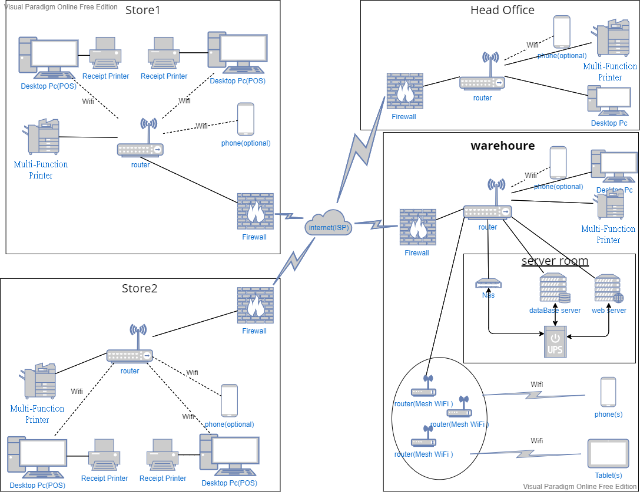

**Network Management Protocol**

Due to using the DHCP network management protocol, we don’t have to assign the IP for each device. DHCP will assign the IP to each device automatically.

**Router**

The router can accept the smartphone from the Staff because They have to connect the network for communication with another department.

**POS & Receipt Printer**

To refill the requirement of the POS system, the Desktop computer will be used as a pos. Also, it connects to a Receipt Printer to print the receipt of the invoice or receipt.

**Multi-Function Printer**

It will be placed at store and warehouse and Head Office, For Printing, copying, scanning or email the documents or reports between departments.

**Firewall**

It is software that protects the data for each network, it can avoid attacks from hacking or Computer viruses. Because These networks have to connect to the internet, firewall software is necessary.

**Internet Service Provider (ISP)**

We will be using HKBN 4.5G 42Mbps 8GB Data Mobile Service Plan for each staff, The delivery workman and installation workman have to edit or check the order from their department. Also, the clerk and manager of each department may have a video conference or sanding massage, or phone calls. after consideration,42Mbps & 8GB is enough for each staff.

**Database Server**

The database server will be placed in the server Room from the warehouse, it stores all the data from Store and each department. Since the scale of this company is not quite big, 1000GB can refill the system requirement. But for the company’s expansion, the database server will be added to 4000GB.

In terms of backup data, RAID 6 will be used for storage. RAID 6 provides increased reliability compared with RAID 0 or RAID 1, but RAID 6 requires a minimum of 4 disks.

Therefore, we choose Dell PowerEdge T140, which has 8 Front Bays, so it is suitable for RAID 6.

**Web Server**

The Web server will be placed in the server Room from the warehouse, it stores the website's files, namely all HTML documents and their related assets, including images, CSS stylesheets, JavaScript files, fonts, and video.

In terms of backup data, RAID 1 will be used for storage. It is simple and easy to implement compared with RAID 5 or RAID 6, RAID 1 Usable data storage capacity is only half of the total drive capacity because data is redundant. But we just have to store a simple web, so this is not a huge problem.

**NAS**

It is a file-level computer data storage server which is much simpler compared with a web server and database server. In this system, NAS will store simple files for each department such as a report, document, the recording of the meeting. It was easier and cheaper to expand the capacity. Ability to combine several disks as one single storage unit. Therefore, NAS is suitable for the system having a limited budget.

**Uninterruptible Power Supply (UPS)**

It will provide near-instantaneous protection from input power interruptions when the input power source or mains power fails. It connects to the web server and database server and NAS because these may data lost when power failure, for avoiding this problem, UPS will be needed.

**Mesh Wi-Fi router**

Since The warehouse has 6000 sq/feet. The Wi-Fi of the router can’t cover all the places. The mesh Wi-Fi and the Wi-Fi extender is the option for solving this problem, but mesh Wi-Fi is a better option, the reason following as:

We don’t have to manually switch over to the extender’s network, because Mesh Wi-Fi is using the same SSID (Service Set Identifier).

Also, mesh systems can overcome some of the speed problems that extenders have by using multiple radios to send and receive information simultaneously. “They can use a 2.4GHz channel to communicate with the client and then use their 5GHz channel to relay data to the other mesh access points on the network,” says Crane. Some mesh systems may even have three radios—one radio dedicated to that backhaul communication to the router, and two radios for communication with laptops, phones, and other client devices. This is particularly useful when there are a lot of devices on the network.

In our case, there are many warehouses clerk for checking or delivering the item, they will use the Tablet of the phone to communicate or our apps. Therefore, mesh Wi-Fi can be helped them in large.

1. Driving Question

Explain how the project answers this question: “How can an organization get benefit from a central computerized management system?”

A central computerized management system is typically stored in a database and used to manage web content, allowing multiple contributors to create, edit and publish.

Better Limited without a central computerized management system that uses handwritten records to store the information of their business, which is more prone to erroneous data. These companies are used to updating data manually which increases the possibility of mistakes. Compared with manual work, using a central computerized management system may decrease the risk of errors and reduce the loss caused by incorrect data. It can simplify the information updates necessary for the company. For instance, Better Limited prepares to expand its business in the Pearl River Delta Region. There may be seasonal or special promotions, or constantly changing products. A central computerized management system lets staff both add new content and remove out-of-date content quickly and efficiently. Therefore, it can boost staff’s motivation working efficiency for companies.

In addition, the central computerized management system lifts the market competitiveness of the company. Up to a minute, the system is successfully employed by megacorporations such as Fortress and Muji. Following these companies, Better Limited uses a central computerized management system to combine information on their branch stores. Due to the central computerized management system, the staff in the different branches can provide a certain answer for them when customers have any question about the company. It increases customers’ confidence in using our products or services. Thus, the system achieves higher competitiveness compared to other companies without this system.

To conclude, the central computerized management system plays a vital role in improving Better Limited's operation. It brings plenty of benefits for an organization such as decreasing the risk of errors and lifting market competitiveness.

1. Constraints & Limitations

**HTTP Unavailability**

We decide to use HTTPS and do not use HTTP because it can protect users from transferring data. If users’ browser does not support HTTPS, they cannot connect to our website.

**Over-reliance with Network**

If our company network shut down, many online services will not be provided, such as online placing order service and online chatroom service. Also, staff cannot read the data from the database server.

**The Environment of the Server Room**

The weather in Hong Kong is very hot, if we have not set up a server room to place the server. It may cause the equipment temperature to be high for a long time, which is very unfavorable for the life of the equipment.

**Depends on the Stability of Electricity**

Except for the server room, other devices have no backup power supply. If there is a power failure in the warehouse or store, the entire system will not work, but the server data can be saved.

**Mech Wi-Fi-Router Positioning.**

There are many storage cabinets in the warehouse. If the placement of the Mesh Wi-Fi router is not suitable, it will reduce the signal range and signal transmission speed received by the wi-fi in the warehouse. Therefore, it is necessary to avoid placing the router in a place with a wall.

**Maximum Number of Wi-Fi Connections**

According to the official data of wi-fi devices, reliable Wi-Fi with speeds of up to 4.2Gbps for over 40 devices, but we don’t need that fast Wi-Fi speed in the proposal system. After consideration, We set the Maximum number of Wi-Fi connections will be 50 devices, therefore we have a constraint on the number of Wi-Fi connections.

**Maximum Number of the Wired Connection**

The 10 ports router is enough for the proposed system, but it can’t handle the extension of the system in the future. Therefore, buying more routers the extend the network is the only way to solve the constraint.

**Cannot Handle Big Data Transferring & DDOS**

If many data are transferring or more than 30000 people connecting the “better limit” online shop website at the same time, the server may not handle it. Also, if some people DDOS the server, the server may not handle it.

1. System Analysis & Design
   1. Use Case Diagram
      1. In-house System – User Authentication Module

**Actor Specification**

|  |  |
| --- | --- |
| **Actor Name**: | User |
| **Description**: | The User is able to reset the password of his/her account willingly or forgot his/her password, access the functionalities by logging into the account and logout the account. |

|  |  |
| --- | --- |
| **Actor Name**: | Sales Employee |
| **Description**: | The Sales Employee has the privileges of the User in the system. |

|  |  |
| --- | --- |
| **Actor Name**: | Inventory Employee |
| **Description**: | The Inventory Employee has the privileges of the User in the system. |

|  |  |
| --- | --- |
| **Actor Name**: | Accounting Employee |
| **Description**: | The Accounting Employee has the privileges of the User in the system. |

|  |  |
| --- | --- |
| **Actor Name**: | Purchase Employee |
| **Description**: | The Purchase Employee has the privileges of the User in the system. |

|  |  |
| --- | --- |
| **Actor Name**: | Technique Support Employee |
| **Description**: | The Technique Support Employee has the privileges of the User in the system. |

|  |  |
| --- | --- |
| **Actor Name**: | Authentication System |
| **Description**: | The Authentication System is responsible for account authentication and the password reset process. |

|  |  |
| --- | --- |
| **Actor Name**: | Admin User |
| **Description**: | The Admin User is responsible for updating the password when the user forgot the password. |

**Use Case Diagram**

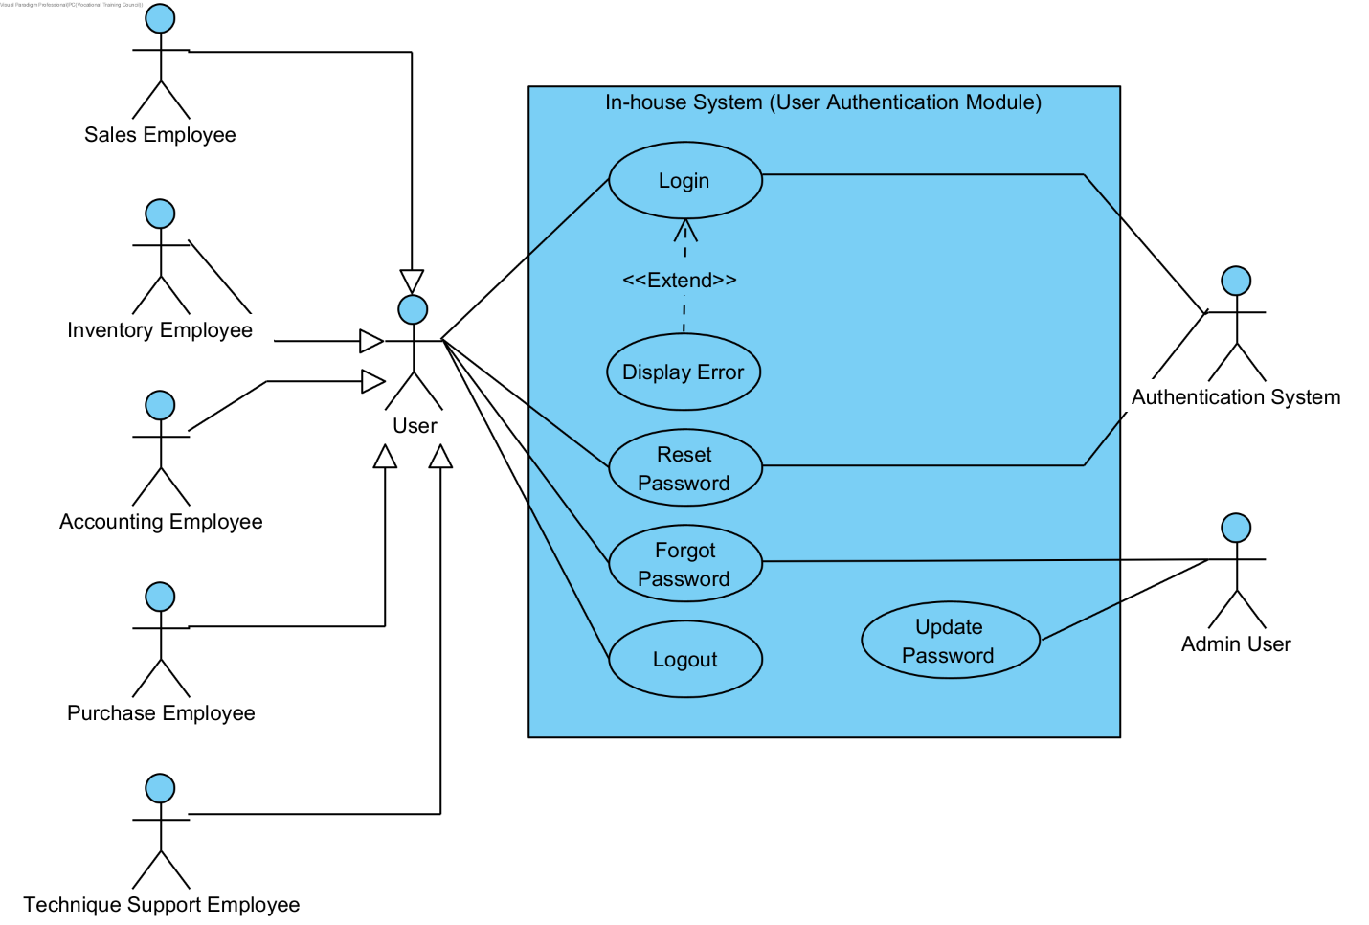

**Use Case Description**

|  |  |
| --- | --- |
| **Use Case Name** | Login |
| **Use Case ID** | UC-101 |
| **Primary Actor(s)** | User (Sales Employee, Inventory Employee, Accounting Employee, Purchase Employee, Technique Support Employee) |
| **Secondary Actor(s)** | Authentication System |
| **Brief Description** | The User logs into the system. |
| **Pre-conditions** | The User must have been provided an employee account by the IT Department in the system. |
| **Post-conditions** | The User logged into his/her account and able to access the functionalities in the system under his/her privileges. |
| **Flow of Events** | 1. The User selects “Login Account”. 2. The User inputs his/her provided username and password into provided input columns. 3. The User presses “Login”, and the system processes his/her information.to authenticate the account. |
| **Alternative Flows & Exceptions** | The User can select “Forgot Password” to reset his/her password if he/she has forgot the password of his/her account. The system will also display an error message if the username or password has entered incorrectly. |
| **Priority** | High |
| **Non-behavioral Requirements** |  |

|  |  |
| --- | --- |
| **Use Case Name** | Reset Password |
| **Use Case ID** | UC-102 |
| **Primary Actor(s)** | User (Sales Employee, Inventory Employee, Accounting Employee, Purchase Employee, Technique Support Employee) |
| **Secondary Actor(s)** | Authentication System |
| **Brief Description** | The User resets his/her password, and the system updates the account data. |
| **Pre-conditions** | The User must have already been provided an employee account by in the system. |
| **Post-conditions** | The System updates his/her account authentication details |
| **Flow of Events** | 1. The User selects “Reset Password”. 2. The User inputs his/her current account username and password into the provided input columns and the authentication system compares them with the account data in the database. 3. The User inputs his/her new password and confirm new password into the provided input columns and the system checks if both of them are match and qualify with the password standard (8 characters, strong, etc.) 4. The User presses “Reset”, and the system updates the account data in the database. |
| **Alternative Flows & Exceptions** | The system will display an error message if any of the steps do not meet the requirements of the condition and the users can cancel anytime in the midway of resetting their password. |
| **Priority** | High |
| **Non-behavioral Requirements** |  |

|  |  |
| --- | --- |
| **Use Case Name** | Forget Password |
| **Use Case ID** | UC-103 |
| **Primary Actor(s)** | User (Sales Employee, Inventory Employee, Accounting Employee, Purchase Employee, Technique Support Employee) |
| **Secondary Actor(s)** | Admin User |
| **Brief Description** | The User forgets his/her password and the system provides a reset password option. |
| **Pre-conditions** | The User must have already been provided an employee account by in the system. |
| **Post-conditions** | The System updates his/her account authentication details |
| **Flow of Events** | 1. The User selects “Forgot Password”. 2. The User inputs his/her staff ID and current account username into provided inputs columns and the authentication system compares them with the staff data and account data in the database. 3. The User presses “Submit”, and the system sends a new password request to the Admin User from the IT Department. 4. The User receives a new password by his/her email from the Admin User. |
| **Alternative Flows & Exceptions** | The account will be lock for thirty minutes if the five-digit code has been entered falsely more than seven times. |
| **Priority** | High |
| **Non-behavioral Requirements** |  |

|  |  |
| --- | --- |
| **Use Case Name** | Logout |
| **Use Case ID** | UC-104 |
| **Primary Actor(s)** | User (Sales Employee, Inventory Employee, Accounting Employee, Purchase Employee, Technique Support Employee) |
| **Secondary Actor(s)** |  |
| **Brief Description** | The User logs out the system. |
| **Pre-conditions** | The User must have already logged in to his/her account in the system. |
| **Post-conditions** |  |
| **Flow of Events** | The User selects “Logout Account”, and the system logs out the user’s account and directs the system back to its login interface. |
| **Alternative Flows & Exceptions** |  |
| **Priority** | High |
| **Non-behavioral Requirements** |  |

|  |  |
| --- | --- |
| **Use Case Name** | Updata Password |
| **Use Case ID** | UC-105 |
| **Actor(s)** | Admin User |
| **Brief Description** | The Admin User updates the password in the account data after generated a new password for the User who has forgotten his/her password and requested a new password. |
| **Pre-conditions** |  |
| **Post-conditions** | The password is updated, and the new password is sent to the respective user. |
| **Flow of Events** | 1. The Admin User generates a new password. 2. The Admin User sends the new password to the respective user by email. 3. The Admin User updates password in the account data of that respective user. |
| **Alternative Flows & Exceptions** |  |
| **Priority** | High |
| **Non-behavioral Requirements** |  |

* + 1. In-house System – POS Module

**Actor Specification**

|  |  |
| --- | --- |
| **Actor Name**: | Sales Representative |
| **Description**: | The Sales Representation is responsible for processing point of sales (POS) transactions and managing sales records. |

|  |  |
| --- | --- |
| **Actor Name**: | Database |
| **Description**: | The Database is responsible for centralizing all data and records in the company, allowing the staff to share resources and access data, and backing up data and records in the company. |

**Use Case Diagram**

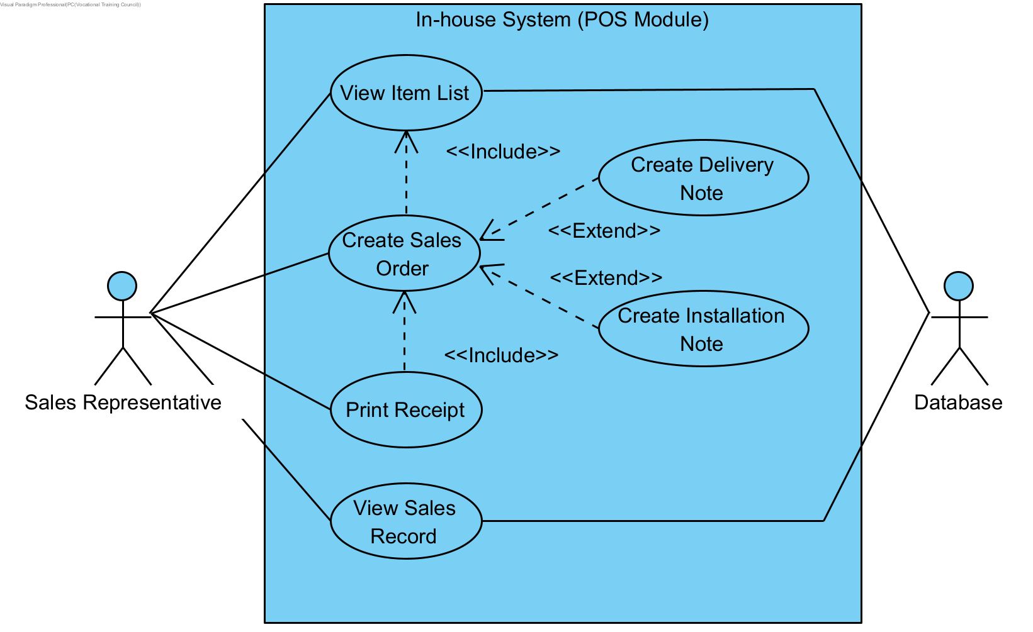

**Use Case Description**

|  |  |
| --- | --- |
| **Use Case Name** | View Item List |
| **Use Case ID** | UC-201 |
| **Primary Actor(s)** | Sales Representative |
| **Secondary Actor(s)** | Database |
| **Brief Description** | The Sales Representative views the item list to check the prices and the state of items when creating a sales order. |
| **Pre-conditions** | The Sales Representative must log into the system. |
| **Post-conditions** |  |
| **Flow of Events** | The Sales Representative views the “Item List”, and the system displays a catalogue of items with each items’ price and stock amount. |
| **Alternative Flows & Exceptions** |  |
| **Priority** | High |
| **Non-behavioral Requirements** | The POS Module should allow the sales representative to view all displayed items and non-displayed in the items catalogue. |

|  |  |
| --- | --- |
| **Use Case Name** | Create Sales Order |
| **Use Case ID** | UC-202 |
| **Primary Actor(s)** | Sales Representative |
| **Secondary Actor(s)** | Database |
| **Brief Description** | The Sales Representative creates a sales order and submit the order to the system for process. |
| **Pre-conditions** | The Sales Representative must log into the system. |
| **Post-conditions** |  |
| **Flow of Events** | 1. Include <<UC-201>> 2. The Sales Representative adds the item(s) into the order list by selecting the items displayed in the items catalogue and inputting the item(s) order quantity. 3. The Sales Representative presses “Create Sales Order” after the selection, and the system displays the order list with the price and quantity of each item and the total payment amount. 4. The Sales Representative submits the sales order after the customer has paid for the items. The system turns the order into a sales record and import the record into the database. |
| **Alternative Flows & Exceptions** | The Sales Representative can create a delivery and installation note by inputting the customers information, including his/her name, phone number and address, if the selected item(s) required a delivery or installation. |
| **Priority** | High |
| **Non-behavioral Requirements** |  |

|  |  |
| --- | --- |
| **Use Case Name** | Print Receipt |
| **Use Case ID** | UC-203 |
| **Primary Actor(s)** | Sales Representative |
| **Secondary Actor(s)** |  |
| **Brief Description** | The Sales Representative prints the receipt for the customer after submitting the sales order. |
| **Pre-conditions** | The Sales Representative must first submit the sales order. |
| **Post-conditions** | A receipt will be printed out for the customer |
| **Flow of Events** | 1. Include <<UC-202>> 2. The Sale Representative presses “Print Receipt”, and the system prints the receipt by a pre-generated formatted. |
| **Alternative Flows & Exceptions** |  |
| **Priority** | High |
| **Non-behavioral Requirements** |  |

|  |  |
| --- | --- |
| **Use Case Name** | View Sales Record |
| **Use Case ID** | UC-204 |
| **Primary Actor(s)** | Sales Representative |
| **Secondary Actor(s)** | Database |
| **Brief Description** | The Sales Representative views the sales record, and the system display the respective data in the relation. |
| **Pre-conditions** | The Sales Representative must log into the system. |
| **Post-conditions** |  |
| **Flow of Events** | The Sales Representative select “View Sales Record” and the system imports the respective data in the relation from the database and displays it in the system. |
| **Alternative Flows & Exceptions** |  |
| **Priority** | High |
| **Non-behavioral Requirements** |  |

* + 1. In-house System – Retail Stock Management Module

**Actor Specification**

|  |  |
| --- | --- |
| **Actor Name**: | Sales Employee |
| **Description**: | The Sales Employee is able to view the items record and the restock record. |

|  |  |
| --- | --- |
| **Actor Name**: | Sales Representative |
| **Description**: | The Sales Representative is responsible for updating the stock record and has the privileges of the Sales Employee in the system. |

|  |  |
| --- | --- |
| **Actor Name**: | Sales Manager |
| **Description**: | The Sales Manager is responsible for creating the restock request and has the privileges of the Sales Employee in the system. |

|  |  |
| --- | --- |
| **Actor Name**: | Inventory Clerk |
| **Description**: | The Inventory Clerk is responsible for approving the restock record. |

|  |  |
| --- | --- |
| **Actor Name**: | Database |
| **Description**: | The Database is responsible for centralizing all data and records in the company, allowing the staff to share resources and access data, and backing up data and records in the company. |

**Use Case Diagram**

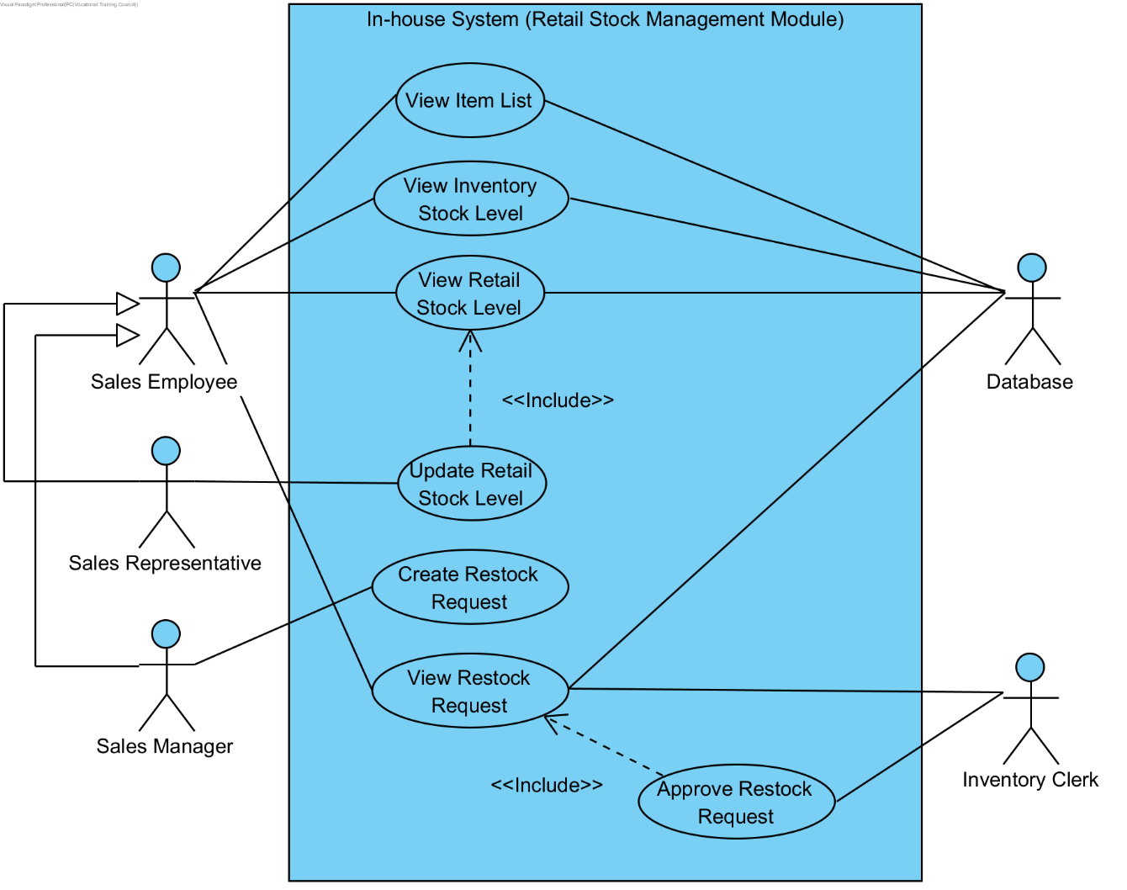

**Use Case Description**

|  |  |
| --- | --- |
| **Use Case Name** | View Item List |
| **Use Case ID** | UC-301 |
| **Primary Actor(s)** | Sales Employee |
| **Secondary Actor(s)** | Database |
| **Brief Description** | The Sales Employee views the view item list, and the system display the respective data in the relation. |
| **Pre-conditions** | The Sales Employee must log into the system. |
| **Post-conditions** |  |
| **Flow of Events** | The Sales Employee select “View Item List” and the system imports the respective data in the relation from the database and displays it in the system. |
| **Alternative Flows & Exceptions** |  |
| **Priority** | High |
| **Non-behavioral Requirements** |  |

|  |  |
| --- | --- |
| **Use Case Name** | View Inventory Stock Level |
| **Use Case ID** | UC-302 |
| **Primary Actor(s)** | Sales Employee |
| **Secondary Actor(s)** | Database |
| **Brief Description** | The Sales Employee views the inventory stock level, and the system display the respective data in the relation. |
| **Pre-conditions** | The Sales Employee must log into the system. |
| **Post-conditions** |  |
| **Flow of Events** | The Sales Employee select “View Inventory Stock Level” and the system imports the respective data in the relation from the database and displays it in the system. |
| **Alternative Flows & Exceptions** |  |
| **Priority** | High |
| **Non-behavioral Requirements** |  |

|  |  |
| --- | --- |
| **Use Case Name** | View Retail Stock Level |
| **Use Case ID** | UC-303 |
| **Primary Actor(s)** | Sales Employee |
| **Secondary Actor(s)** | Database |
| **Brief Description** | The Sales Employee views the retail stock Level, and the system display the respective data in the relation. |
| **Pre-conditions** | The Sales Employee must log into the system. |
| **Post-conditions** |  |
| **Flow of Events** | The Sales Employee select “View Retail Stock Level” and the system imports the respective data in the relation from the database and displays it in the system. |
| **Alternative Flows & Exceptions** |  |
| **Priority** | High |
| **Non-behavioral Requirements** |  |

|  |  |
| --- | --- |
| **Use Case Name** | Update Retail Stock Level |
| **Use Case ID** | UC-304 |
| **Primary Actor(s)** | Sales Representative |
| **Secondary Actor(s)** |  |
| **Brief Description** | The Sales Representative updates retail stock level, and the system updates the record and imports it into the database. |
| **Pre-conditions** | The Sales Representative must log into the system. |
| **Post-conditions** |  |
| **Flow of Events** | 1. Include <<UC-303>> 2. The Sales Representative presses “Edit”. 3. The Sales Representative inputs the new date into the stock record. 4. The Sales Representatives selects “Enter” and the system updates the record and imports it into the database. |
| **Alternative Flows & Exceptions** |  |
| **Priority** | High |
| **Non-behavioral Requirements** |  |

|  |  |
| --- | --- |
| **Use Case Name** | Create Restock Request |
| **Use Case ID** | UC-305 |
| **Primary Actor(s)** | Sales Employee |
| **Secondary Actor(s)** |  |
| **Brief Description** | The Sales Employee creates a restock request and the system imports it into the database. |
| **Pre-conditions** | The Sales Employee must log into the system. |
| **Post-conditions** |  |
| **Flow of Events** | 1. The Sales Employee selects “Create Restock Request”. 2. The Sales Employee inputs the restock data into the provided input columns. 3. The Sales Employee selects “Submit Record”, and the system generates a restock record and imports it into the database. |
| **Alternative Flows & Exceptions** |  |
| **Priority** | High |
| **Non-behavioral Requirements** |  |

|  |  |
| --- | --- |
| **Use Case Name** | View Restock Request |
| **Use Case ID** | UC-306 |
| **Primary Actor(s)** | Sales Employee, Inventory Clerk |
| **Secondary Actor(s)** | Database |
| **Brief Description** | The Sales Employee or Inventory Clerk view the restock request, and the system display the respective data in the relation. |
| **Pre-conditions** | The Sales Employee and Inventory Clerk must log into the system. |
| **Post-conditions** |  |
| **Flow of Events** | The Sales Employee or Inventory Clerk select “View Restock Request” and the system imports the respective data in the relation from the database and displays it in the system. |
| **Alternative Flows & Exceptions** |  |
| **Priority** | High |
| **Non-behavioral Requirements** |  |

|  |  |
| --- | --- |
| **Use Case Name** | Approve Restock Request |
| **Use Case ID** | UC-307 |
| **Actor(s)** | Inventory Clerk |
| **Brief Description** | The Inventory Clerk approves to the restock request. |
| **Pre-conditions** | The Inventory Clerk must log into the system. |
| **Post-conditions** | The restock request is approved, and the system updates the record and imports it into the database |
| **Flow of Events** | 1. Include << UC-306>> 2. The Inventory Clerk selects “Approve Restock Request”, and the system will approve the record by altering the “Record Approval” field in the record |
| **Alternative Flows & Exceptions** |  |
| **Priority** | High |
| **Non-behavioral Requirements** |  |

* + 1. In-house System – Inventory Stock Management Module

**Actor Specification**

|  |  |
| --- | --- |
| **Actor Name**: | Inventory Clerk |
| **Description**: | The Inventory Clerk is able to view the inventory stock record and re-order request and responsible for creating a re-order request. |

|  |  |
| --- | --- |
| **Actor Name**: | Goods Inward Clerk |
| **Description**: | The Goods Inward Clerk is able to view purchase order and goods received note and responsible for creating the goods received note. |

|  |  |
| --- | --- |
| **Actor Name**: | Purchasing Officer |
| **Description**: | Purchasing Officer is able to view the re-order request, purchase order, purchase invoice and goods received note and responsible for creating the purchase order and uploading purchase invoice. |

|  |  |
| --- | --- |
| **Actor Name**: | Accounting Clerk |
| **Description**: | Accounting Clerk is able to view the purchase order, purchase invoice and goods received note. |

**Use Case Diagram**

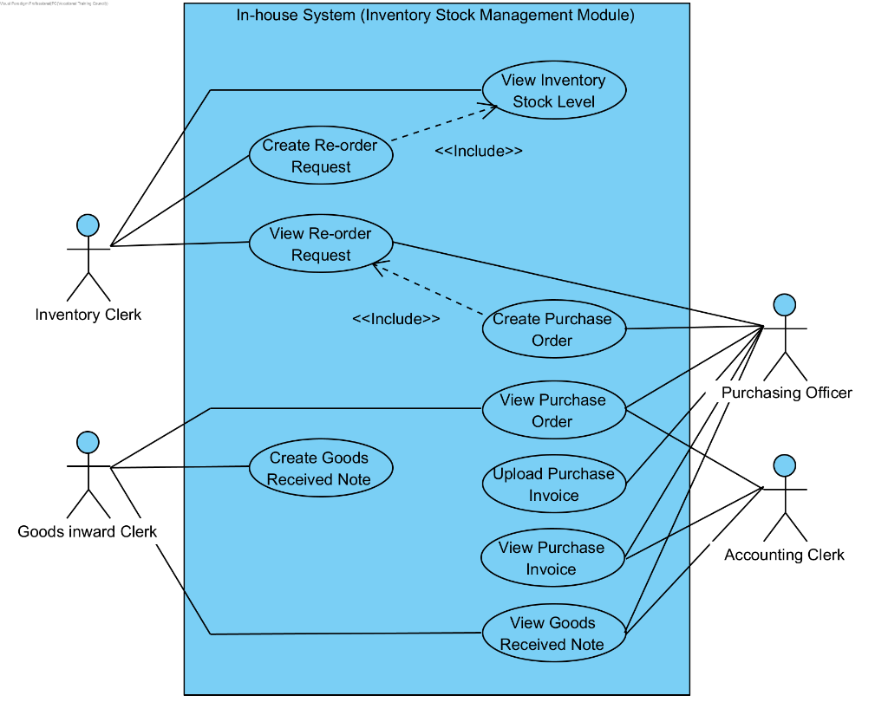

**Use Case Description**

|  |  |
| --- | --- |
| **Use Case Name** | View Inventory Stock Level |
| **Use Case ID** | UC-401 |
| **Primary Actor(s)** | Inventory Clerk |
| **Secondary Actor(s)** |  |
| **Brief Description** | The Inventory Clerk views the inventory stock level, and the system display the respective data in the relation. |
| **Pre-conditions** | The Inventory Clerk must log into the system. |
| **Post-conditions** |  |
| **Flow of Events** | The Inventory Clerk select “View Inventory Stock Level” and the system imports the respective data in the relation from the database and displays it in the system. |
| **Alternative Flows & Exceptions** |  |
| **Priority** | High |
| **Non-behavioral Requirements** |  |

|  |  |
| --- | --- |
| **Use Case Name** | Create Re-order Request |
| **Use Case ID** | UC-402 |
| **Primary Actor(s)** | Inventory Clerk |
| **Secondary Actor(s)** |  |
| **Brief Description** | The Inventory Clerk creates a re-stock request by viewing the inventory stock record. |
| **Pre-conditions** | The Inventory Clerk must log into the system. |
| **Post-conditions** | The restock request is created and the system imports it into the database. |
| **Flow of Events** | 1. Include << UC-401>> 2. The Inventory Clerk selects “Create Re-order Request” 3. The Inventory Clerk selects the item(s) that he/she want to re-order in the inventory stock record and inputs the re-order quantity of each item. 4. The Inventory Clerk selects “Create”, and the system creates the re-order request and imports it into the database. |
| **Alternative Flows & Exceptions** |  |
| **Priority** | High |
| **Non-behavioral Requirements** |  |

|  |  |
| --- | --- |
| **Use Case Name** | View Re-order Request |
| **Use Case ID** | UC-403 |
| **Actor(s)** | Inventory Clerk, Purchasing Officer |
| **Brief Description** | The Inventory Clerk or Purchasing Officer view the re-order request, and the system display the respective data in the relation. |
| **Pre-conditions** | The Inventory Clerk and Purchasing Officer must log into the system. |
| **Post-conditions** |  |
| **Flow of Events** | The Inventory Clerk or Purchasing Officer select “View Re-order Request” and the system imports the respective data in the relation from the database and displays it in the system. |
| **Alternative Flows & Exceptions** |  |
| **Priority** | High |
| **Non-behavioral Requirements** |  |

|  |  |
| --- | --- |
| **Use Case Name** | Create Purchase Order |
| **Use Case ID** | UC-404 |
| **Actor(s)** | Purchasing Officer |
| **Brief Description** | The Purchasing Officer creates a purchase order, and the system imports it into the database. |
| **Pre-conditions** | The Purchasing Officer must log into the system. |
| **Post-conditions** |  |
| **Flow of Events** | 1. Include << UC-403>> 2. The Purchasing Officer selects “Create Purchase Order”. 3. The Purchasing Officer inputs the purchase data into the provided input columns. 4. The Purchasing Officer selects “Submit Order”, and the system generates a purchase order and imports it into the database. |
| **Alternative Flows & Exceptions** |  |
| **Priority** | High |
| **Non-behavioral Requirements** |  |

|  |  |
| --- | --- |
| **Use Case Name** | View Purchase Order |
| **Use Case ID** | UC-405 |
| **Actor(s)** | Goods Inward Clerk, Purchasing Officer, Accounting Clerk |
| **Brief Description** | The Goods Inward Clerk, Purchasing Officer or Accounting Clerk view the purchase order, and the system display the respective data in the relation. |
| **Pre-conditions** | The Goods Inward Clerk, Purchasing Officer and Accounting Clerk must log into the system. |
| **Post-conditions** |  |
| **Flow of Events** | The Goods Inward Clerk, Purchasing Officer or Accounting Clerk select “View Purchase Order” and the system imports the respective data in the relation from the database and displays it in the system. |
| **Alternative Flows & Exceptions** |  |
| **Priority** | High |
| **Non-behavioral Requirements** |  |

|  |  |
| --- | --- |
| **Use Case Name** | Create Goods Received Note |
| **Use Case ID** | UC-406 |
| **Actor(s)** | Goods Inward Clerk |
| **Brief Description** | The Goods Inward Clerk creates a goods received note, and the system imports it into the database. |
| **Pre-conditions** | The Goods Inward Clerk must log into the system. |
| **Post-conditions** |  |
| **Flow of Events** | 1. The Goods Inward Clerk selects “Create Goods Received Note”. 2. The Goods Inward Clerk inputs the supplier’s delivery note data into the provided input columns. 3. The Goods Inward Clerk selects “Submit Note”, and the system generates a goods received note and imports it into the database. |
| **Alternative Flows & Exceptions** |  |
| **Priority** | High |
| **Non-behavioral Requirements** |  |

|  |  |
| --- | --- |
| **Use Case Name** | Upload Purchase Invoice Record |
| **Use Case ID** | UC-407 |
| **Actor(s)** | Purchasing Officer |
| **Brief Description** | The Purchasing Officer uploads a purchase invoice record, and the system imports it into the database. |
| **Pre-conditions** | The Purchasing Officer must log into the system. |
| **Post-conditions** |  |
| **Flow of Events** | 1. The Purchasing Officer selects “Upload Purchase Invoice Record”. 2. The Purchasing Officer drags the purchase invoice into the provided space or inputs the file directory of the invoice into the provided input column. 3. The Purchasing Officer selects “Upload”, and the system uploads the purchase invoice and imports it into the database. |
| **Alternative Flows & Exceptions** |  |
| **Priority** | High |
| **Non-behavioral Requirements** |  |

|  |  |
| --- | --- |
| **Use Case Name** | View Purchase Invoice |
| **Use Case ID** | UC-408 |
| **Actor(s)** | Purchasing Officer, Accounting Clerk |
| **Brief Description** | The Purchasing Officer or Accounting Clerk view the purchase invoice, and the system display the respective data in the relation. |
| **Pre-conditions** | The Purchasing Officer and Accounting Clerk must log into the system. |
| **Post-conditions** |  |
| **Flow of Events** | The Purchasing Officer or Accounting Clerk select “View Purchase Invoice” and the system imports the respective data in the relation from the database and displays it in the system. |
| **Alternative Flows & Exceptions** |  |
| **Priority** | High |
| **Non-behavioral Requirements** |  |

* + 1. In-house System – Delivery & Installation Module

**Actor Specification**

|  |  |
| --- | --- |
| **Actor Name**: | Inventory Clerk |
| **Description**: | The Inventory Clerk is able to view the workmen record, workman duty record and delivery arrangement and responsible for printing out the delivery notes and confirming the completion of an arrangement. |

|  |  |
| --- | --- |
| **Actor Name**: | Technical Support Officer |
| **Description**: | The Technical Support Officer is able to view the workmen record, workman duty record and installation arrangement and responsible for printing out the installation note and confirming the completion of a installation. |

|  |  |
| --- | --- |
| **Actor Name**: | Database |
| **Description**: | The Database is responsible for centralizing all data and records in the company, allowing the staff to share resources and access data, and backing up data and records in the company. |

**Use Case Diagram**

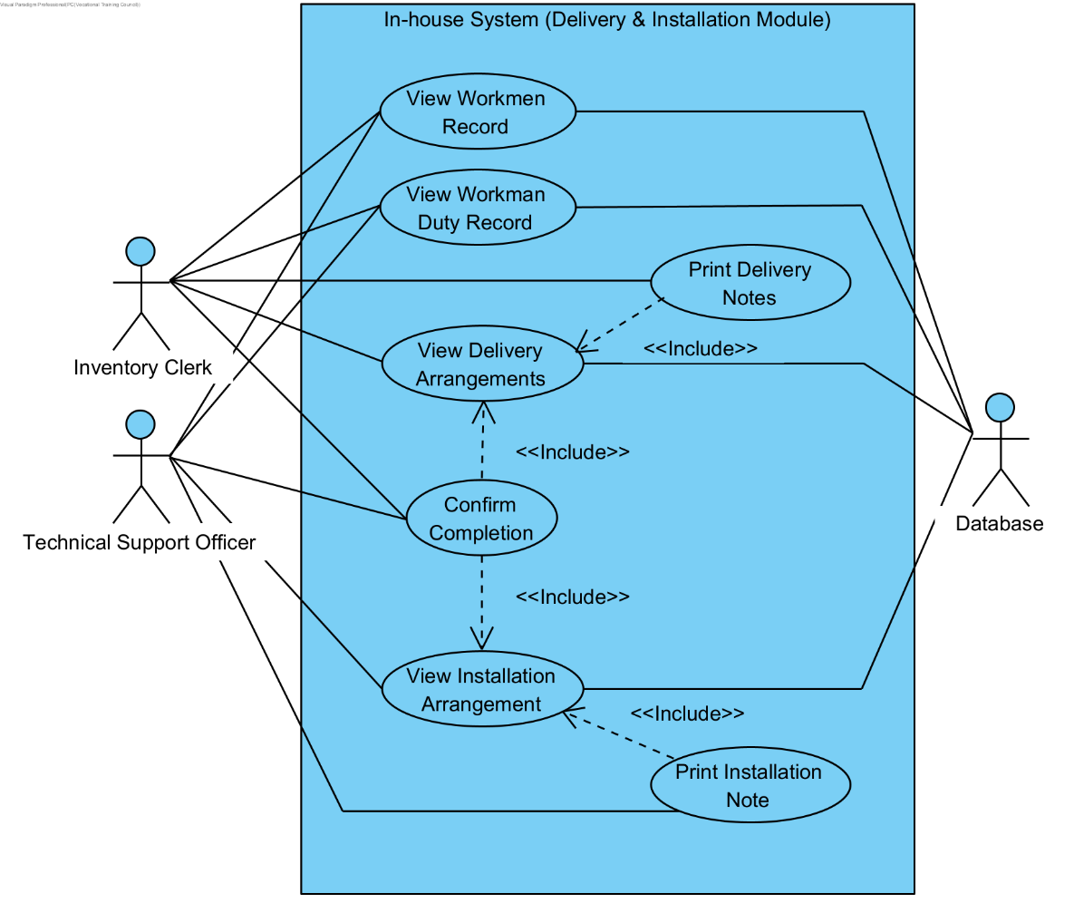

**Use Case Description**

|  |  |
| --- | --- |
| **Use Case Name** | View Workmen Record |
| **Use Case ID** | UC-501 |
| **Primary Actor(s)** | Inventory Clerk, Technical Support Officer |
| **Secondary Actor(s)** | Database |
| **Brief Description** | The Inventory Clerk or Technical Support Officer view the workmen record, and the system display the respective data in the relation. |
| **Pre-conditions** | The Inventory Clerk and Technical Support Officer must log into the system. |
| **Post-conditions** |  |
| **Flow of Events** | The Inventory Clerk or Technical Support Officer select “View Workmen Record” and the system imports the respective data in the relation from the database and displays it in the system. |
| **Alternative Flows & Exceptions** |  |
| **Priority** | High |
| **Non-behavioral Requirements** |  |

|  |  |
| --- | --- |
| **Use Case Name** | View Workman Duty Record |
| **Use Case ID** | UC-502 |
| **Primary Actor(s)** | Inventory Clerk, Technical Support Officer |
| **Secondary Actor(s)** | Database |
| **Brief Description** | The Inventory Clerk or Technical Support Officer view the workmen duty record, and the system display the respective data in the relation. |
| **Pre-conditions** | The Inventory Clerk and Technical Support Officer must log into the system. |
| **Post-conditions** |  |
| **Flow of Events** | The Inventory Clerk or Technical Support Officer select “View Workman Duty Record” and the system imports the respective data in the relation from the database and displays it in the system. |
| **Alternative Flows & Exceptions** |  |
| **Priority** | High |
| **Non-behavioral Requirements** |  |

|  |  |
| --- | --- |
| **Use Case Name** | View Delivery Arrangement |
| **Use Case ID** | UC-503 |
| **Primary Actor(s)** | Inventory Clerk |
| **Secondary Actor(s)** | Database |
| **Brief Description** | The Inventory Clerk views the delivery arrangement, and the system display the respective data in the relation. |
| **Pre-conditions** | The Inventory Clerk must log into the system. |
| **Post-conditions** |  |
| **Flow of Events** | The Inventory Clerk select “View Delivery Arrangement” and the system imports the respective data in the relation from the database and displays it in the system. |
| **Alternative Flows & Exceptions** |  |
| **Priority** | High |
| **Non-behavioral Requirements** |  |

|  |  |
| --- | --- |
| **Use Case Name** | Print Delivery Notes |
| **Use Case ID** | UC-504 |
| **Primary Actor(s)** | Inventory Clerk |
| **Secondary Actor(s)** |  |
| **Brief Description** | The Inventory Clerk prints the delivery notes for the arrangements that have been assigned to the delivery workman. |
| **Pre-conditions** |  |
| **Post-conditions** | The delivery notes will be printed out for the workman |
| **Flow of Events** | 1. Include <<UC-503>> 2. The Inventory Clerk selects “Print Delivery Notes”, and the system prints the delivery notes by a pre-generated formatted. |
| **Alternative Flows & Exceptions** |  |
| **Priority** | High |
| **Non-behavioral Requirements** |  |

|  |  |
| --- | --- |
| **Use Case Name** | Confirm Completion |
| **Use Case ID** | UC-505 |
| **Actor(s)** | Inventory Clerk, Technical Support Officer |
| **Brief Description** | The Inventory Clerk and Technical Support Officer confirms the completion of the delivery and installation arrangements respectively. |
| **Pre-conditions** | The Inventory Clerk and Technical Support Officer must log into the system. |
| **Post-conditions** | The delivery and installation is confirmed completion, and the system updates the arrangement status and imports it into the database |
| **Flow of Events** | 1. Include << UC-504>> 2. The Inventory Clerk selects “Confirm Completion”, and the system confirms the completion of the arrangements by altering the “Status” field in the record. |
| **Alternative Flows & Exceptions** |  |
| **Priority** | High |
| **Non-behavioral Requirements** |  |

|  |  |
| --- | --- |
| **Use Case Name** | View Installation Arrangement |
| **Use Case ID** | UC-506 |
| **Primary Actor(s)** | Technical Support Officer |
| **Secondary Actor(s)** | Database |
| **Brief Description** | The Technical Support Officer views the installation arrangement, and the system display the respective data in the relation. |
| **Pre-conditions** | The Technical Support Officer must log into the system. |
| **Post-conditions** |  |
| **Flow of Events** | The Technical Support Officer select “View Installation Arrangement” and the system imports the respective data in the relation from the database and displays it in the system. |
| **Alternative Flows & Exceptions** |  |
| **Priority** | High |
| **Non-behavioral Requirements** |  |

|  |  |
| --- | --- |
| **Use Case Name** | Print Installation Notes |
| **Use Case ID** | UC-507 |
| **Primary Actor(s)** | Technical Support Officer |
| **Secondary Actor(s)** |  |
| **Brief Description** | The Technical Support Officer prints the installation notes for the arrangements that have been assigned to the installation technician. |
| **Pre-conditions** |  |
| **Post-conditions** | The delivery notes will be printed out for the technician. |
| **Flow of Events** | 1. Include <<UC-506>> 2. The Technical Support Officer selects “Print Installation Notes”, and the system prints the installation notes by a pre-generated formatted. |
| **Alternative Flows & Exceptions** |  |
| **Priority** | High |
| **Non-behavioral Requirements** |  |

* + 1. In-house System – Product Management Module

**Actor Specification**

|  |  |
| --- | --- |
| **Actor Name**: | Manager |
| **Description**: | The Manager is able to view the items record and responsible for managing new products and the states of the current products in the record by updating the price, re-order level, re-order amount and marking phasing out items. |

|  |  |
| --- | --- |
| **Actor Name**: | Sales Manager |
| **Description**: | The Sales Manager has the privileges of the Manager in the system. |

|  |  |
| --- | --- |
| **Actor Name**: | Accounting Manager |
| **Description**: | The Accounting Manager has the privileges of the Manager in the system. |

|  |  |
| --- | --- |
| **Actor Name**: | Purchase Manager |
| **Description**: | The Purchase Manager has the privileges of the Manager in the system. |

|  |  |
| --- | --- |
| **Actor Name**: | Database |
| **Description**: | The Database is responsible for centralizing all data and records in the company, allowing the staff to share resources and access data, and backing up data and records in the company. |

**Use Case Diagram**

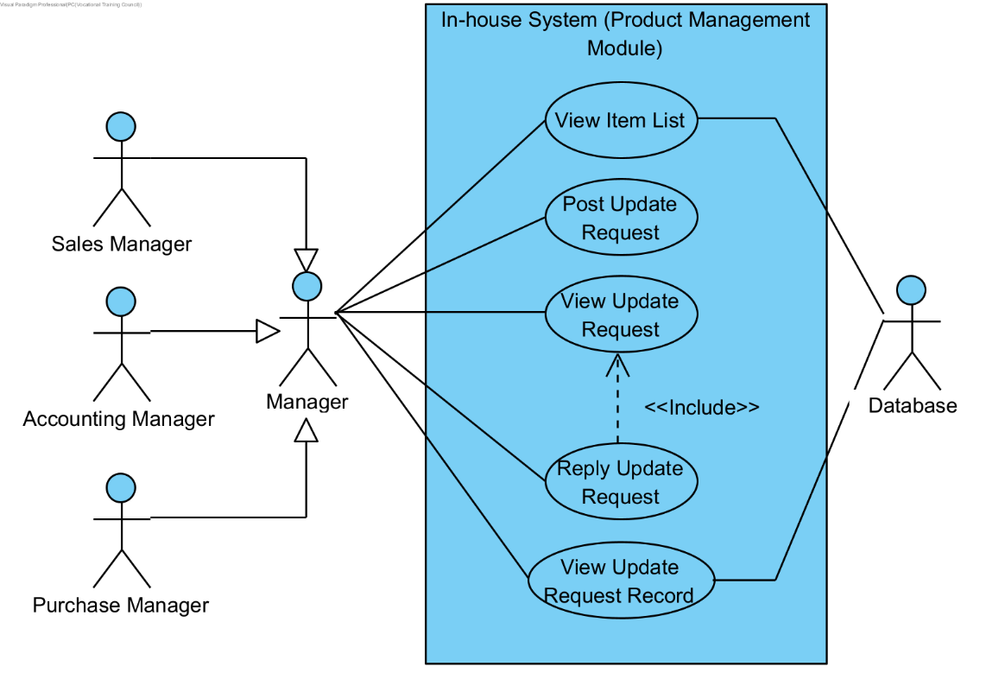

**Use Case Description**

|  |  |
| --- | --- |
| **Use Case Name** | View Item List |
| **Use Case ID** | UC-601 |
| **Primary Actor(s)** | Manager (Sales Manager, Accounting Manager, Purchase Manager) |
| **Secondary Actor(s)** | Database |
| **Brief Description** | The Manager views the item list, and the system display the respective data in the relation. |
| **Pre-conditions** | The Manager must log into the system. |
| **Post-conditions** |  |
| **Flow of Events** | The Manager select “View Item List” and the system imports the respective data in the relation from the database and displays it in the system. |
| **Alternative Flows & Exceptions** |  |
| **Priority** | High |
| **Non-behavioral Requirements** |  |

|  |  |
| --- | --- |
| **Use Case Name** | Post Update Request |
| **Use Case ID** | UC-602 |
| **Primary Actor(s)** | Manager (Sales Manager, Accounting Manager, Purchase Manager) |
| **Secondary Actor(s)** |  |
| **Brief Description** | The Manager posts an update request on the goods record. |
| **Pre-conditions** | The Manager must log into the system. |
| **Post-conditions** | The update request is posted for other managers to view and waiting for their replies and approvals. |
| **Flow of Events** | 1. The Manager selects “Post Update Request” 2. The Manager adds item(s) by inputting the data of the item(s) in the provided input columns or selects the item(s) from the goods record that he/she wants to update. 3. The Manager selects “Post”, and the system will post the update request on the goods record that the Manager has selected in the system. |
| **Alternative Flows & Exceptions** |  |
| **Priority** | High |
| **Non-behavioral Requirements** |  |

|  |  |
| --- | --- |
| **Use Case Name** | View Update Request |
| **Use Case ID** | UC-603 |
| **Primary Actor(s)** | Manager (Sales Manager, Accounting Manager, Purchase Manager) |
| **Secondary Actor(s)** |  |
| **Brief Description** | The Manager views an update request on the goods record. |
| **Pre-conditions** | The Manager must log into the system. |
| **Post-conditions** | The update requested is approved and the system will update the goods record. |
| **Flow of Events** | 1. The Manager selects “View Update Request”, and the system displays a list of update requests from different department managers. 2. The Manager selects the update request that he/she wants to view, and the database displays the details of the request. |
| **Alternative Flows & Exceptions** |  |
| **Priority** | High |
| **Non-behavioral Requirements** |  |

|  |  |
| --- | --- |
| **Use Case Name** | Replay Update Requests |
| **Use Case ID** | UC-604 |
| **Primary Actor(s)** | Manager (Sales Manager, Accounting Manager, Purchase Manager) |
| **Secondary Actor(s)** |  |
| **Brief Description** | The Manager replies to an update request on the item(s) from items record. |
| **Pre-conditions** | The Manager must log into the system. |
| **Post-conditions** | The update request is replied and approved and the system updates the items record and imports it into the database |
| **Flow of Events** | 1. Include << UC-505>> 2. The Manager selects “Replay Update Requests” 3. The Manager replies the request by messages, an edit of the request or an approval of the request. 4. The Managers selects “Sent” and the update request is replied. |
| **Alternative Flows & Exceptions** |  |
| **Priority** | High |
| **Non-behavioral Requirements** |  |

|  |  |
| --- | --- |
| **Use Case Name** | View Update Request Record |
| **Use Case ID** | UC-605 |
| **Primary Actor(s)** | Manager (Sales Manager, Accounting Manager, Purchase Manager) |
| **Secondary Actor(s)** |  |
| **Brief Description** | The Manager views the update request record to review the pervious requests posted by different managers. |
| **Pre-conditions** | The Manager must log into the system. |
| **Post-conditions** |  |
| **Flow of Events** | 1. The Manager selects “View Update Request Record”, and the system displays a list of update request records from different department managers. 2. The Manager selects the different update request records that he/she wants to view, and the database displays the details of the record. |
| **Alternative Flows & Exceptions** |  |
| **Priority** | High |
| **Non-behavioral Requirements** |  |

* + 1. In-house System –Accounting Analysis Module

**Actor Specification**

|  |  |
| --- | --- |
| **Actor Name**: | Accounting Clerk |
| **Description**: | The Accounting Clerk is able to view a variety of records form different departments and create an analysis report. |

|  |  |
| --- | --- |
| **Actor Name**: | Manager |
| **Description**: | The Manager is able to view the analysis reports respective to their departments. |

|  |  |
| --- | --- |
| **Actor Name**: | Sales Manager |
| **Description**: | The Sales Manager has the privileges of the Manager in the system. |

|  |  |
| --- | --- |
| **Actor Name**: | Inventory Manager |
| **Description**: | The Inventory Manager has the privileges of the Manager in the system. |

|  |  |
| --- | --- |
| **Actor Name**: | Purchase Manager |
| **Description**: | The Purchase Manager has the privileges of the Manager in the system. |

|  |  |
| --- | --- |
| **Actor Name**: | Accounting Manager |
| **Description**: | The Accounting Manager has the privileges of the Manager in the system. |

|  |  |
| --- | --- |
| **Actor Name**: | Database |
| **Description**: | The Database is responsible for centralizing all data and records in the company, allowing the staff to share resources and access data, and backing up data and records in the company. |

**Use Case Diagram**

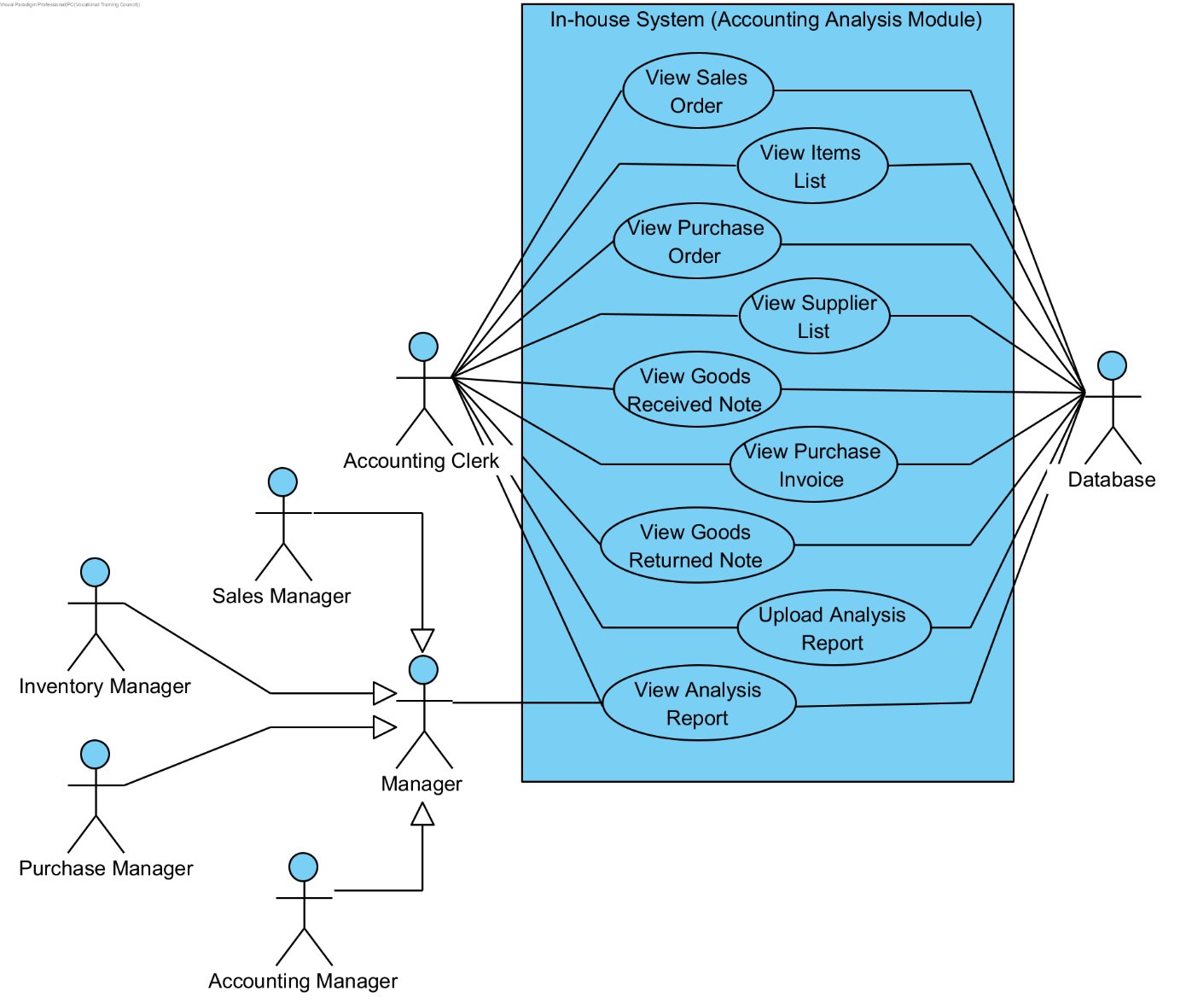

**Use Case Description**

|  |  |
| --- | --- |
| **Use Case Name** | View Sales Order |
| **Use Case ID** | UC-701 |
| **Primary Actor(s)** | Accounting Clerk |
| **Secondary Actor(s)** | Database |
| **Brief Description** | The Accounting Clerk views the sales order, and the system display the respective data in the relation. |
| **Pre-conditions** | The Accounting Clerk must log into the system. |
| **Post-conditions** |  |
| **Flow of Events** | The Accounting Clerk select “View Sales Order” and the system imports the respective data in the relation from the database and displays it in the system. |
| **Alternative Flows & Exceptions** |  |
| **Priority** | High |
| **Non-behavioral Requirements** |  |

|  |  |
| --- | --- |
| **Use Case Name** | View Item List |
| **Use Case ID** | UC-702 |
| **Primary Actor(s)** | Accounting Clerk |
| **Secondary Actor(s)** | Database |
| **Brief Description** | The Accounting Clerk views the item list, and the system display the respective data in the relation. |
| **Pre-conditions** | The Accounting Clerk must log into the system. |
| **Post-conditions** |  |
| **Flow of Events** | The Accounting Clerk select “View Item List” and the system imports the respective data in the relation from the database and displays it in the system. |
| **Alternative Flows & Exceptions** |  |
| **Priority** | High |
| **Non-behavioral Requirements** |  |

|  |  |
| --- | --- |
| **Use Case Name** | View Purchase Order |
| **Use Case ID** | UC-703 |
| **Primary Actor(s)** | Accounting Clerk |
| **Secondary Actor(s)** | Database |
| **Brief Description** | The Accounting Clerk views the purchase order, and the system display the respective data in the relation. |
| **Pre-conditions** | The Accounting Clerk must log into the system. |
| **Post-conditions** |  |
| **Flow of Events** | The Accounting Clerk select “View Purchase Order” and the system imports the respective data in the relation from the database and displays it in the system. |
| **Alternative Flows & Exceptions** |  |
| **Priority** | High |
| **Non-behavioral Requirements** |  |

|  |  |
| --- | --- |
| **Use Case Name** | View Supplier List |
| **Use Case ID** | UC-704 |
| **Primary Actor(s)** | Accounting Clerk |
| **Secondary Actor(s)** | Database |
| **Brief Description** | The Accounting Clerk views the supplier list, and the system display the respective data in the relation. |
| **Pre-conditions** | The Accounting Clerk must log into the system. |
| **Post-conditions** |  |
| **Flow of Events** | The Accounting Clerk select “View Supplier List” and the system imports the respective data in the relation from the database and displays it in the system. |
| **Alternative Flows & Exceptions** |  |
| **Priority** | High |
| **Non-behavioral Requirements** |  |

|  |  |
| --- | --- |
| **Use Case Name** | View Goods Received Note |
| **Use Case ID** | UC-705 |
| **Primary Actor(s)** | Accounting Clerk |
| **Secondary Actor(s)** | Database |
| **Brief Description** | The Accounting Clerk views the goods received note, and the system display the respective data in the relation. |
| **Pre-conditions** | The Accounting Clerk must log into the system. |
| **Post-conditions** |  |
| **Flow of Events** | The Accounting Clerk select “View Goods Received Note” and the system imports the respective data in the relation from the database and displays it in the system. |
| **Alternative Flows & Exceptions** |  |
| **Priority** | High |
| **Non-behavioral Requirements** |  |

|  |  |
| --- | --- |
| **Use Case Name** | View Purchase Invoice |
| **Use Case ID** | UC-706 |
| **Primary Actor(s)** | Accounting Clerk |
| **Secondary Actor(s)** | Database |
| **Brief Description** | The Accounting Clerk views the purchase invoice, and the system display the respective data in the relation. |
| **Pre-conditions** | The Accounting Clerk must log into the system. |
| **Post-conditions** |  |
| **Flow of Events** | The Accounting Clerk select “View Purchase Invoice” and the system imports the respective data in the relation from the database and displays it in the system. |
| **Alternative Flows & Exceptions** |  |
| **Priority** | High |
| **Non-behavioral Requirements** |  |

|  |  |
| --- | --- |
| **Use Case Name** | View Goods Received Note |
| **Use Case ID** | UC-707 |
| **Primary Actor(s)** | Accounting Clerk |
| **Secondary Actor(s)** | Database |
| **Brief Description** | The Accounting Clerk views the goods returned note, and the system display the respective data in the relation. |
| **Pre-conditions** | The Accounting Clerk must log into the system. |
| **Post-conditions** |  |
| **Flow of Events** | The Accounting Clerk select “View Goods Received Note” and the system imports the respective data in the relation from the database and displays it in the system. |
| **Alternative Flows & Exceptions** |  |
| **Priority** | High |
| **Non-behavioral Requirements** |  |

|  |  |
| --- | --- |
| **Use Case Name** | Create Analysis Report |
| **Use Case ID** | UC-708 |
| **Primary Actor(s)** | Accounting Clerk |
| **Secondary Actor(s)** | Database |
| **Brief Description** | The Accounting Clerk creates an analysis report and submit the order to the system for process. |
| **Pre-conditions** | The Accounting Clerk must log into the system. |
| **Post-conditions** |  |
| **Flow of Events** | 1. The Accounting Clerk selects “Create Analysis Report”. 2. The Accounting Clerk inputs the calculated data into the provided input columns. 3. The Accounting Clerk selects “Submit Report”, and the system generates an analysis report by inserting the inputted data into a pre-formatted report and imports it into the database. |
| **Alternative Flows & Exceptions** |  |
| **Priority** | High |
| **Non-behavioral Requirements** |  |

|  |  |
| --- | --- |
| **Use Case Name** | View Analysis Report |
| **Use Case ID** | UC-709 |
| **Primary Actor(s)** | Accounting Clerk, Manager (Sales Manager, Inventory Manager, Purchase Manager, Accounting Manager) |
| **Secondary Actor(s)** | Database |
| **Brief Description** | The Accounting Clerk or Manager view the analysis report, and the system display the respective data in the relation. |
| **Pre-conditions** | The Accounting Clerk and Manager must log into the system. |
| **Post-conditions** |  |
| **Flow of Events** | The Accounting Clerk or Manager select “View Analysis Report” and the system imports the respective data in the relation from the database and displays it in the system. |
| **Alternative Flows & Exceptions** |  |
| **Priority** | High |
| **Non-behavioral Requirements** |  |

* + 1. In-house System – Return Items Module

**Actor Specification**

|  |  |
| --- | --- |
| **Actor Name**: | Sales Representative |
| **Description**: | The Sale Representative is responsible for creating a goods returned record upon receiving a returned goods form a customer. |

|  |  |
| --- | --- |
| **Actor Name**: | Inventory Clerk |
| **Description**: | The Inventory is able to view the goods returned records and responsible for sending the returned goods back to their respective suppliers outside the system. |

|  |  |
| --- | --- |
| **Actor Name**: | Accounting Clerk |
| **Description**: | The Accounting Clerk is able to view the goods returned records and responsible for confirming the needs of returning the items to the supplier. |

**Use Case Diagram**

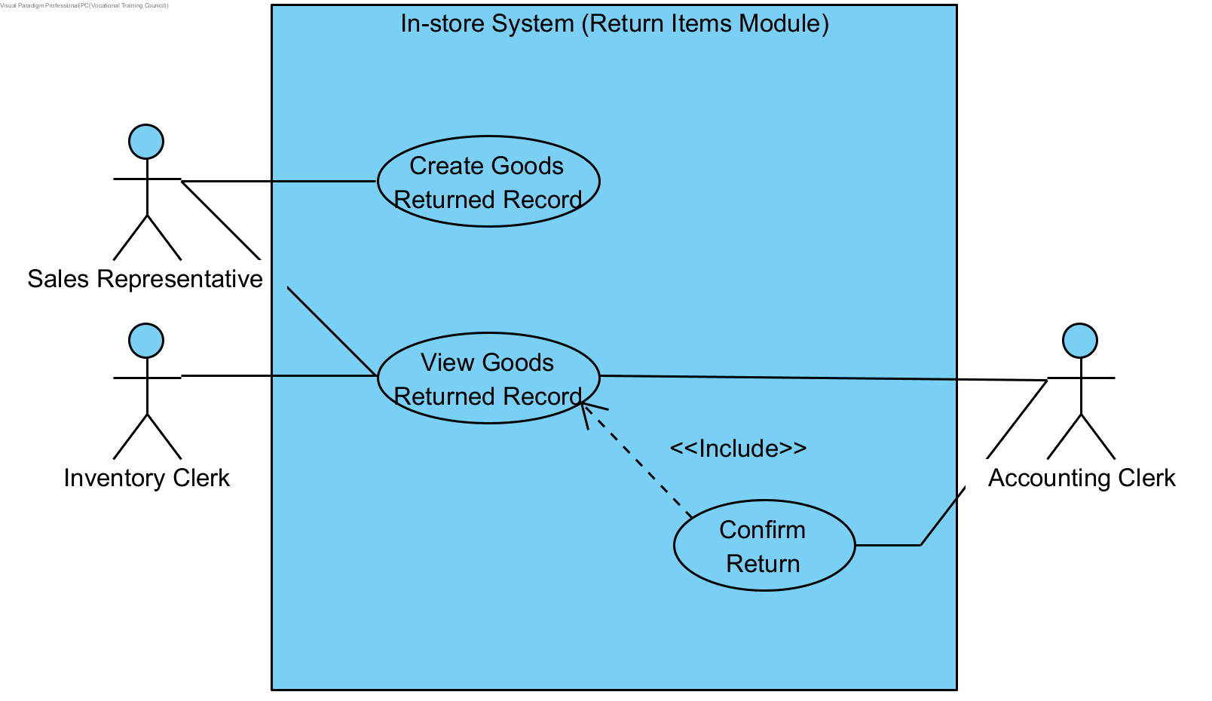

**Use Case Description**

|  |  |
| --- | --- |
| **Use Case Name** | Create Goods Returned Record |
| **Use Case ID** | UC-801 |
| **Primary Actor(s)** | Sales Representative |
| **Secondary Actor(s)** |  |
| **Brief Description** | The Accounting Clerk creates a goods returned record and the system import the record into the database. |
| **Pre-conditions** | The Sales Representative must log into the system. |
| **Post-conditions** |  |
| **Flow of Events** | 1. The Sales Representative selects “Create Goods Returned Record”. 2. The Sales Representative inputs the information of the returned item(s) and the customer who formerly owns it. 3. The Sales Representative selects “Submit Record”, and the system generates a record and imports it into the database. |
| **Alternative Flows & Exceptions** |  |
| **Priority** | High |
| **Non-behavioral Requirements** |  |

|  |  |
| --- | --- |
| **Use Case Name** | View Goods Returned Record |
| **Use Case ID** | UC-802 |
| **Primary Actor(s)** | Inventory Clerk |
| **Secondary Actor(s)** | Database |
| **Brief Description** | The Inventory Clerk views the goods returned record, and the system display the respective data in the relation. |
| **Pre-conditions** | The Inventory Clerk must log into the system. |
| **Post-conditions** |  |
| **Flow of Events** | The Inventory Clerk select “View Goods Returned Record” and the system imports the respective data in the relation from the database and displays it in the system. |
| **Alternative Flows & Exceptions** |  |
| **Priority** | High |
| **Non-behavioral Requirements** |  |

|  |  |
| --- | --- |
| **Use Case Name** | Confirm Return |
| **Use Case ID** | UC-803 |
| **Actor(s)** | Accounting Clerk |
| **Brief Description** | The Accounting Clerk views the goods returned record and confirms the needs of returning the items to the supplier. |
| **Pre-conditions** | The Inventory Clerk must log into the system. |
| **Post-conditions** |  |
| **Flow of Events** | 1. Include <<UC-902>> 2. The Accounting Clerk selects “Confirm Return”, and the system will confirm the needs of returning the items to the supplier by altering the “Confirm Return” field in the record. |
| **Alternative Flows & Exceptions** |  |
| **Priority** | High |
| **Non-behavioral Requirements** |  |

* 1. Class Diagram
     1. In-house System – User Authentication Module

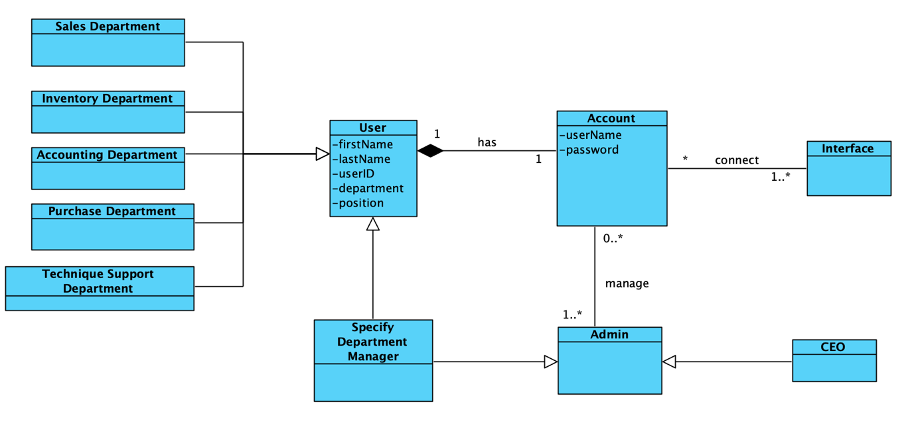

|  |  |
| --- | --- |
| **Class** | **Definition** |
| User | One user must have one account. It holds first name, last name, user ID, department and position. |
| Sales Department | It inherits User class. |
| Inventory Department | It inherits User class. |
| Accounting Department | It inherits User class. |
| Purchase Department | It inherits User class. |
| Technique Support Department | It inherits User class. |
| Account | Account should be logged in by user. It holds staff name, staff ID, password, department and involve method such as login, logout, display error and forget password. |
| Interface | Interface show the information and function for staff to use. |
| Admin | Admin manages account. It holds method including add user, delete user and reset password |
| CEO | It inherits Admin class. |
| Specify Department Manager | It inherits Admin class. |

|  |  |
| --- | --- |
| **Association** | **Verb Phase** |
| A user has an account. | has |
| Admin manages accounts. | manage |
| Accounts connect the interface. | connect |

* + 1. In-house System – POS Module

|  |  |
| --- | --- |
| **Class** | **Definition** |
| Sales Representative | Sales Representative is responsible for all function of Point of Sale System, which includes Sale Order, Receipt, Item List and Schedule. |
| Sales Order | When customer want to buy appliance, Sales Order is completed by sales representative for customer.  It holds Sales Order ID, store name, Item Name, Item ID, Item description, quantity, date, staff ID, staff name, payment method. |
| Delivery Note | Sales order may include delivery note when customer require the delivery service.  It holds delivery ID, customer name, customer ID, address, phone number, delivery date, expected delivery time, delivery item and completion status. |
| Installation Note | Sales order may include Installation Note when customer require the installation service.  It holds customer name, customer ID, address, phone number, installation date, expected installation time, installation item and completion status. |
| Schedule | Schedule, including Delivery Schedule and Installation Schedule is arranged by Sales Representative. |
| Delivery Schedule | Delivery Schedule inherits Schedule. |
| Installation Schedule | Installation Schedule inherits Schedule. |
| Receipt | Receipt is printed for customers.  It holds unit price apart from attributes of Sales Order, Customer Delivery Note and Installation Note. |
| Item List | Item list stores all item information and is checked by sales representative.  It holds item name, item ID, item description, unit price, good location and supplier ID. |
| Customer List | Customer List store all registered customers information.  It holds customer name, customer ID, address, order ID and receipts ID. |
| Payment Gateway | The gateway that will handle payment sent by customer. It can be either deducted from credit card or prepaid account balance. On success, an approval code will be returned to the system. |

|  |  |
| --- | --- |
| **Association** | **Verb Phase** |
| Sales Representative creates Sales Order. | create |
| Payment Gateway handled the Sales Order | handle |
| Sales Representative view Item List and Customer List. | view |
| Sales Order has Installation Note and Customer Delivery Note. | has |
| Sales Representative print Receipt. | print |
| Sales Representative arranges Schedule. | arrange |

* + 1. In-house System – Retail Stock Management Module

|  |  |
| --- | --- |
| **Class** | **Definition** |
| Sales Department | Sales Department Staff view Customer List, Item List, Inventory Stock Level and Retail tore Stock Level. |
| Sales Representative | It inherits Sales Department class. |
| Sales Manager | Sales Manager updates Restock Request and inherits Sales Department class. |
| Notification | Notification remind Sales Manager to re-order items. It holds item Name, item ID, remain quantity. |
| Item List | Item List store all item information and is viewed by Sales Department. It holds item name, item ID, item description, unit price, good location and supplier ID. |
| Retail Store Stock Level | Retail Store Stock Level is convenient for sales checking item quantity in the specify store. It holds store ID, item name, item ID and quantity. |
| Inventory Stock Level | Inventory Stock Level is convenient for sales checking item quantity in the warehouse. It holds, item name, item ID and quantity. |
| Restock Request | Re-stock Request is sent by Sales Manager when the stock level is too low in store. It holds item name, item ID, quantity, username and store ID. |

|  |  |
| --- | --- |
| **Association** | **Verb Phase** |
| Sales Manager creates Restock Request. | create |
| Sales Department view Item List, Retail Store Stock Level, Inventory Stock Level and Restock Request | view |

* + 1. In-house System – Inventory Stock Management Module

|  |  |
| --- | --- |
| **Class** | **Definition** |
| Inventory Clerk | Inventory Department Staff view Inventory Stock Level and creates Re-order Request when stock level is low. |
| Notification | When inventory stock level is low, system send message to remind clerk to restock. It holds item name, item ID and remaining quantity. It holds item name, item ID and remain quantity. |
| Goods Inward Clerk | Goods Inwards Clerk create Goods Received Note through viewing Delivery Note from Supplier and Purchase Order. If the items and the corresponding quantity are correct, the clerk updates Inventory Stock Level. |
| Purchase Department | Purchase Department view Re-order Request and create Purchase Order. The department clerk uploads Purchase Invoice after receiving Purchase Invoice from supplier. |
| Re-order Request | Re-order Request is created by Inventory Clerk. It holds item name, item ID, quantity and username. |
| Delivery Note from Supplier | Delivery Note from Supplier is viewed by Goods Inward Clerk. It holds supplier name, item name and quantity. |
| Inventory Stock Level | Inventory Stock Level is updated by Goods Inward Clerk. It sends notification that remind Inventory Clerk to re-order item. It holds item name, item ID and quantity. |
| Accounting Department | Accounting Department views Purchase Order, Purchase Invoice and Goods Received Note. |
| Goods Received Note | Goods Received Note is created by Goods Inward Clerk. It holds received ID, supplier ID, item ID, item name, quantity, inbound date and inbound time |
| Supplier List | Supplier List is updated by Purchase Department. It holds supplier ID and supplier name. |
| Purchase Order | Purchase Order is created by Purchase Department. It holds item name, quantity and unit price. |
| Purchase Invoice | Purchase Invoice is uploaded by Purchase Department. |

|  |  |
| --- | --- |
| **Association** | **Verb Phase** |
| - Goods Inward Clerk updates Inventory Stock Level.  - Purchasing Department updates Supplier List | update |
| - Goods Inward Clerk views Delivery Note From Supplier and Purchase Order.  - Inventory Clerk views Inventory Stock Level  - Purchasing Department views Re-order Request and Goods Received Note.  - Accounting Department views Goods Received Note, Purchase Order and Purchase Invoice | view |
| - Goods Inward Clerk creates Goods Received Note  - Clerk creates Re-order Request  - Purchase Department creates Purchase Order | Create |
| Purchase Department uploads Purchase Invoice | upload |

* + 1. In-house System – Delivery & Installation Module

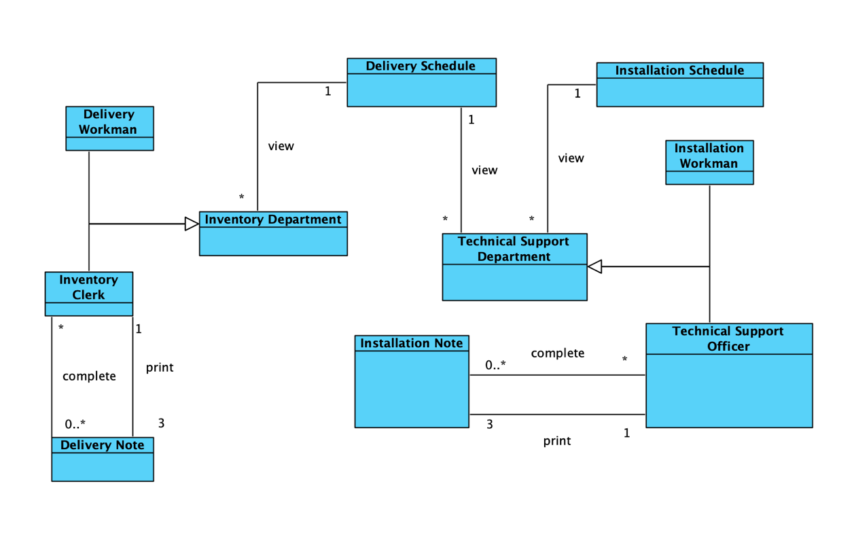

|  |  |
| --- | --- |
| **Class** | **Definition** |
| Inventory Department | Inventory Department, including Inventory Clerk and Delivery Workman, views Delivery Schedule . |
| Inventory Clerk | Inventory Clerk deals with delivery note following Delivery Schedule. |
| Delivery Workman | It inherits Inventory Department. |
| Technical Support Department | Technical Support Department, including Technical Support Officer and Installation Workman, views Delivery Schedule and Installation Schedule. |
| Technical Support Officer | Technical Support Officer deals with installation notes a following Delivery Schedule and Installation Schedule. |
| Installation Workman | It inherits Technical Support Department. |
| Delivery Schedule | Delivery Schedule is viewed by Inventory Department and Technical Support Department |
| Delivery Note | Delivery Note is dealt with by Inventory Clerk. |
| Installation Schedule | Delivery Schedule is viewed by Technical Support Department |
| Installation Note | Installation Note is dealt with by Technical Support Officer. |

|  |  |
| --- | --- |
| **Association** | **Verb Phase** |
| - Inventory Department views Delivery Schedule  - Technical Support Department views Delivery Schedule and Delivery Schedule | view |
| - Inventory Clerk completes Delivery Note  - Technical Support Clerk completes Installation Note | complete |
| - Inventory Clerk prints Delivery Note  - Technical Support Clerk prints Installation Note | print |

* + 1. In-house System – Goods Management Module

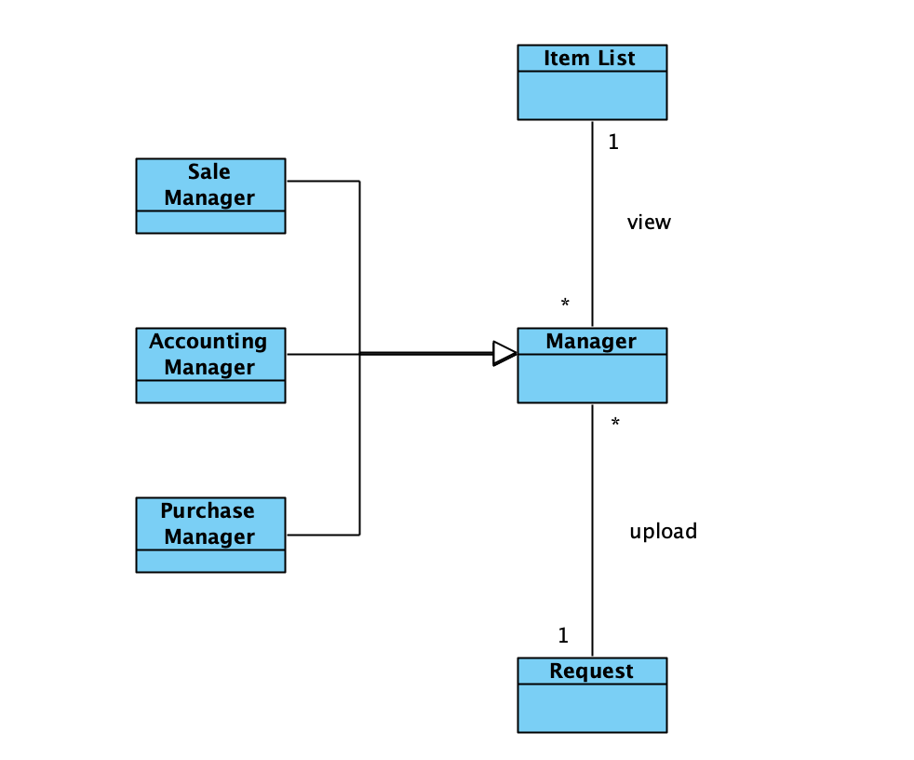

|  |  |
| --- | --- |
| **Class** | **Definition** |
| Manager | Manger views Item List and uploads Request. |
| Sale Manager | Sale Manager inherits Manager. |
| Accounting Manager | Accounting Manager inherits Manager. |
| Purchase Manager | Purchase Manager inherits Manager. |
| Item List | Item List store all item information and is viewed by Sales Department. It holds item name, item ID, item description, unit price, good location and supplier ID. |
| Request |  |

|  |  |
| --- | --- |
| **Association** | **Verb Phase** |
| Manager views Item List | upload |
| Manager uploads Request | view |

* + 1. In-house System –Accounting Analysis Module

|  |  |
| --- | --- |
| **Class** | **Definition** |
| Manager | Manager views Analysis Report. |
| Sale Manager | Sale Manager inherits Manager. |
| Inventory Manager | Inventory Manager inherits Manager. |
| Purchase Manager | Purchase Manager inherits Manager. |
| Accounting Manager | Accounting Manager inherits Manager. |
| Accounting Clerk | Accounting Clerk upload Analysis Report following overall information. |
| Analysis Report | Analysis Report is uploaded by Accounting Clerk. |
| Receipt | Receipt is viewed by Accounting Clerk. |
| Goods Return Note | Goods Return Note is viewed by Accounting Clerk. |
| Purchase Order | Purchase Order is viewed by Accounting Clerk. |
| Purchase Invoice | Purchase Invoice is viewed by Accounting Clerk. |
| Item List | Item List is viewed by Accounting Clerk. |
| Supplier List | Supplier List is viewed by Accounting Clerk. |
| Goods Received Note | Goods Received Note is viewed by Accounting Clerk. |

|  |  |
| --- | --- |
| **Association** | **Verb Phase** |
| - Managers view Analysis Report  - Accounting Clerk views Receipt, Goods Return Note, Purchase Order, Purchase Invoice, Item List, Supplier List and Goods Received Note | view |
| Accounting Clerk uploads Analysis Report | upload |

* + 1. In-house System – Return Items Module

|  |  |
| --- | --- |
| **Class** | **Definition** |
| Sales Representative | Sales Representative create Goods Return Note for customer |
| Inventory Clerk | Inventory Clerk views Goods Return Note |
| Accounting Clerk | Accounting Clerk confirms Goods Return Note |
| Goods Return Note | If the sold goods have any defect, sales representative have to create and complete Goods Return Note.  It holds item name, item ID, return date, defect description, username, user ID. |

|  |  |
| --- | --- |
| **Association** | **Verb Phase** |
| Inventory Clerk views Goods Return Note | view |
| Sales Representative creates Goods Return Note | create |
| Accounting Clerk confirms Goods Return Note | confirm |

* + 1. Entire Module

* 1. Sequence Diagram
     1. In-house System – User Authentication Module

**Login**

|  |  |
| --- | --- |
| **Actor Input(public user)** | **System Response** |
|  | Ask Login username & password |
| Enter username & password |  |
|  | Show Login successfully |

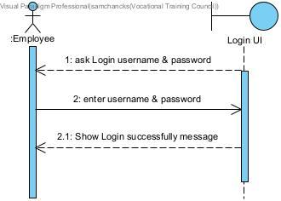

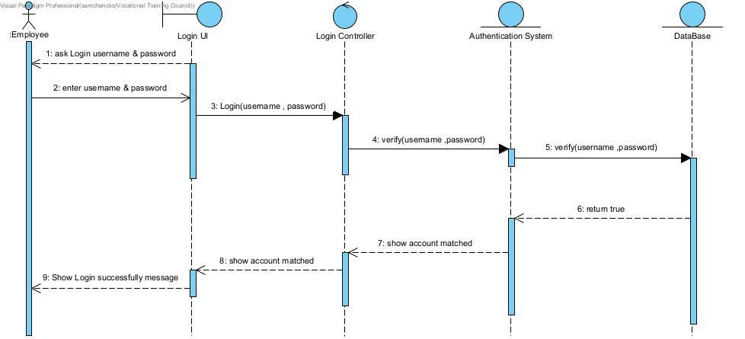

**Display Error**

|  |  |
| --- | --- |
| **Actor Input(public user)** | **System Response** |
|  | Ask Login username & password |
| Enter username & password |  |
|  | Show Login successfully |

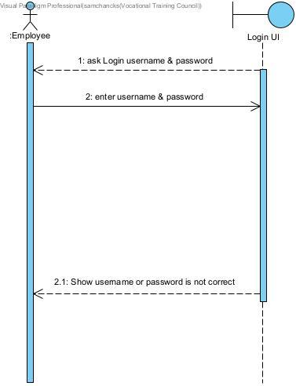

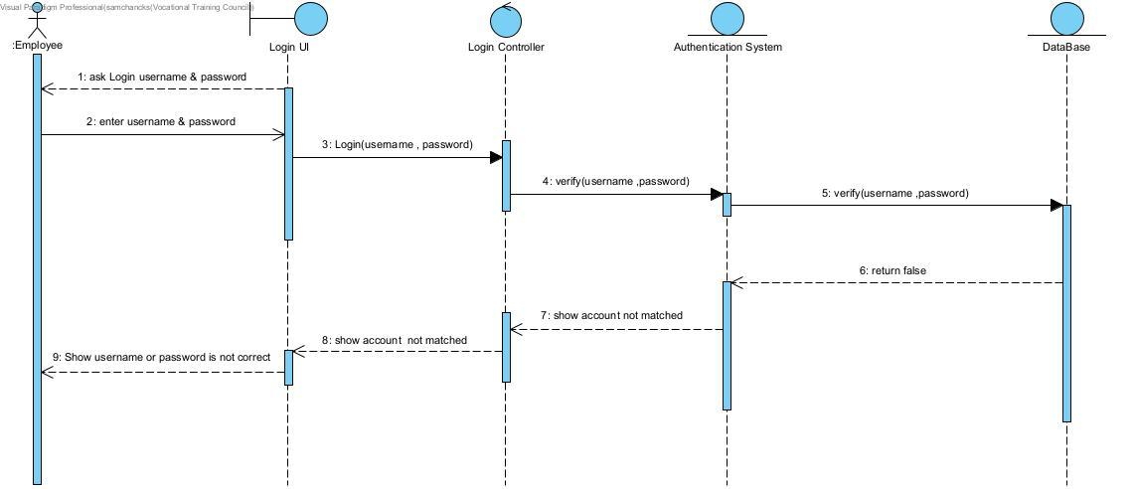

**Reset Password**

|  |  |
| --- | --- |
| **Actor Input(public user)** | **System Response** |
|  | Ask old password & new password |
| Enter old password & new password & confrim new password |  |
|  | Show Reset password successfully message |

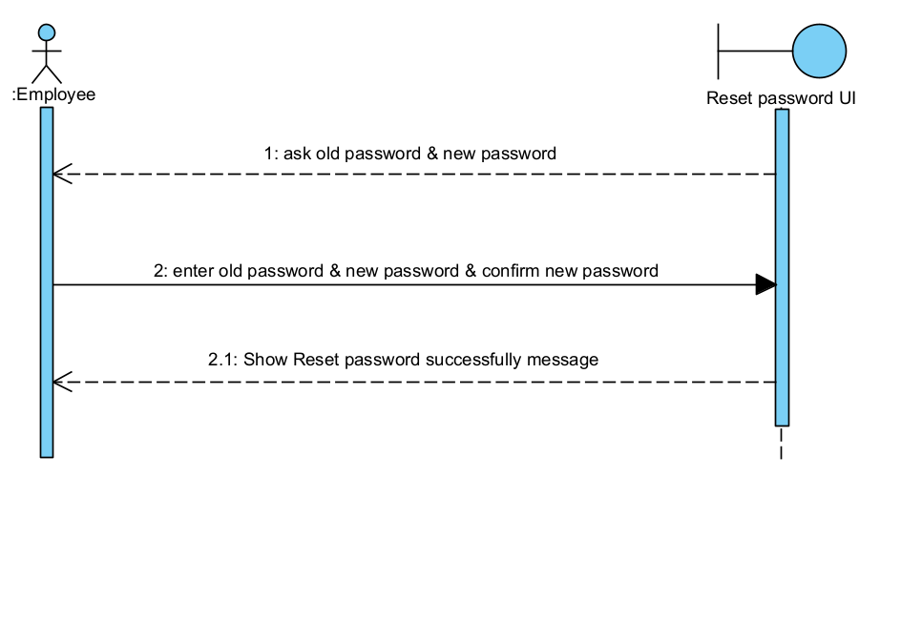

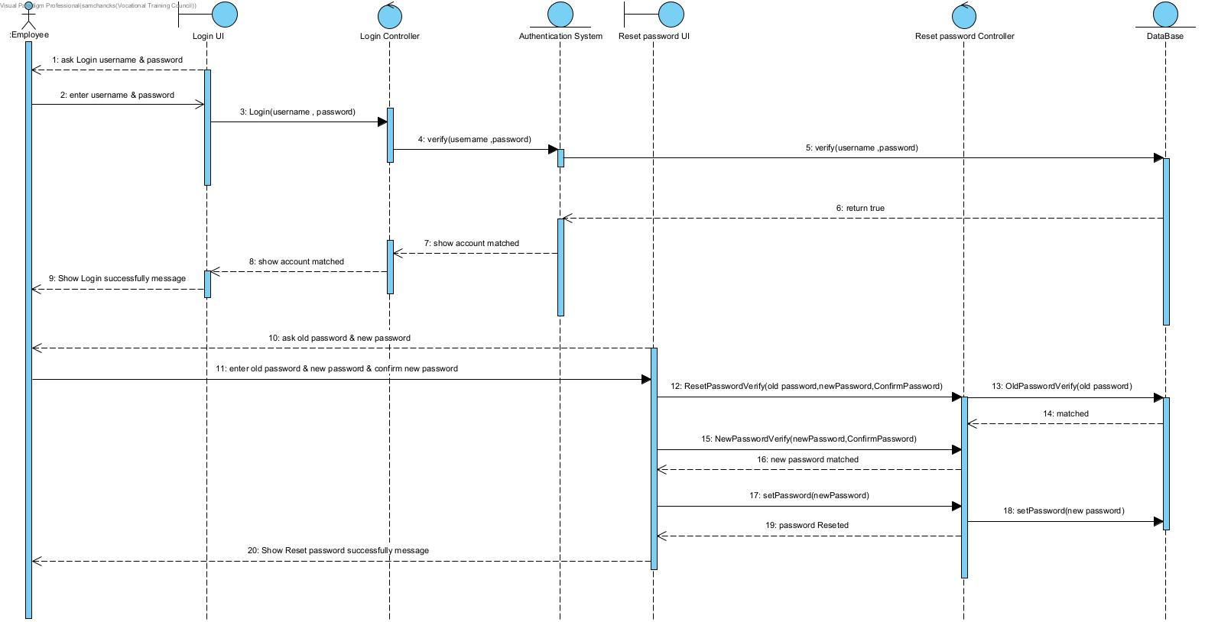

**Update Password & Forgot Password**

|  |  |
| --- | --- |
| **Actor Input(public user)** | **System Response** |
|  | ask username & staff number |
| Enter username & staff number |  |
|  | Show Reset password successfully message |

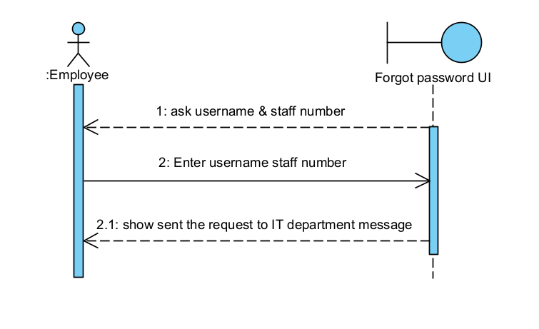

|  |  |
| --- | --- |
| **Actor Input(public user)** | **System Response** |
| Enter to Forgot password Request Table |  |
|  | Show Forgot password Request List |

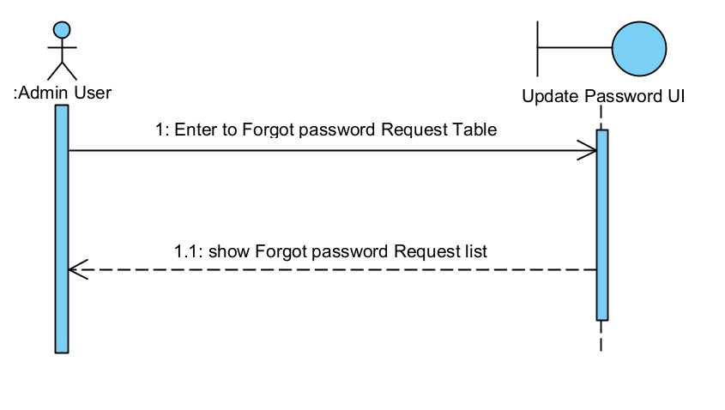

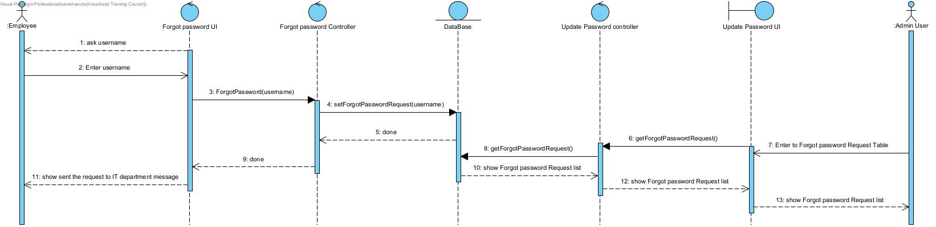

**Logout**

|  |  |
| --- | --- |
| **Actor Input(public user)** | **System Response** |
|  | Ask Login username & password |
| Enter username & password |  |
|  | Show Login successfully message |
| Enter to Logout |  |
|  | Logout |

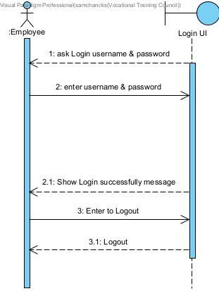

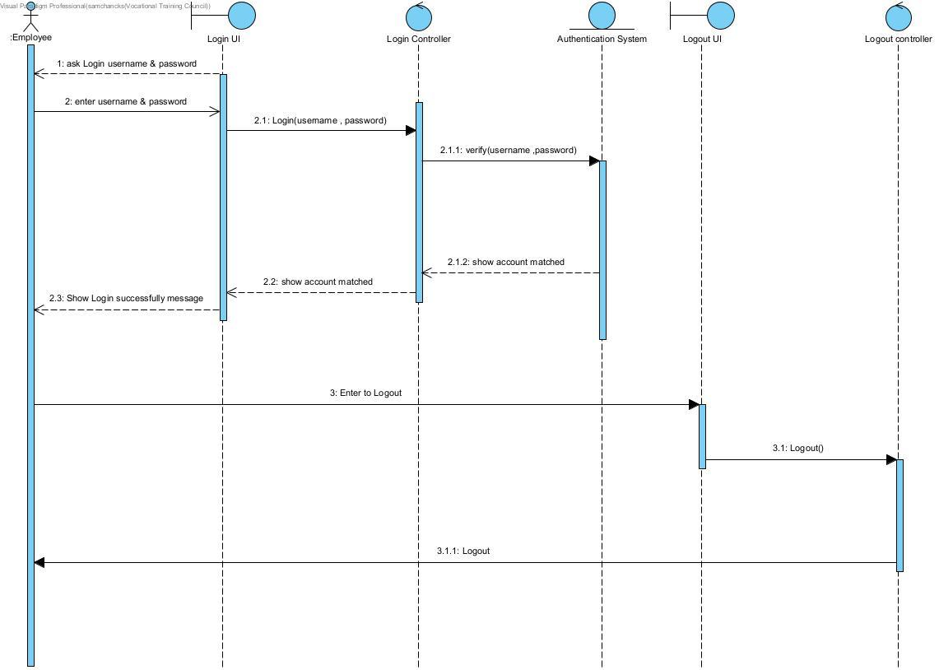

**User Authentication Module**

Login + Reset password + Logout

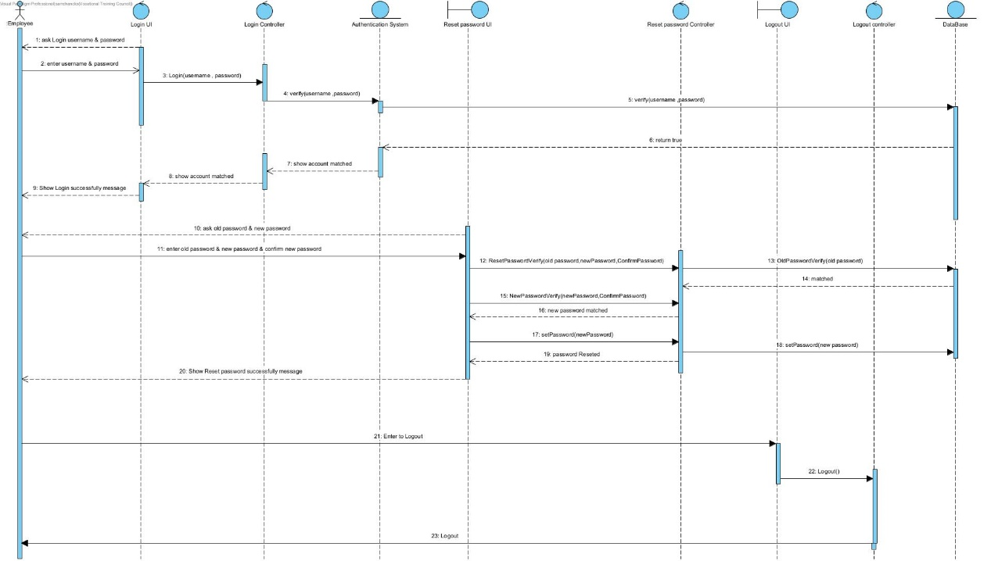

Display error from Login + Update password & Forgot Password

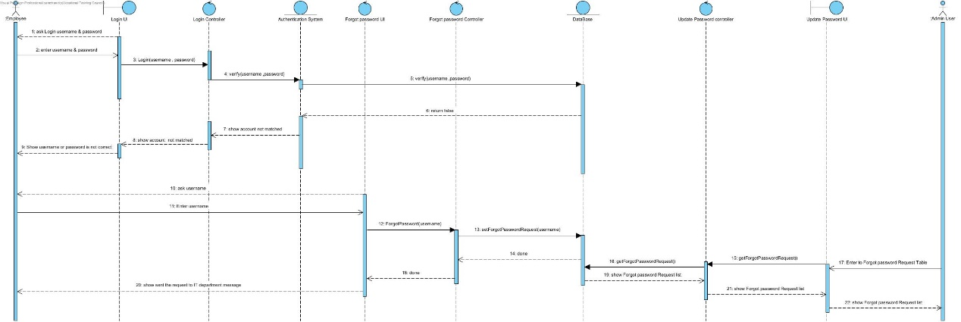

* + 1. In-house System – POS Module

|  |  |  |
| --- | --- | --- |
| **Combined Fragment** | **Actor Input(public user)** | **System Response** |
|  | Enter the Customer ID |  |
| Loop condition |  | Show "choose Product" message |
| add Products to order & quantity |  |
|  |  | Show total Price of order |
|  | Ask take away or Delivery |  |
| if condition(choose take away) | choose take away service & input take away time |  |
|  | Show set Time successfully message |
|  |  |  |
| if condition(choose Delivery) | choose Delivery & input Address & Delivery time and date |  |
|  | show set Delivery successfully Message |
|  | ask Installation time & date |
| enter Installation time & date |  |
|  | show set installation successfully Message |
|  | ask Installation time & date |
| enter Installation time & date |  |
|  | show set installation successfully Message |
|  | Cash & Enter exact amount |  |
|  |  | Show Money Changes |
|  |  | Show Printed message |

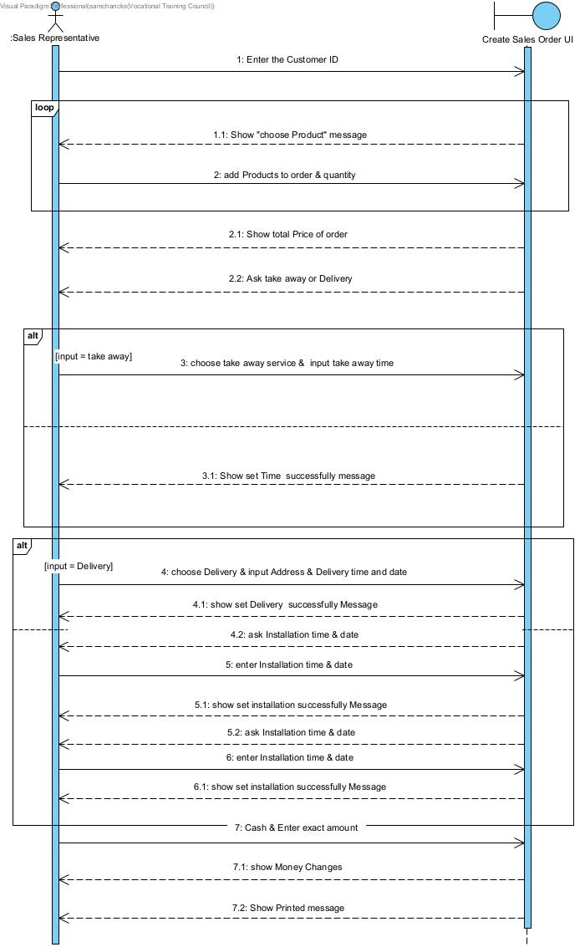

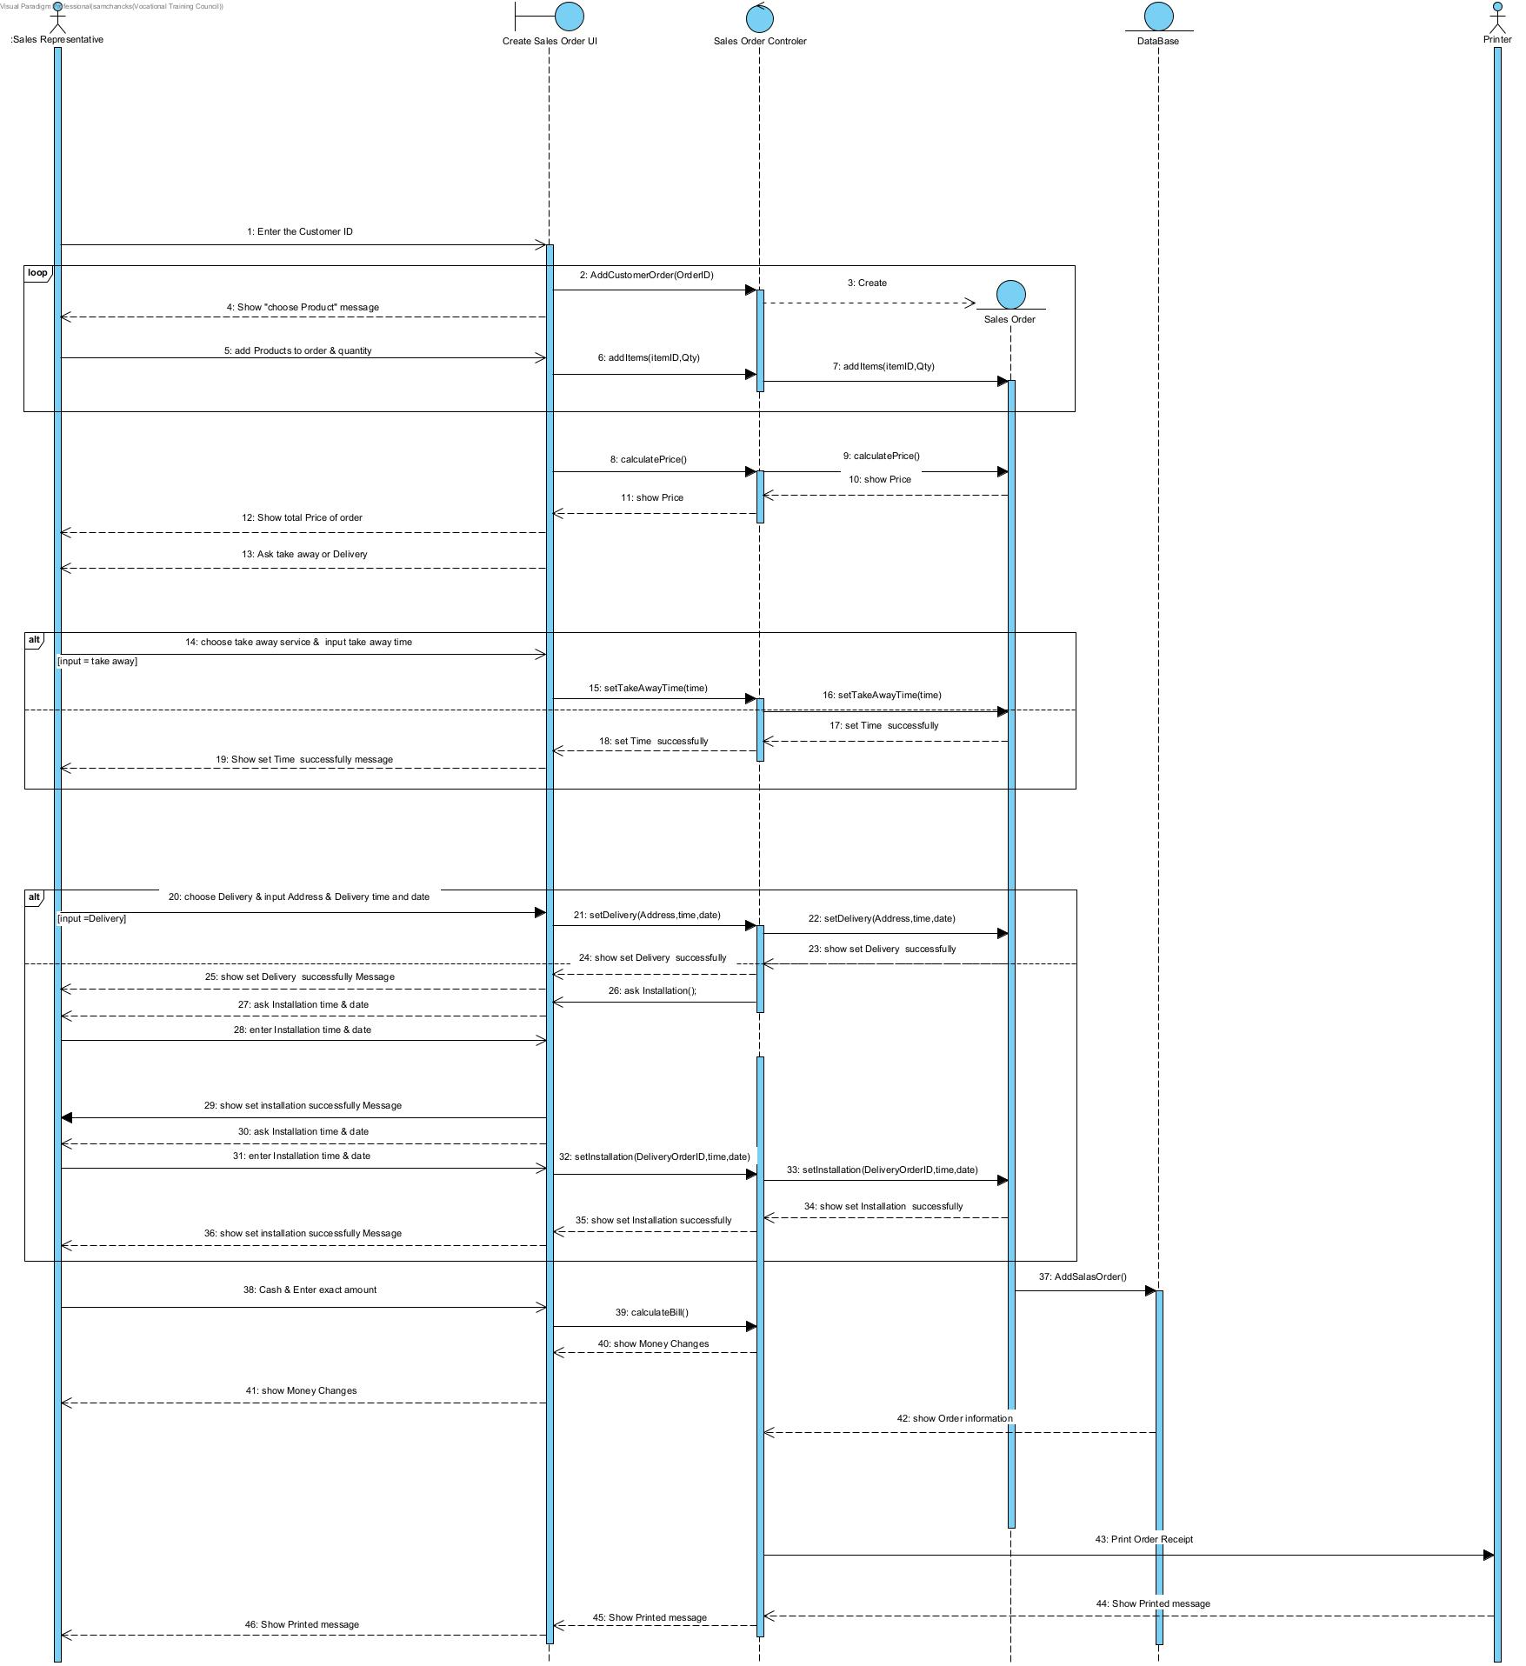

* + 1. In-house System – Retail Stock Management Module

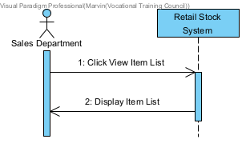**Scenario 1: View Item List**

|  |  |
| --- | --- |
| **Actor Input (Sales Department)** | **System Response** |
| Click View Item List |  |
|  | Display Item List |

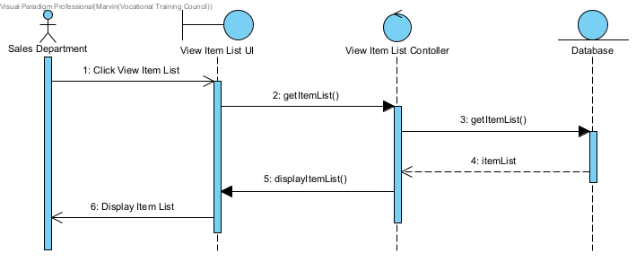

**Scenario 2: View Inventory Stock Level**

|  |  |
| --- | --- |
| **Actor Input (Sales Department)** | **System Response** |
| Click View Inventory Stock Levek |  |
|  | Display Inventory Stock Levek |

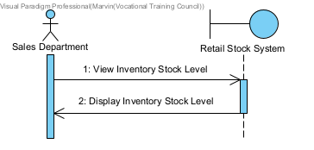

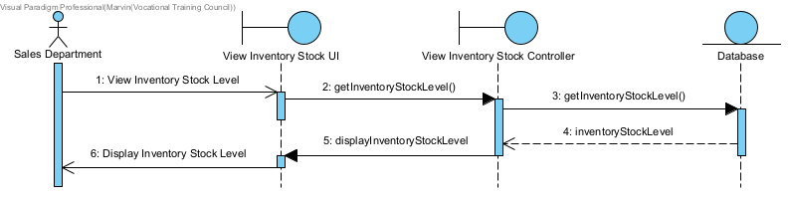

**Scenario 3: View and Update Retail Stock Level**

|  |  |
| --- | --- |
| **Actor Input (Sales Department)** | **System Response** |
| Click View Retail Stock Level |  |
|  | Display Retail Stock Level |
| Click Update Retail Stock Level |  |
|  | Ask User Input Item ID and Quantity |
| Input Item ID and Quantity |  |
|  | Display Updated Retail Stock Level |

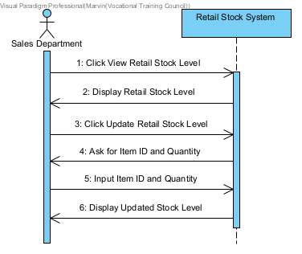

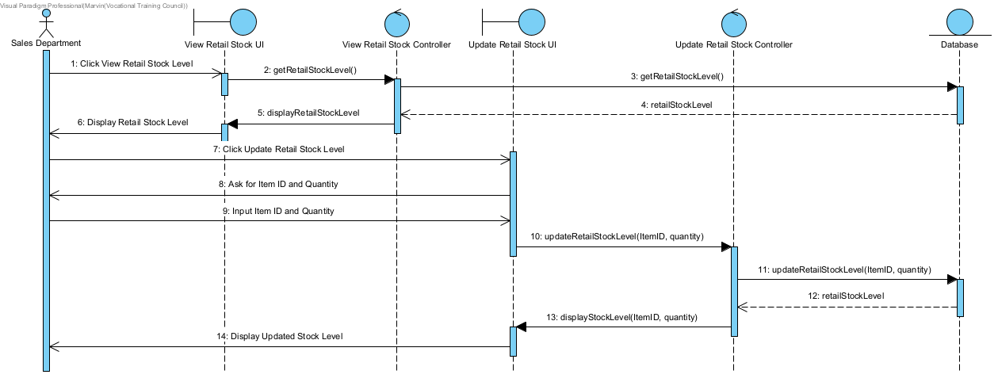

**Scenario 4: View Restock Request**

|  |  |
| --- | --- |
| **Actor Input (Sales Department)** | **System Response** |
| Click View Restock Request |  |
|  | Display Restock Request |

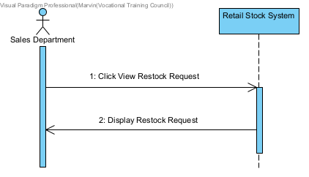

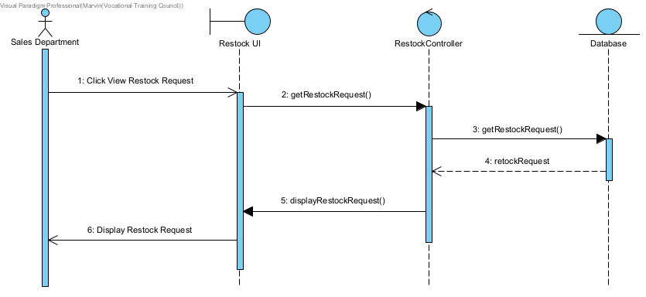

**Scenario 5: Create Restock Request and Approval**

|  |  |  |
| --- | --- | --- |
| **Actor Input (Sales Manager)** | **System Response** | **Inventory Department** |
| Click Create Restock Request |  |  |
|  | Ask User Input Restock Item ID and Quantity |  |
| Input Restock Item ID and Quantity |  |  |
|  | Send Request To Inventory Department |  |
|  |  | Approve Restock Request |
|  | Display Restock Request Confirmation |  |

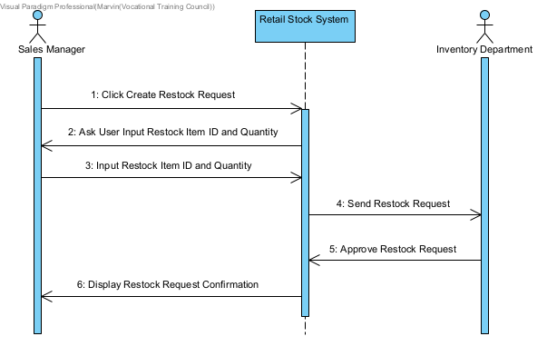

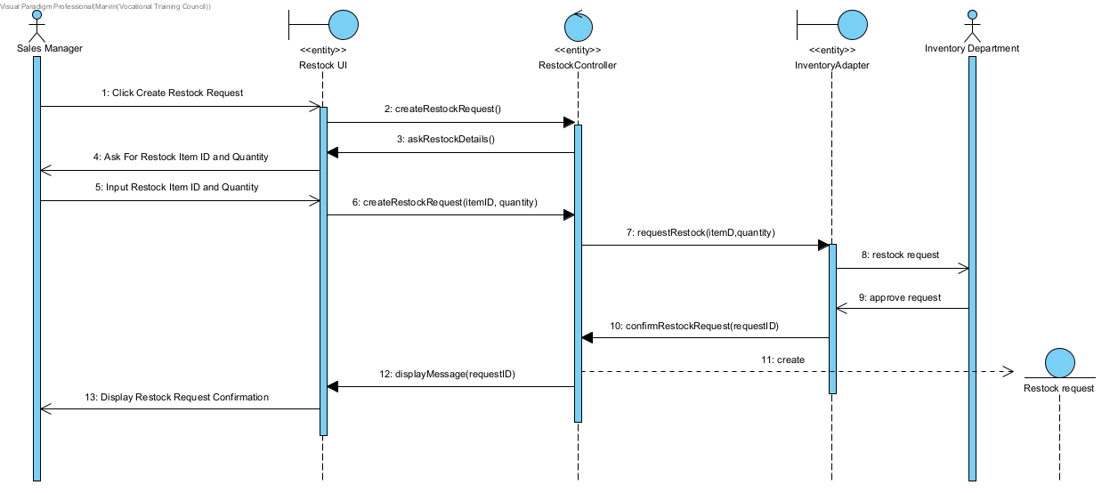

**Retail Stock Management Module**

View Stock & Send Restock Request

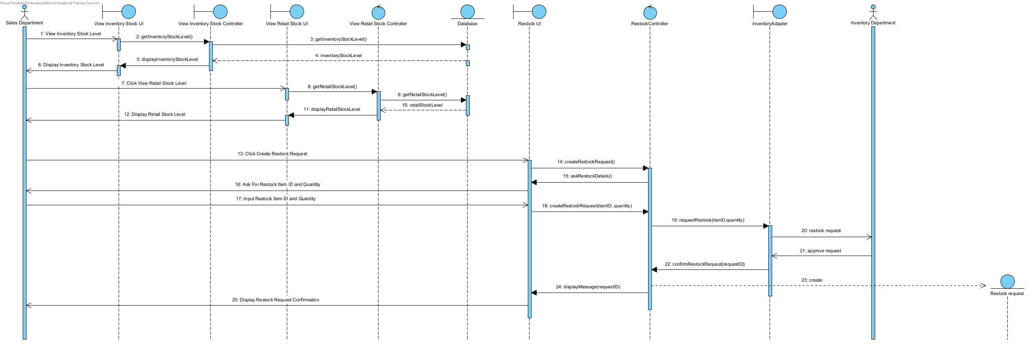

* + 1. In-house System – Inventory Stock Management Module

**Scenario 1: View Inventory Stock Level**

|  |  |
| --- | --- |
| **Actor Input (Inventory Department)** | **System Response** |
| Click View Inventory Stock Level |  |
|  | Display Inventory Stock Level |

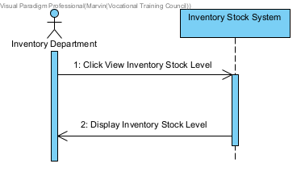

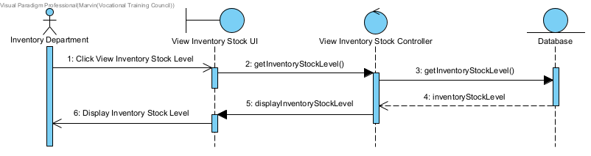

**Scenario 2: Create Re-order Request**

|  |  |  |
| --- | --- | --- |
| **Actor Input (Inventory Department)** | **System Response** | **Purchase Department** |
| Click Create Re-order Request |  |  |
|  | Ask User Input Re-order Item ID and Quantity |  |
| Input Re-order Item ID and Quantity |  |  |
|  | Send Re-order To Purchase Department |  |
|  |  | Approve Re-order Request |
|  | Display Re-order Request Confirmation |  |

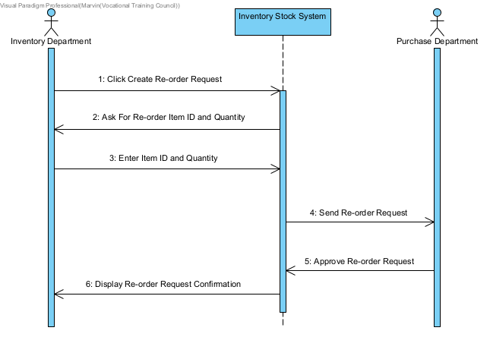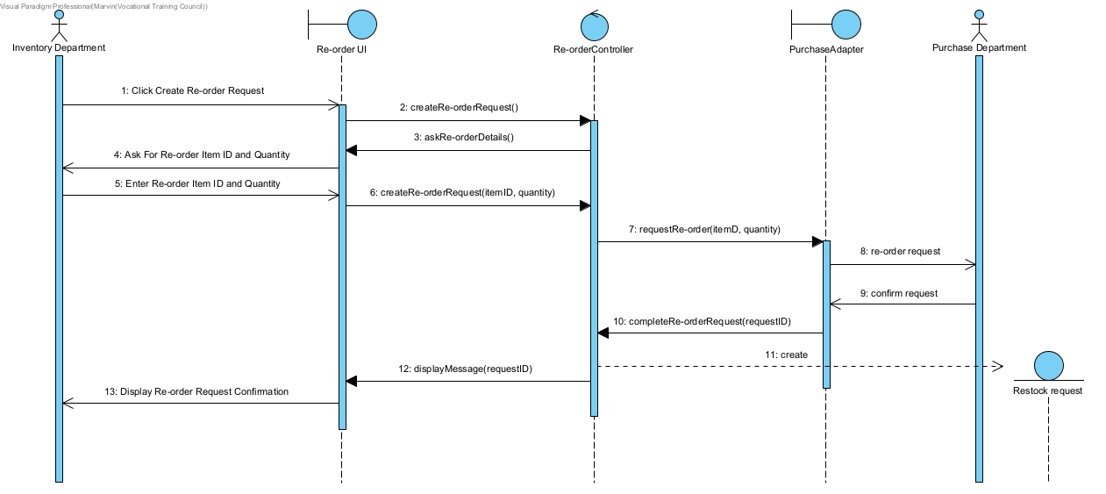

**Scenario 3: View Re-order Request**

|  |  |
| --- | --- |
| **Actor Input (Inventory Department)** | **System Response** |
| Click View Re-order Request |  |
|  | Display Re-order Request |

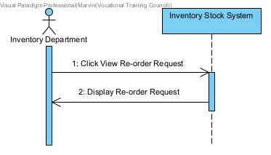

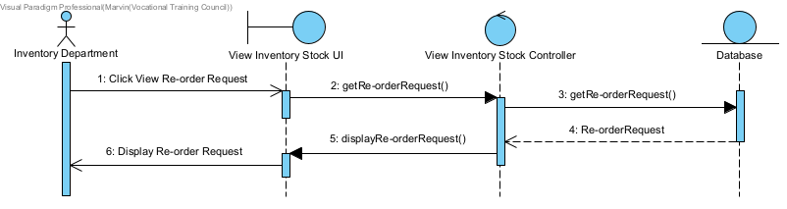

**Scenario 4: Create Purchase Order**

|  |  |  |
| --- | --- | --- |
| **Actor Input (Purchase Department)** | **System Response** | **Accounting Department** |
| Click Create Purchase Order |  |  |
|  | Ask User Input Purchase Item ID and Quantity |  |
| Input Purchase Item ID and Quantity |  |  |
|  | Send Purchase Order To Accounting Department |  |
|  |  | Received Purchase Order |
|  | Display Purchase Order |  |

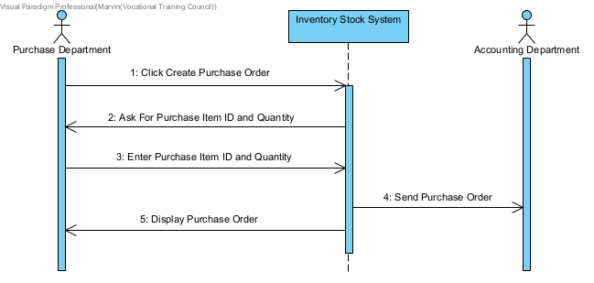

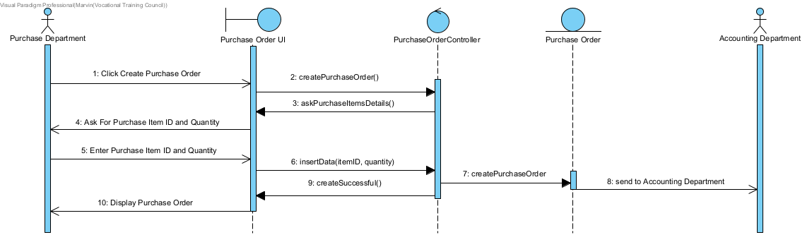

**Scenario 5: View Purchase Order**

|  |  |
| --- | --- |
| **Actor Input (Inventory Department)** | **System Response** |
| Click View Purchase Order |  |
|  | Display Purchase Order |

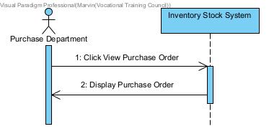

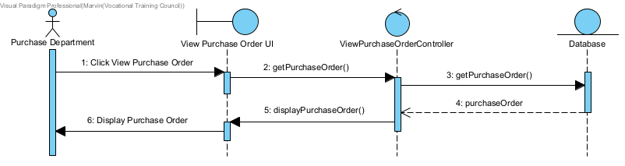

**Scenario 6: Create Goods Received Note**

|  |  |
| --- | --- |
| **Actor Input (Goods Inward Clerk)** | **System Response** |
| Click Create Goods Received Note |  |
|  | Ask User Input Received Item ID and Quantity |
| Input Received Item ID and Quantity |  |
|  | Display Goods Received Note |

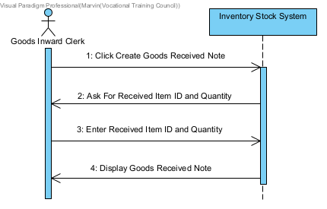

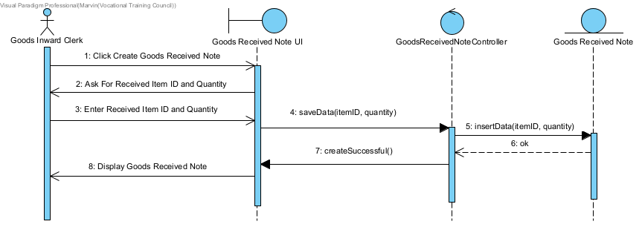

**Scenario 7: View and Upload Purchase Invoice**

|  |  |
| --- | --- |
| **Actor Input (Purchase Department)** | **System Response** |
| Click View Purchase Invoice |  |
|  | Display Purchase Invoice |
| Click Upload Purchase Invoice |  |
|  | Display Uploaded Purchase Invoice |

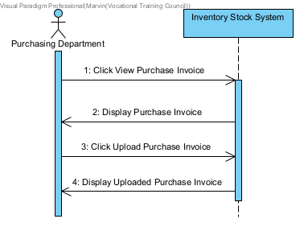

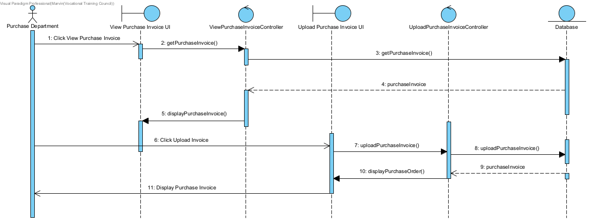

**Inventory Stock Management Module**

Re-order Request & Create + View Purchase Order

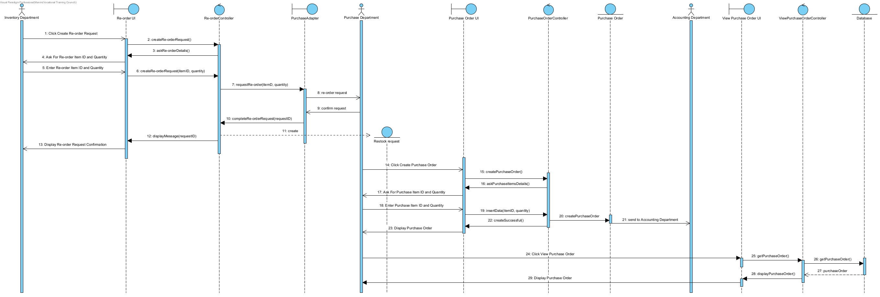

* + 1. In-house System – Delivery & Installation Module

**View Workman Record**

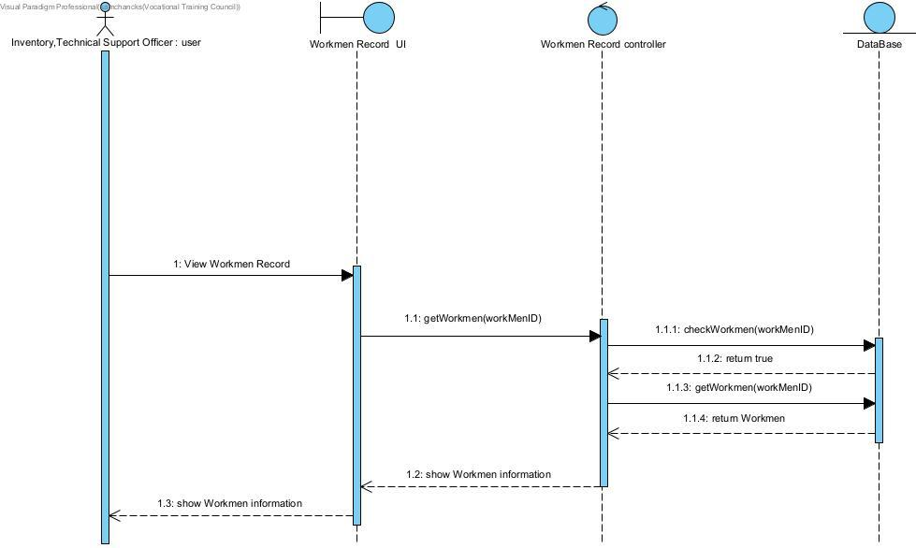

**Print Delivery Notes**

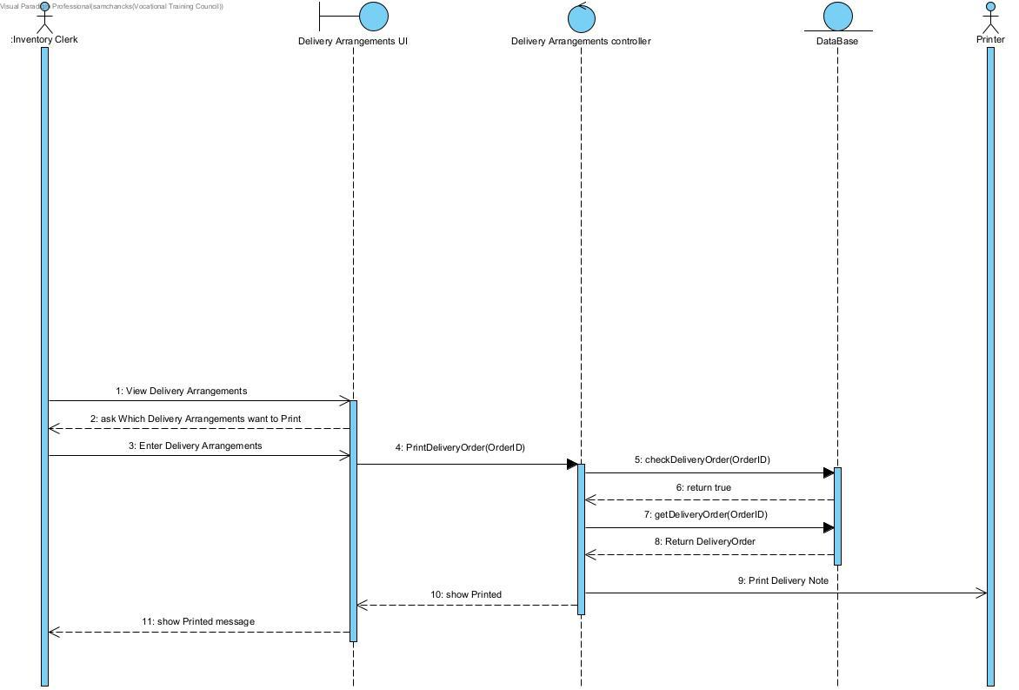

**View Delivery Arrangements**

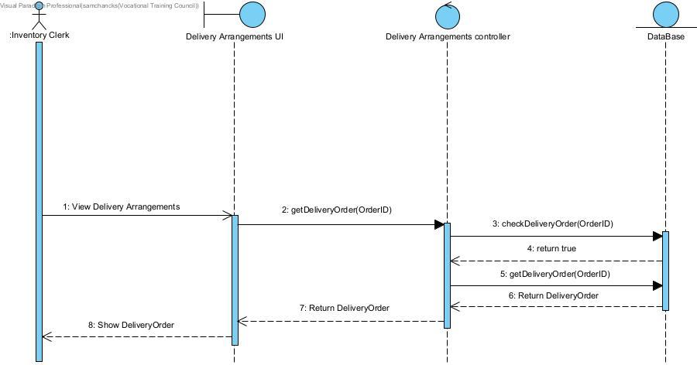

**View Installation Arrangement**

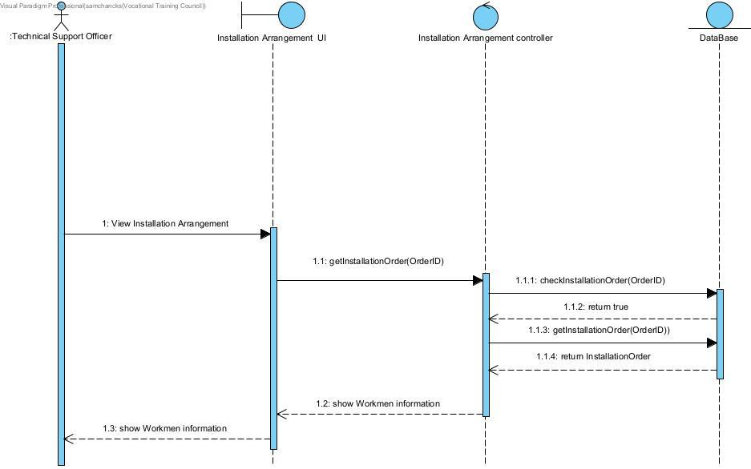

**Print Installation Note**

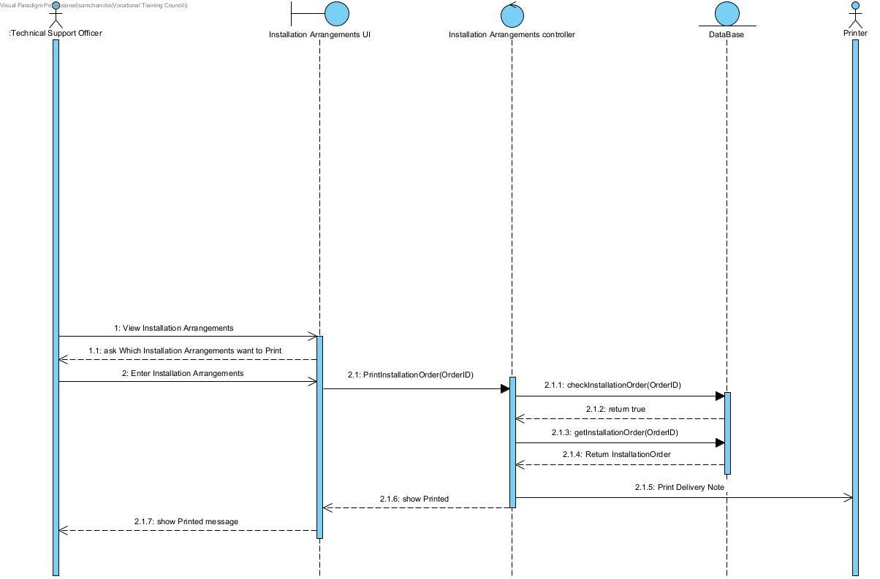

**Confirm Completion (Delivery)**

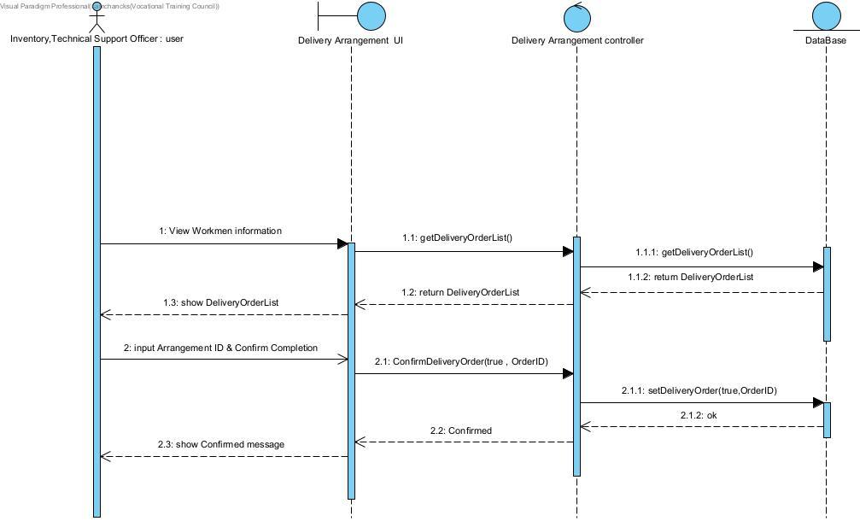

**Confirm Completion (Installation)**

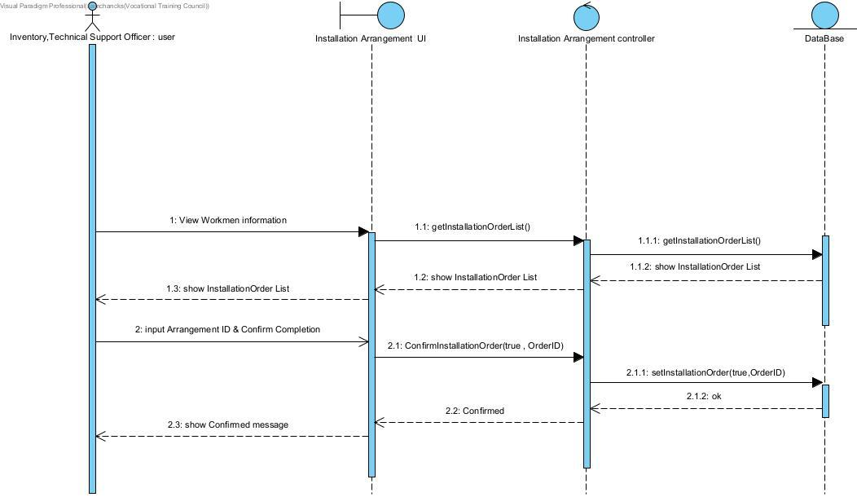

**Delivery & Installation Module**

Confirm Completion + Print Delivery Note, Print & Confirm Completion + Print Installation Note

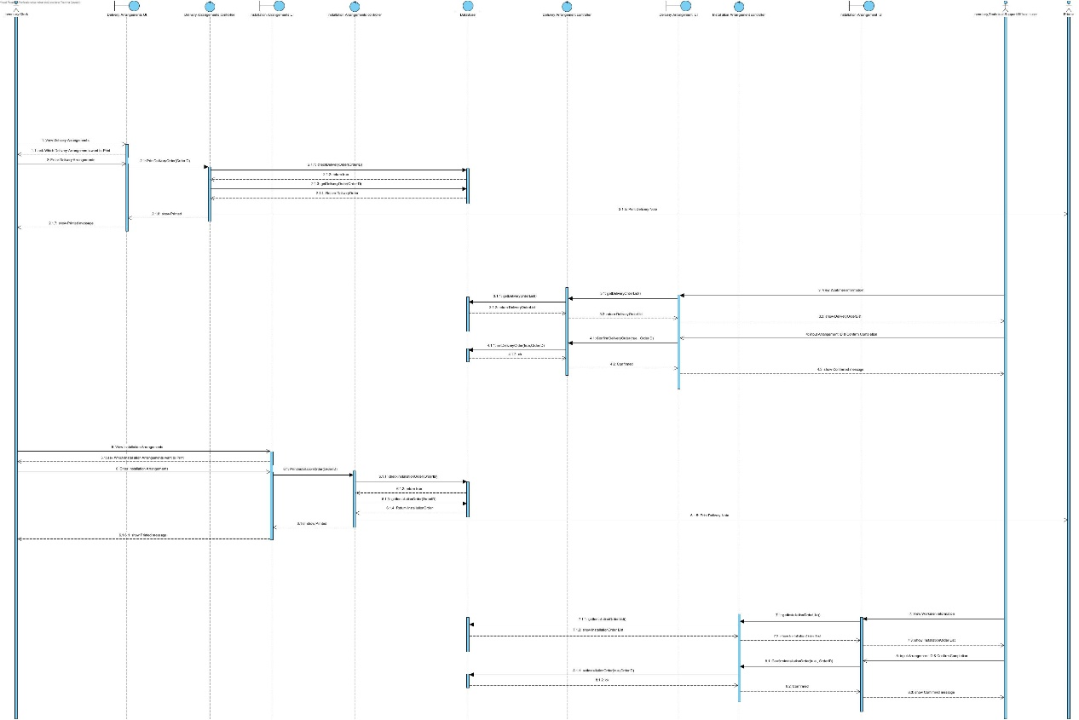

View Workmen Record + View Delivery Arrangements + View Installation Arrangements

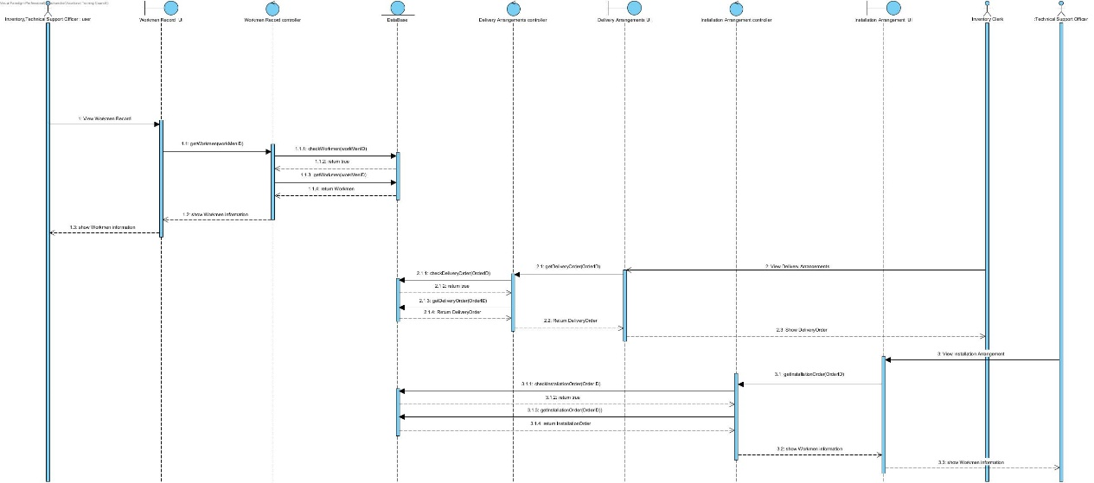

* + 1. In-house System – Goods Management Module

**Scenario 1: View Item List**

|  |  |
| --- | --- |
| **Actor Input (Manager)** | **System Response** |
| Click View Item List |  |
|  | Display Item List |

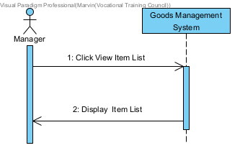

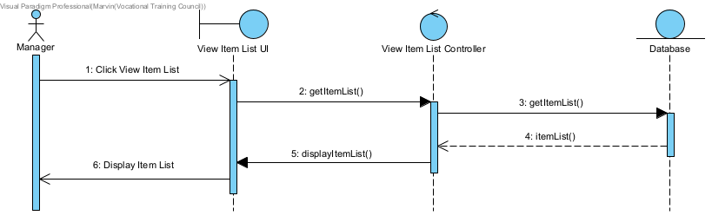

**Scenario 2: View Update Request**

|  |  |
| --- | --- |
| **Actor Input (Manager)** | **System Response** |
| Click View Update Request |  |
|  | Display Update Request |

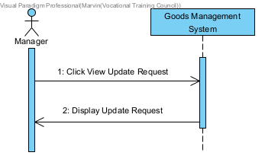

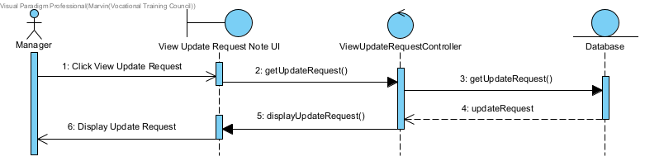

**Scenario 3: Post and Reply Update Request**

|  |  |  |
| --- | --- | --- |
| **Actor Input (Manager)** | **System Response** | **All Manager** |
| Click Post Update Request |  |  |
|  | Ask User Input Update Details |  |
| Enter Update Details |  |  |
|  | Display Update Details |  |
|  | Send Update Request To All Manager |  |
|  |  | Reply ok |
|  | Display Updated Details |  |

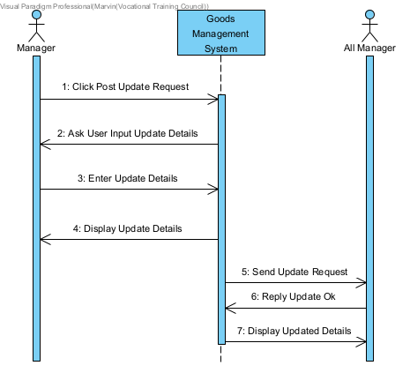

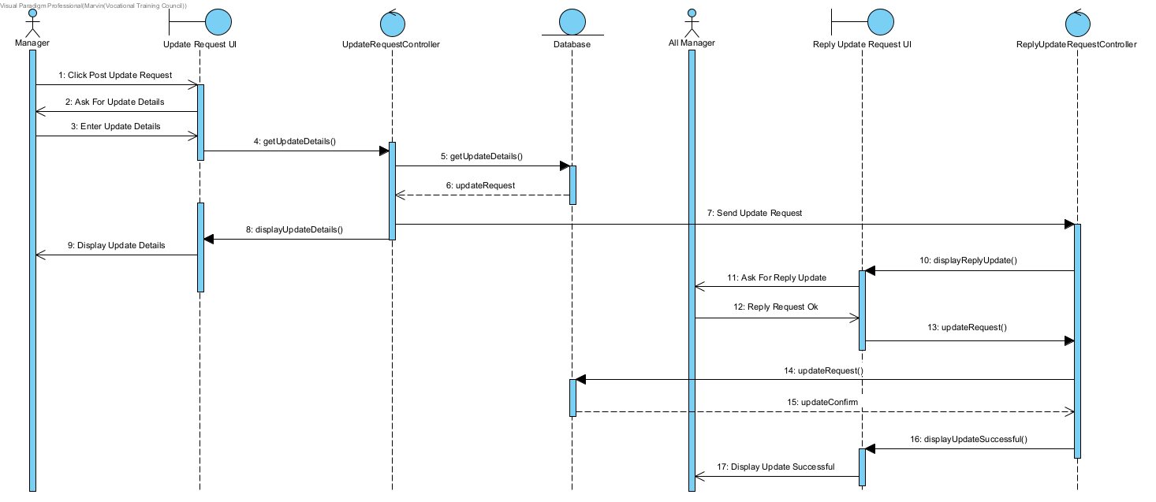

**Goods Management Module**

View Item List & Post + View & Reply Update Request

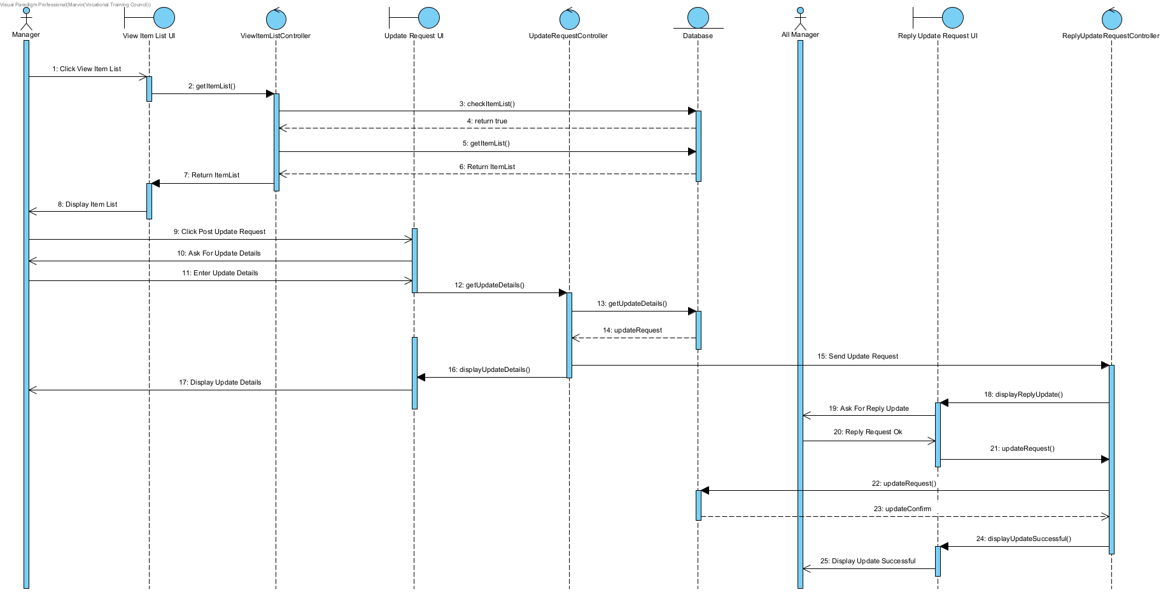

* + 1. In-house System – Accounting Analysis Module

**View Sales Order**

|  |  |
| --- | --- |
| **Actor Input(public user)** | **System Response** |
| Enter to View Sales Order |  |
|  | Show Sales Order |

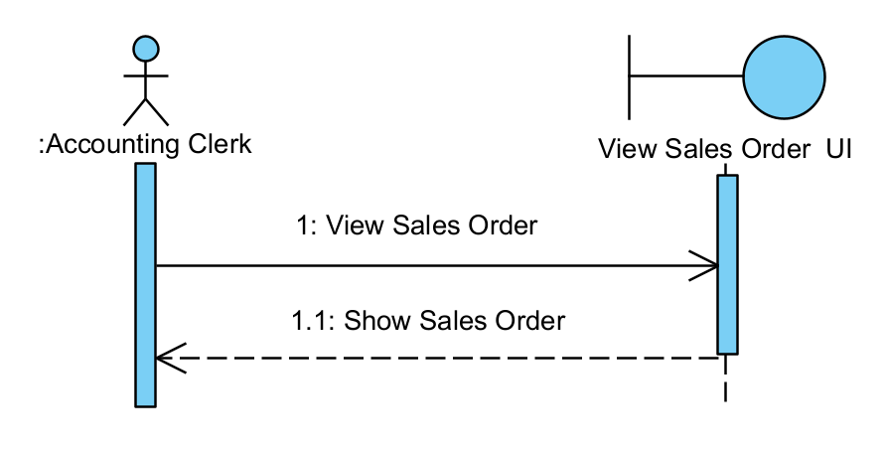

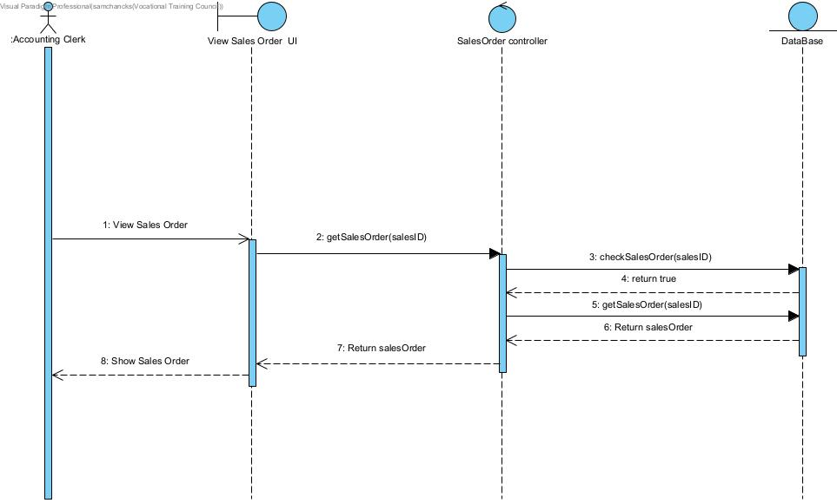

**View item list**

|  |  |
| --- | --- |
| **Actor Input(public user)** | **System Response** |
| Enter to View item list |  |
|  | Show item list |

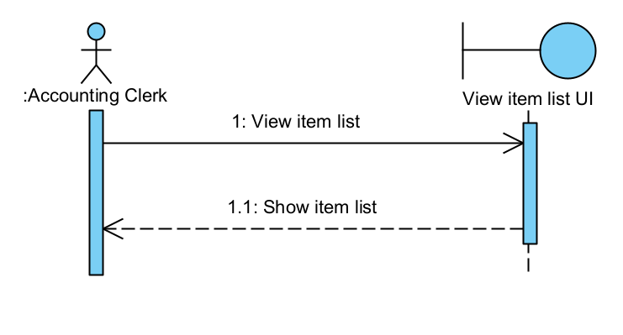

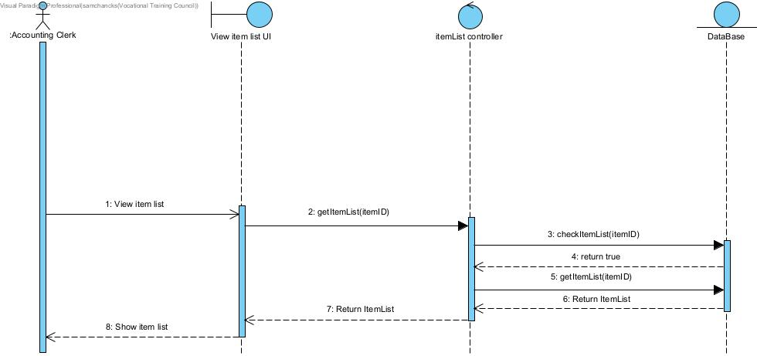

**View Purchase Order**

|  |  |
| --- | --- |
| **Actor Input(public user)** | **System Response** |
| input Order ID for View Purchase Order Record |  |
|  | Show Purchase Order |

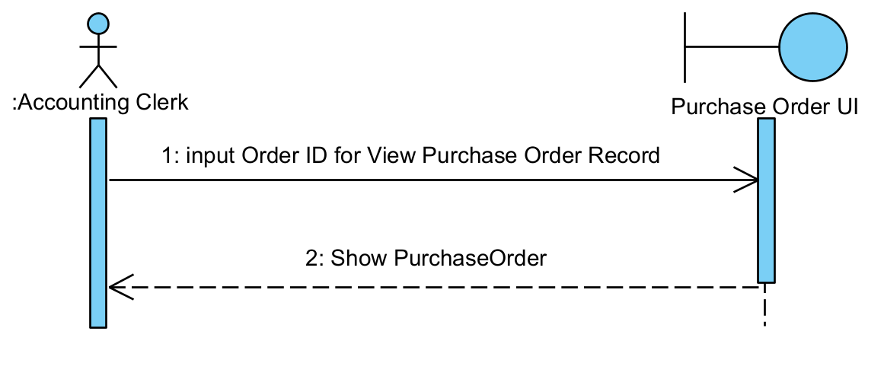

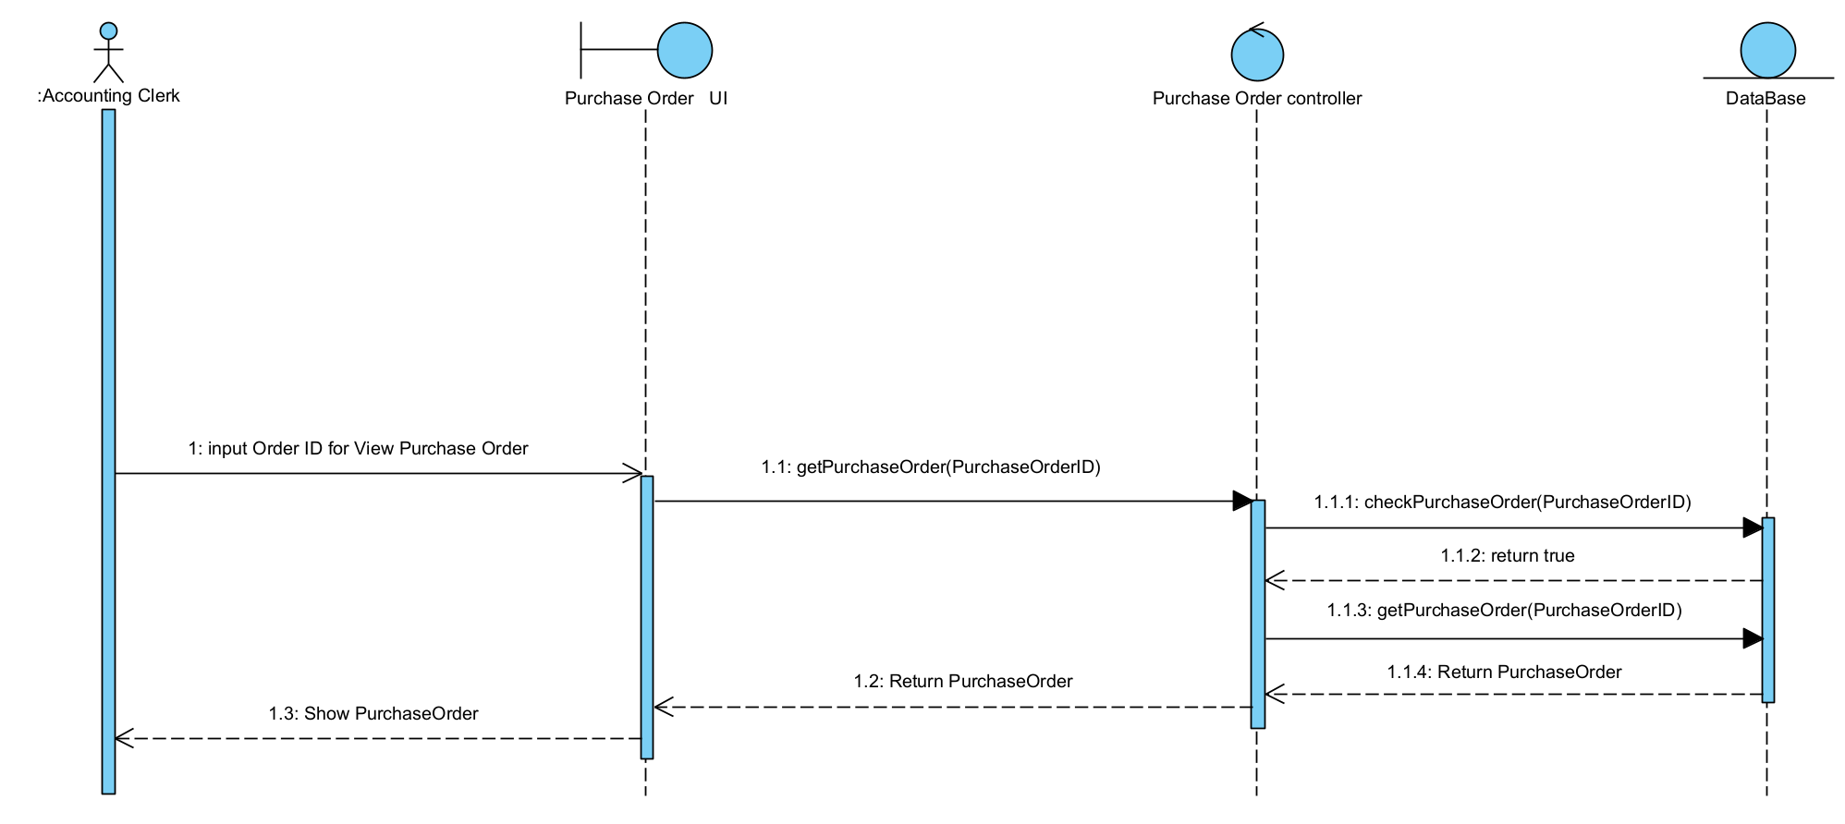

**View Supplier List**

|  |  |
| --- | --- |
| **Actor Input(public user)** | **System Response** |
| Enter to View Supplier Record |  |
|  | Show Supplier List |

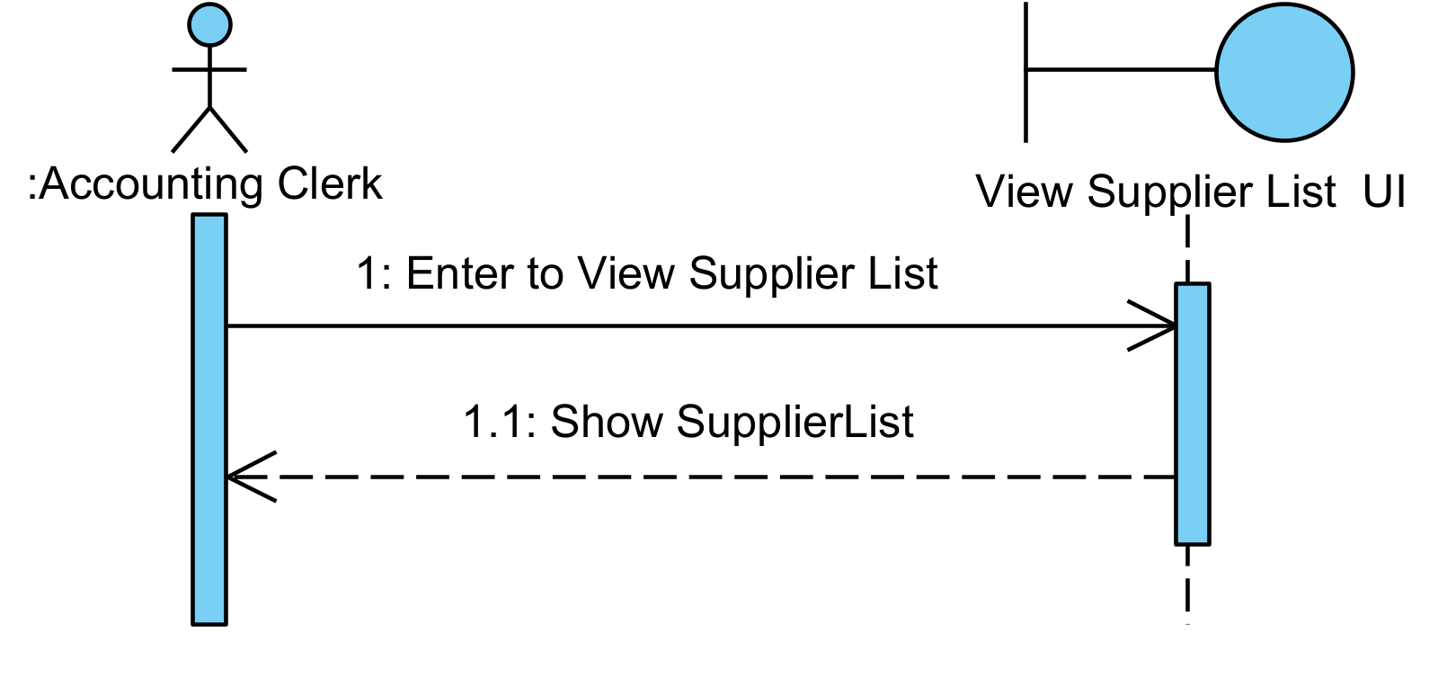

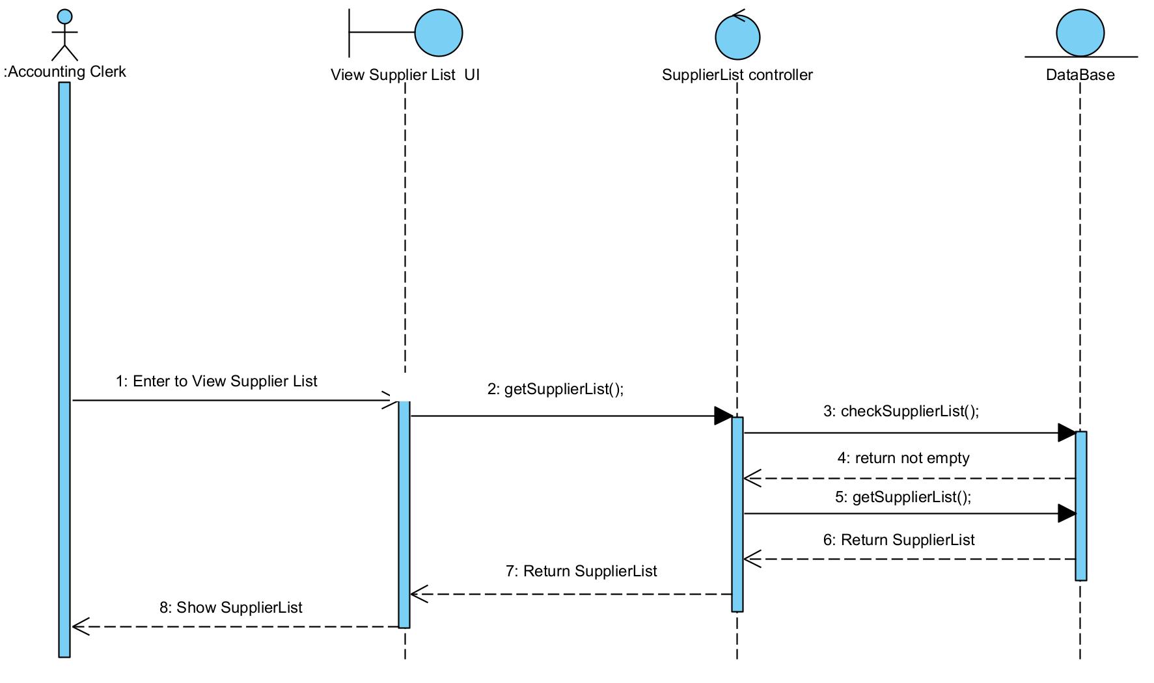

**View Goods Received Note**

|  |  |
| --- | --- |
| **Actor Input(public user)** | **System Response** |
| Input record ID for View Goods Received Note |  |
|  | Show GoodsReceivedNote |

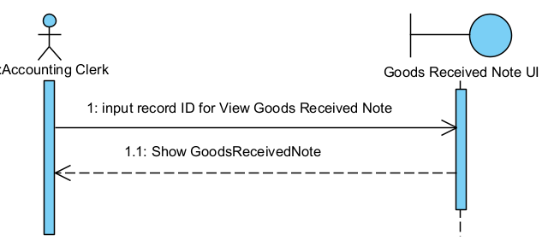

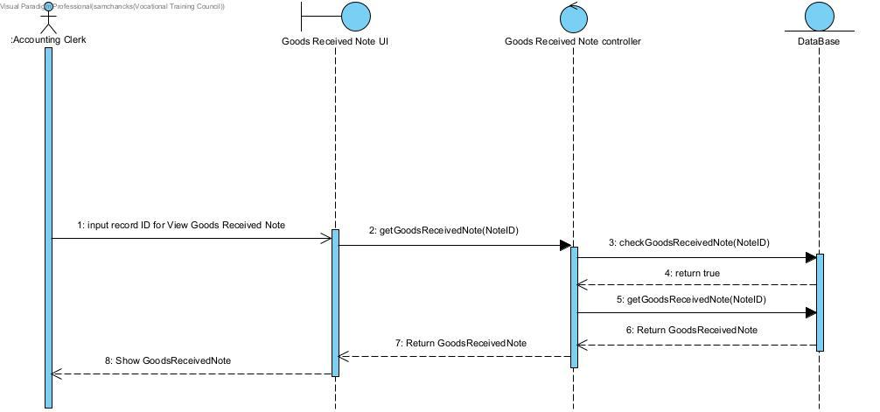

**View Purchase Invoice**

|  |  |
| --- | --- |
| **Actor Input(public user)** | **System Response** |
| input record ID for View Purchase Invoice |  |
|  | Show PurchaseInvoice |

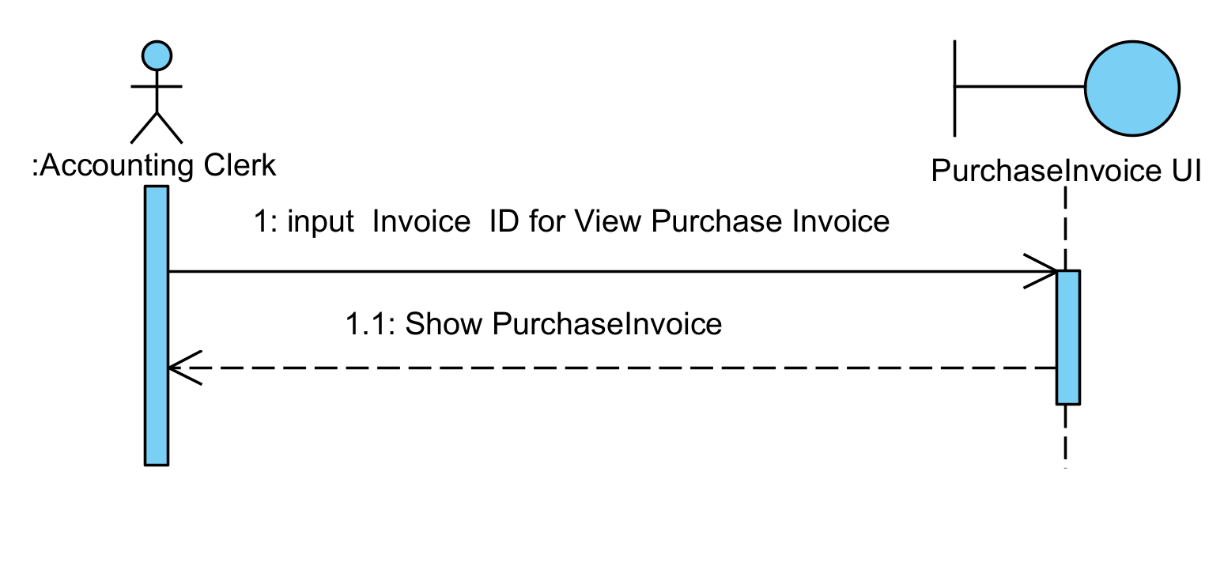

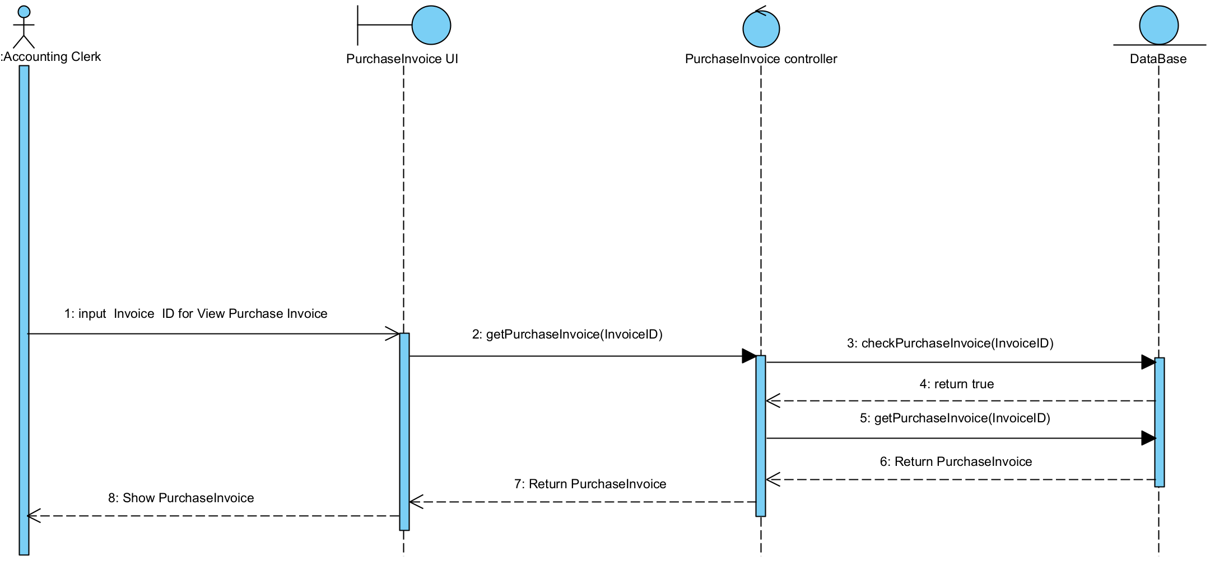

**View Goods Returned Record**

|  |  |
| --- | --- |
| **Actor Input(public user)** | **System Response** |
| input record ID for View Goods Returned Record |  |
|  | Show Goods Returned Record |

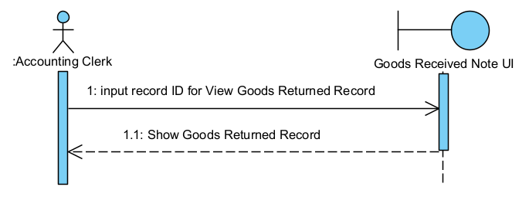

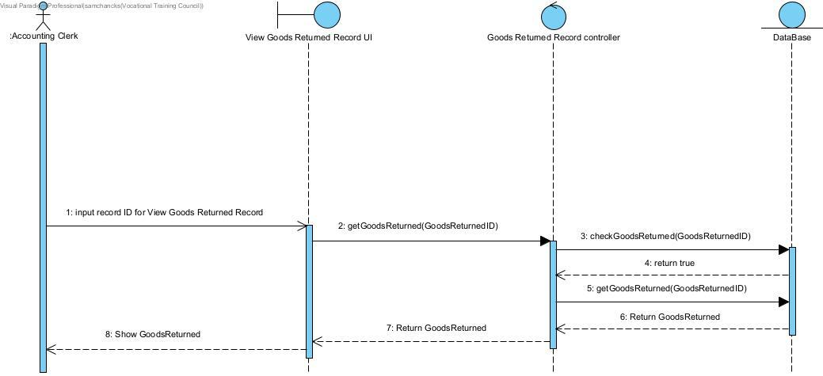

**Upload Analysis Report**

|  |  |
| --- | --- |
| **Actor Input(public user)** | **System Response** |
| Upload Analysis Report |  |
|  | Show upload Report successfully |

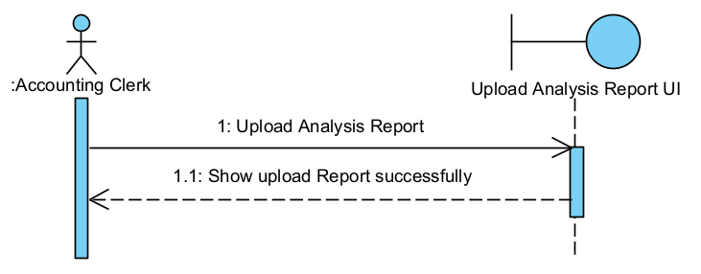

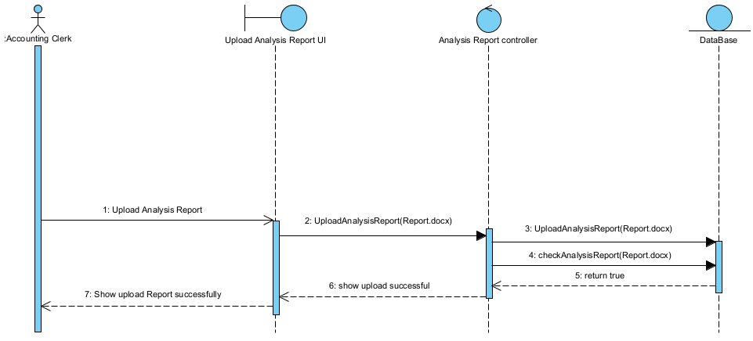

**View Analysis Report**

|  |  |
| --- | --- |
| **Actor Input(public user)** | **System Response** |
| Enter to View Analysis |  |
|  | Click button for download Report |

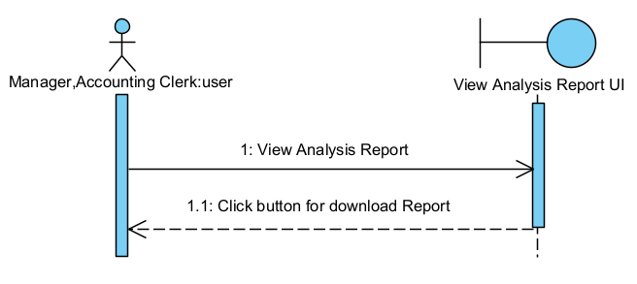

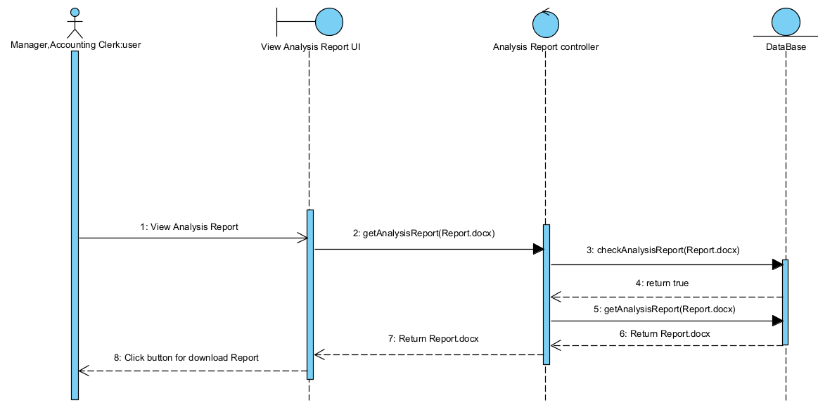

* + 1. In-house System – Return Items Module

**Scenario 1: Create Goods Return Note**

|  |  |
| --- | --- |
| **Actor Input (Sales Representative)** | **System Response** |
| Click Create Goods Return Note |  |
|  | Ask User Input Order ID and Return Item ID |
| Input Order ID and Return Item ID |  |
|  | Display Goods Return Note |

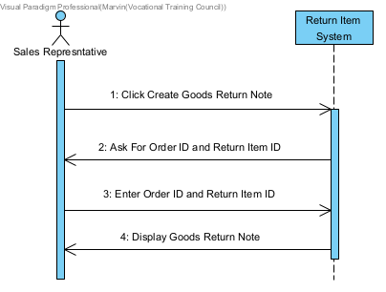

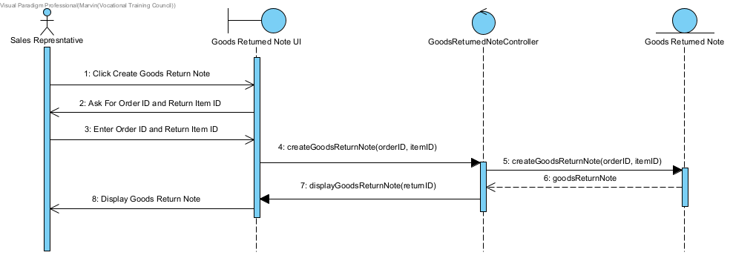

**Scenario 2: View Goods Return Note aad Confirm Return**

|  |  |  |
| --- | --- | --- |
| **Actor Input (Sales Representative, Inventory Clerk)** | **System Response** | **Accounting Clerk** |
| Click View Goods Return Note |  |  |
|  | Display Goods Return Note |  |
|  | Send Goods Return Note To Accounting Clerk |  |
|  |  | Confirm Return |
|  | Display Return Confirmation |  |

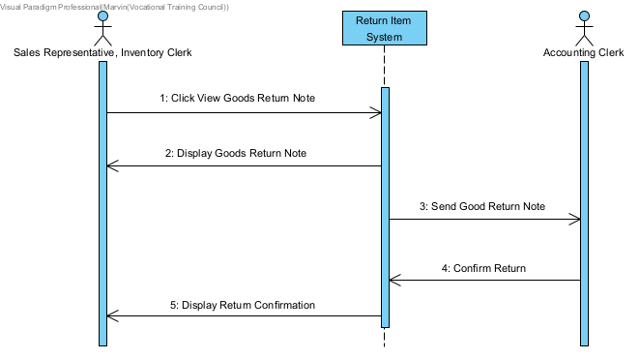

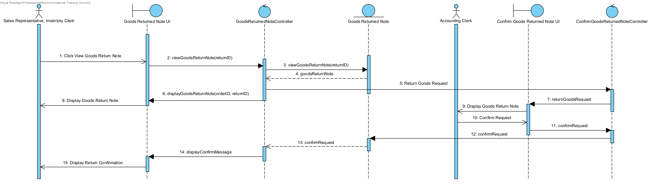

**Accounting Analysis Module**

View Goods Record + View Goods Received Note + View Goods Returned Record

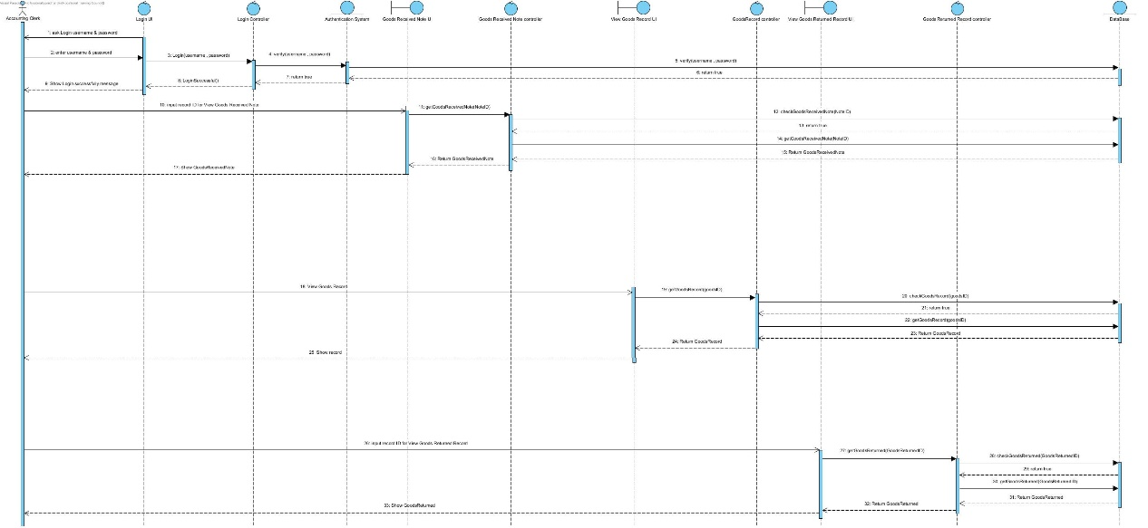

View Purchase Invoice + View Purchase Order Record + View Supplier Record

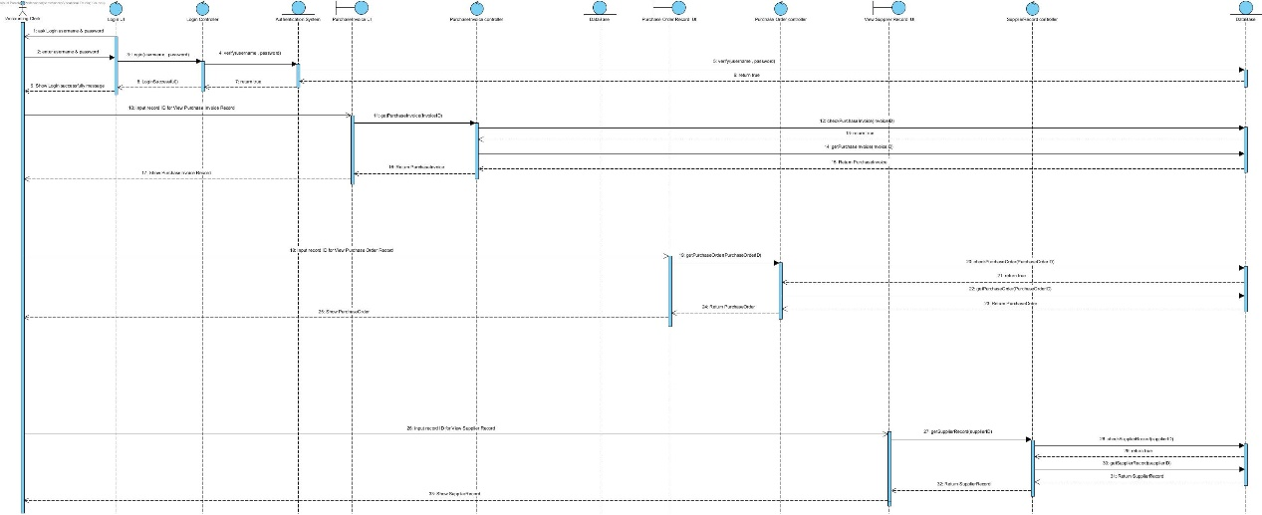

1. Entity Relation Diagram

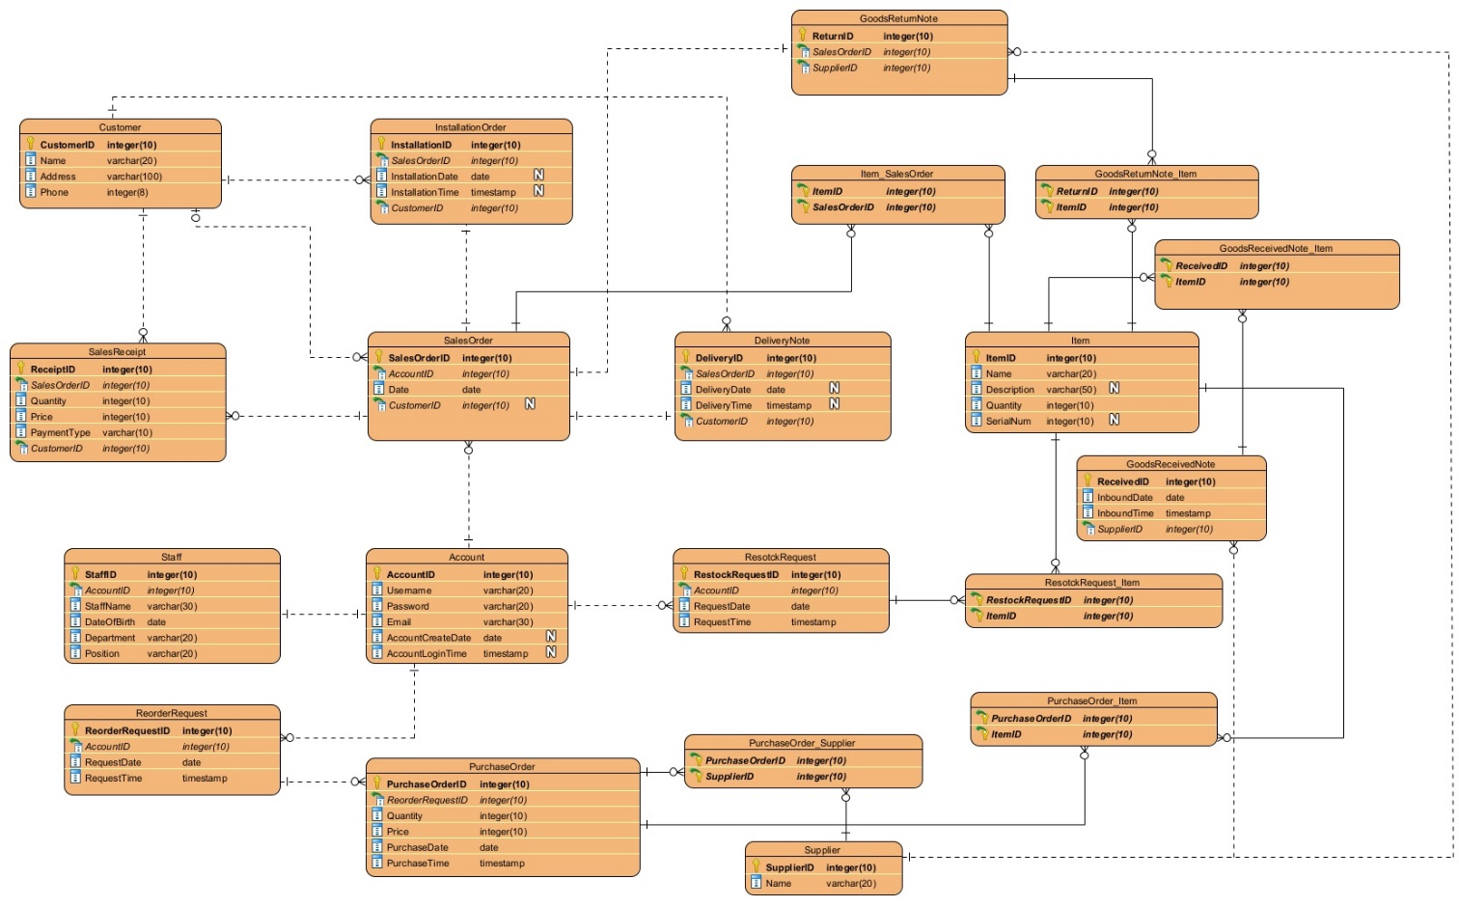

1. Detailed Database Design

**Table: Staff**

|  |  |  |  |  |
| --- | --- | --- | --- | --- |
| **Column Name** | **Type (Length)** | **Null?** | **Key** | **Description** |
| StaffID | Integer (10) | No | Primary Key | Unique ID for staff.  Format: 10001  (10001 – 9999999999) |
| AccountID | Integer (10) | No | Foreign Key | Refer to AccountID of Account table. |
| StaffName | Varchar (30) | No |  | Name of the staff. |
| DateOfBirth | Date | No |  | Birthday of the staff. |
| Department | Varchar (20) | No |  | Department of the staff. |
| Position | Varchar (20) | No |  | Position of the staff. |

**Table: Account**

|  |  |  |  |  |
| --- | --- | --- | --- | --- |
| **Column Name** | **Type (Length)** | **Null?** | **Key** | **Description** |
| AccountID | Integer (10) | No | Primary Key | Unique ID for staff’s login account.  Format: 10001  (10001 – 9999999999) |
| Username | Varchar (20) | No |  | Username of the account. |
| Password | Varchar (20) | No |  | Password of the account. Default as staff’s DOB. |
| Email | Varchar (30) | No |  | Contact email. |
| AccountCreateDate | Date | Yes |  | Log for recording the time of the creation of the account. |
| AccountLoginTime | TimeStamp | Yes |  | Log for recording the time of the last login of the account. |

**Table: Customer**

|  |  |  |  |  |
| --- | --- | --- | --- | --- |
| **Column Name** | **Type (Length)** | **Null?** | **Key** | **Description** |
| CustomerID | Integer (10) | No | Primary Key | Unique ID for the customer.  Format: 10001  (10001 – 9999999999) |
| Name | Varchar (20) | No |  | The name of the customer. |
| Address | Varchar (100) | No |  | The address of the customer. |
| Phone | Integer (8) | No |  | The phone number of the customer. |

**Table: SalesOrder**

|  |  |  |  |  |
| --- | --- | --- | --- | --- |
| **Column Name** | **Type (Length)** | **Null?** | **Key** | **Description** |
| SalesOrderID | Integer (10) | No | Primary Key | Unique ID for the sales order.  Format: 10001  (10001 – 9999999999) |
| AccountID | Integer (10) | No | Foreign Key | Refer to AccountID of Account table. |
| Date | Date | No |  | Sales order create date. |
| CustomerID | Integer (10) | Yes | Foreign Key | Refer to CustomerID of Customer table. |

**Table: SalesReceipt**

|  |  |  |  |  |
| --- | --- | --- | --- | --- |
| **Column Name** | **Type (Length)** | **Null?** | **Key** | **Description** |
| ReceiptID | Integer (10) | No | Primary Key | Unique ID for the sales receipt.  Format: 10001  (10001 – 9999999999) |
| SalesOrderID | Integer (10) | No | Foreign Key | Refer to SalesOrderID of SalesOrder table. |
| Quantity | Integer (10) | No |  | The quantity of the goods. |
| Price | Integer (10) | No |  | The price of the goods |
| PaymentType | Varchar (10) | No |  | The payment type selected by the customer. |
| CustomerID | Integer (10) | No | Foreign Key | Refer to CustomerID of Customer table. |

**Table: DeliveryNote**

|  |  |  |  |  |
| --- | --- | --- | --- | --- |
| **Column Name** | **Type (Length)** | **Null?** | **Key** | **Description** |
| DeliveryID | Integer (10) | No | Primary Key | Unique ID for the delivery note.  Format: 10001  (10001 – 9999999999) |
| SalesOrderID | Integer (10) | No | Foreign Key | Refer to SalesOrderID of SalesOrder table. |
| DeliveryDate | Date | Yes |  | The date of the delivery. |
| DeliveryTime | TimeStamp | Yes |  | The time of the delivery. |
| CustomerID | Integer (10) | No | Foreign Key | Refer to CustomerID of Customer table. |

**Table: InstallationOrder**

|  |  |  |  |  |
| --- | --- | --- | --- | --- |
| **Column Name** | **Type (Length)** | **Null?** | **Key** | **Description** |
| InstallationID | Integer (10) | No | Primary Key | Unique ID for installation order.  Format: 10001  (10001 – 9999999999) |
| SalesOrderID | Integer (10) | No | Foreign Key | Refer to SalesOrderID of SalesOrder table. |
| InstallationDate | Date | Yes |  | The date of the installation. |
| InstallationTime | TimeStamp | Yes |  | The time of the installation. |
| CustomerID | Integer (10) | No | Foreign Key | Refer to CustomerID of Customer table. |

**Table: Item**

|  |  |  |  |  |
| --- | --- | --- | --- | --- |
| **Column Name** | **Type (Length)** | **Null?** | **Key** | **Description** |
| ItemID | Integer (10) | No | Primary Key | Unique ID for the item.  Format: 10001  (10001 – 9999999999) |
| Name | Varchar(20) | No |  | The name of the item. |
| Description | Varchar(50) | Yes |  | The description of the item. |
| Quantity | Integer (10) | No |  | The quantity of the item. |
| SerialNum | Integer (10) | Yes |  | The serial number of the item. |

**Table: Item_SalesOrder**

|  |  |  |  |  |
| --- | --- | --- | --- | --- |
| **Column Name** | **Type (Length)** | **Null?** | **Key** | **Description** |
| ItemID | Integer (10) | No | Primary Key Foreign Key | Refer to ItemID of Item table. |
| SalesOrderID | Integer (10) | No | Primary Key Foreign Key | Refer to SalesOrderID of SalesOrder table. |

**Table: RestockRequest**

|  |  |  |  |  |
| --- | --- | --- | --- | --- |
| **Column Name** | **Type (Length)** | **Null?** | **Key** | **Description** |
| RestockRequestID | Integer (10) | No | Primary Key | Unique ID for restock request.  Format: 10001  (10001 – 9999999999) |
| AccountID | Integer (10) | No | Foreign Key | Refer to AccountID of Account table. |
| RequestDate | Date | No |  | The date of the restock request. |
| RequestTime | TimeStamp | No |  | The time of the restock request. |

**Table: RestockRequest_Item**

|  |  |  |  |  |
| --- | --- | --- | --- | --- |
| **Column Name** | **Type (Length)** | **Null?** | **Key** | **Description** |
| RestockRequestID | Integer (10) | No | Primary Key Foreign Key | Refer to RestockRequestID of RestockRequest table. |
| ItemID | Integer (10) | No | Primary Key Foreign Key | Refer to ItemID of Item table. |

**Table: Supplier**

|  |  |  |  |  |
| --- | --- | --- | --- | --- |
| **Column Name** | **Type (Length)** | **Null?** | **Key** | **Description** |
| SupplierID | Integer (10) | No | Primary Key | Unique ID for the supplier.  Format: 10001  (10001 – 9999999999) |
| Name | Varchar(20) | No |  | The name of the supplier. |

**Table: GoodsReturnNote**

|  |  |  |  |  |
| --- | --- | --- | --- | --- |
| **Column Name** | **Type (Length)** | **Null?** | **Key** | **Description** |
| ReturnID | Integer (10) | No | Primary Key | Unique ID for goods return note.  Format: 10001  (10001 – 9999999999) |
| SalesOrderID | Integer (10) | No | Foreign Key | Refer to SalesOrderID of SalesOrder table. |
| SupplierID | Integer (10) | No | Foreign Key | Refer to SupllierID of Supplier table. |

**Table: GoodsReturnNote_Item**

|  |  |  |  |  |
| --- | --- | --- | --- | --- |
| **Column Name** | **Type (Length)** | **Null?** | **Key** | **Description** |
| ReturnID | Integer (10) | No | Primary Key Foreign Key | Refer to ReturnID of GoodsReturnNote table. |
| ItemID | Integer (10) | No | Primary Key Foreign Key | Refer to ItemID of Item table. |

**Table: GoodsReceivedNote**

|  |  |  |  |  |
| --- | --- | --- | --- | --- |
| **Column Name** | **Type (Length)** | **Null?** | **Key** | **Description** |
| ReceivedID | Integer (10) | No | Primary Key | Unique ID for goods received note.  Format: 10001  (10001 – 9999999999) |
| InboundDate | Date | No |  | The inbound date of the goods. |
| InboundTime | TimeStamp | No |  | The inbound time of the goods. |
| SupplierID | Integer (10) | No | Foreign Key | Refer to SupllierID of Supplier table. |

**Table: GoodsReceivedNote_Item**

|  |  |  |  |  |
| --- | --- | --- | --- | --- |
| **Column Name** | **Type (Length)** | **Null?** | **Key** | **Description** |
| ReceivedID | Integer (10) | No | Primary Key Foreign Key | Refer to ReceivedID of GoodsReceivedNote table. |
| ItemID | Integer (10) | No | Primary Key Foreign Key | Refer to ItemID of Item table. |

**Table: ReorderRequest**

|  |  |  |  |  |
| --- | --- | --- | --- | --- |
| **Column Name** | **Type (Length)** | **Null?** | **Key** | **Description** |
| ReorderRequestID | Integer (10) | No | Primary Key | Unique ID for reorder request.  Format: 10001  (10001 – 9999999999) |
| AccountID | Integer (10) | No | Foreign Key | Refer to AccountID of Account table. |
| RequestDate | Date | No |  | The date of the reorder request. |
| RequestTime | TimeStamp | No |  | The time of the reorder request. |

**Table: PurchaseOrder**

|  |  |  |  |  |
| --- | --- | --- | --- | --- |
| **Column Name** | **Type (Length)** | **Null?** | **Key** | **Description** |
| PurchaseOrder ID | Integer (10) | No | Primary Key | Unique ID for the purchase order.  Format: 10001  (10001 – 9999999999) |
| ReorderRequestID | Integer (10) | No | Foreign Key | Refer to ReorderRequestID of ReorderRequest table. |
| Quantity | Integer (10) | No |  | The quantity of the purchase order. |
| Price | Integer (10) | No |  | The price of the purchase order. |

**Table: PurchaseOrder _Item**

|  |  |  |  |  |
| --- | --- | --- | --- | --- |
| **Column Name** | **Type (Length)** | **Null?** | **Key** | **Description** |
| PurchaseOrderID | Integer (10) | No | Primary Key Foreign Key | Refer to PurchaseOrderID of PurchaseOrder table. |
| ItemID | Integer (10) | No | Primary Key Foreign Key | Refer to ItemID of Item table. |

**Table: PurchaseOrder _Supplier**

|  |  |  |  |  |
| --- | --- | --- | --- | --- |
| **Column Name** | **Type (Length)** | **Null?** | **Key** | **Description** |
| PurchaseOrderID | Integer (10) | No | Primary Key Foreign Key | Refer to PurchaseOrderID of PurchaseOrder table. |
| SupplierID | Integer (10) | No | Primary Key Foreign Key | Refer to SupplierID of Supplier table. |

1. Project Schedule

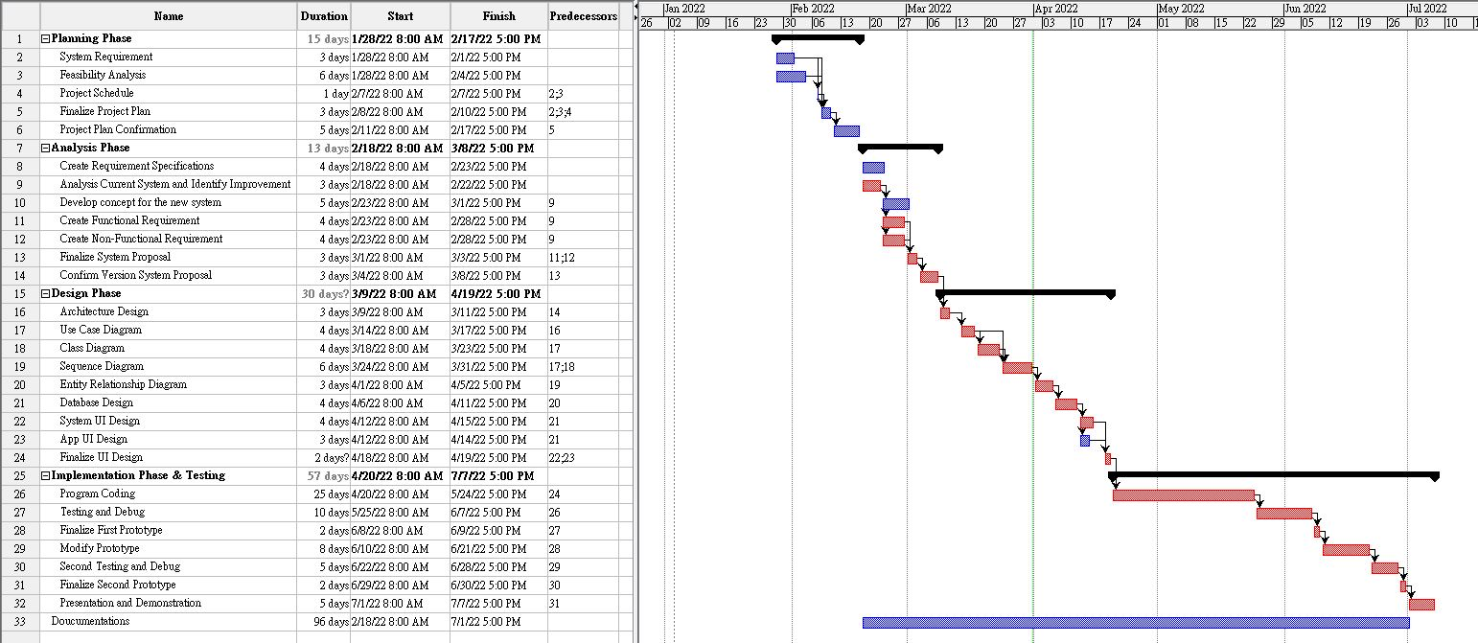

1. Conclusion

Nowadays, information technology has gradually integrated into society. The computerized data management system provides services for various entrepreneurs, making it easier for growing a successful business.

In order to enhance the competitiveness of this company, we have planned to build up a computerized system to improve the current situation. It can reduce the manpower cost of the company. On the other hand, it can increase the operating efficiency of the company and reduce the chance of mistakes.

In the current plan, we did a detailed analysis based on this company’s background, operations, and comments from staff with various positions.

We did a detailed analysis based on this company’s background, operations, and comments from staff with various positions.

In fact, the company uses standalone PCs and electronic spreadsheets to manage the delivery services in the centres. Since the PCs are not interconnected, data between different centres cannot be readily shared. If their data sharing system is not perfected, it will lead to a large number of communication errors and delays in the transaction of goods, resulting in large losses for the company.

The Company decides to improve the current situation with the best usage of information technology. We are going to develop a warehouse management system. The purpose of the system is the Computerized storage of data and calculations. To solve part of the major problems of lots of handwriting work, causing frequent errors in data entry. Also, we are going to add some functions to solve the major problems of message reception error and slow communication.

Finally, we will plan the design specification to implement the system.

1. Project Log

|  |  |  |
| --- | --- | --- |
| **Task** | **Finish Date** | **Responsible** |
| Abstract | 13/2 | Wong Yu Cheung |
| Introduction | 13/2 | Wong Yu Cheung |
| Problems Findings | 15/2 | Wong Yu Cheung, Chan Kei Sum |
| Functional Requirements | 19/2 | MAK Chi Wang, Wong Yu Cheung |
| Non-Functional Requirements | 19/2 | CHIU Chung Yiu, Chan Kei Sum |
| Driving Question | 18/2 | CHIU Chung Yiu |
| Conclusion | 20/2 | Chan Kei Sum |
| System Architecture | 10/3 | Chan Kei Sum |
| Use Case | 23/3 | Wong Yu Cheung |
| Class Diagram | 24/3 | CHIU Chung Yiu |
| Sequence Diagram | 26/3 | MAK Chi Wang, Chan Kei Sum |
| Entity Relationship Diagram | 10/3 | MAK Chi Wang |
| Gantt Chart | 29/3 | MAK Chi Wang |
| Project Log | 29/3 | MAK Chi Wang |

1. Reference

Martin, M. (2022, February 18). What is a Functional Requirement in Software Engineering? [Blog post]

Retrieved from <https://www.guru99.com/functional-requirement-specification-example.html>

Oracle. (n.d.). What Is Data Management? [Article]. Retrieved from

Retrieved from <https://www.oracle.com/database/what-is-data-management/>

Coleman & Co. (2016, January 23). 9 Advantages to Using Computerized Accounting Systems [Blog post].

Retrieved from <https://colemanandco-ni.co.uk/9-advantages-to-using-computerised-accounting-systems/>

Brandenburg, L. (n.d.). What Goes into a Functional Specification? [Blog post].

Retrieved from <https://www.bridging-the-gap.com/functional-specification/>

Porter, D. (2020, March 30). Benefits of CMMS Software for Your Organization [Blog post].

Retrieved from <https://www.gofmx.com/blog/benefits-of-cmms-software/>

IBM. (n.d.). What is a computerized maintenance management system (CMMS)? [Article].

Retrieved from <https://www.ibm.com/hk-en/topics/what-is-a-cmms>

ATS. (n.d.). 7 Benefits of Computerized Maintenance Management Systems (CMMS) [Blog post].

Retrieved from <https://www.advancedtech.com/blog/7-benefits-of-computerized-maintenance-management-systems/>

Emaint. (n.d.). Computerized Maintenance Management System (CMMS) [Article].

Retrieved from <https://www.emaint.com/what-is-a-cmms/>

Gimenes. N. (2018, October 24). What is the Platformization? Learn how to Compete in the Age of Digital Platforms [Blog post].

Retrieved from <https://www.sensedia.com/post/what-is-the-platformization-learn-how-to-compete-in-the-age-of-digital-platforms>

Sumup. (n.d.). What's the difference between a receipt and an invoice? [Article].

Retrieved from <https://sumup.co.uk/invoices/invoicing-essentials/difference-between-receipt-and-invoice/>

Flexible. (2018, April 30). The risks of storing physical documents in-house [Article].

Retrieved from <https://flexible-storage.co.uk/risks-storing-physical-documents-house/>